Atlantic Charter

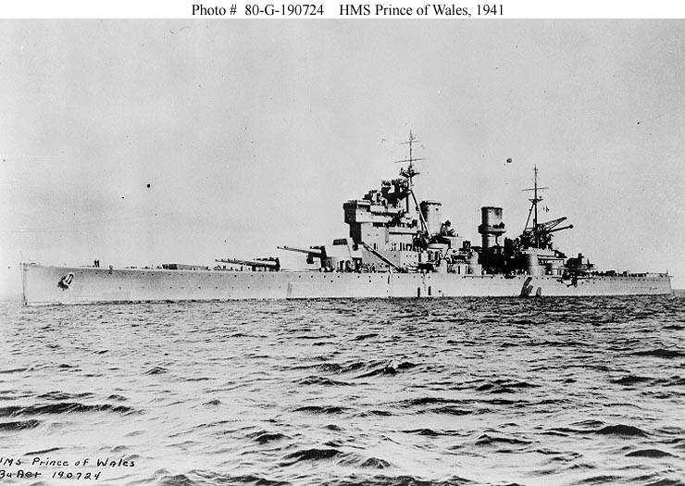AUGUST 14, 1941
The President of the United States of America and the Prime Minister, Mr. Churchill, representing His Majesty's Government in the United Kingdom, being met together, deem it right to make known certain common principles in the national policies of their respective countries on which they base their hopes for a better future for the world.
First, their countries seek no aggrandizement, territorial or other;
Second, they desire to see no territorial changes that do not accord with the freely expressed wishes of the peoples concerned;
Third, they respect the right of all peoples to choose the form of government under which they will live; and they wish to see sovereign rights and self government restored to those who have been forcibly deprived of them;
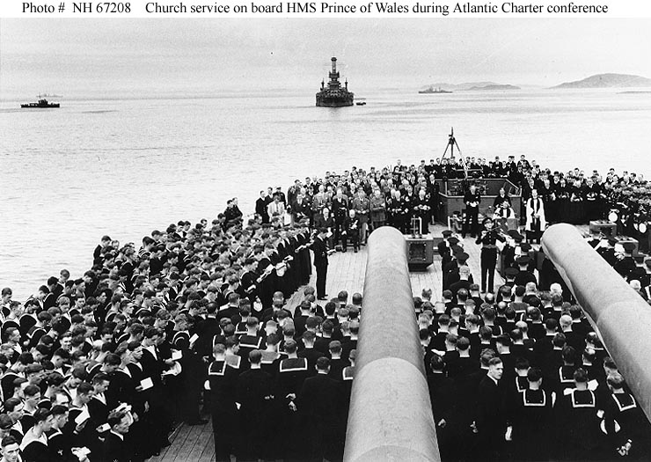
Fourth, they will endeavor, with due respect for their existing obligations, to further the enjoyment by all States, great or small, victor or vanquished, of access, on equal terms, to the trade and to the raw materials of the world which are needed for their economic prosperity;
Fifth, they desire to bring about the fullest collaboration between all nations in the economic field with the object of securing, for all, improved labor standards, economic advancement and social security;
Sixth, after the final destruction of the Nazi tyranny, they hope to see established a peace which will afford to all nations the means of dwelling in safety within their own boundaries, and which will afford assurance that all the men in all lands may live out their lives in freedom from fear and want;
Seventh, such a peace should enable all men to traverse the high seas and oceans without hindrance;
Eighth, they believe that all of the nations of the world, for realistic as well as spiritual reasons must come to the abandonment of the use of force. Since no future peace can be maintained if land, sea or air armaments continue to be employed by nations which threaten, or may threaten, aggression outside of their frontiers, they believe, pending the establishment of a wider and permanent system of general security, that the disarmament of such nations is essential. They will likewise aid and encourage all other practicable measure which will lighten for peace-loving peoples the crushing burden of armaments.
Franklin D. Roosevelt
Winston S. Churchill
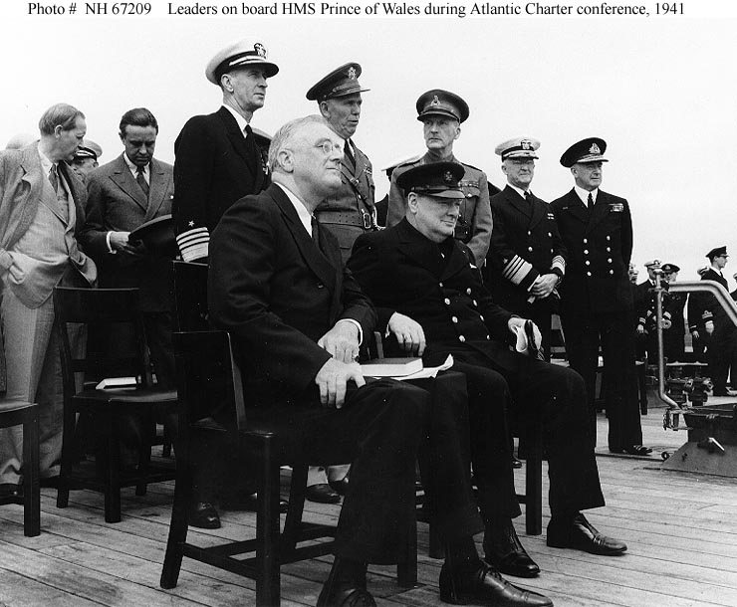

DEEM – VERB to consider or judge something in a particular way Soditi, meniti, misliti

CERTAIN – ADJECTIVE having no doubt or knowing exactly that something is true, or known to be true, correct, exact or effective Določen, nedvomljiv, zanesljiv

PRINCIPLE – NOUN a basic idea or rule that explains or controls how something happens or works Princip, načelo, vodilo

RESPECTIVE – ADJECTIVE relating or belonging to each of the individual people or things you have just mentioned Individualen, zadeven

AGGRANDIZEMENT usually aggrandisement – NOUN increase in power, importance or wealth

DESIRE – VERB to want something, especially strongly Poželenje, hrepenenje, želja

CONCERN – NOUN a feeling of worry or nervousness, or something that worries you Ukvarjati se, skrbeti, biti deležen

SOVEREIGN – ADJECTIVE an extremely successful way of dealing with a problem Suveren, vrhovni, glavni

FORCIBLY – ADVERB physical, especially violent, strength or power

DEPRIVE – VERB to take something, especially something necessary or pleasant, away from someone Prikrajšati, odvzeti, oropati

ENDEAVOR – VERB to try to do something Prizadevati, potruditi se

OBLIGATION – NOUN to force someone to do something, or to make it necessary for someone to do something Obveza, zaveza

VANQUISH – VERB to defeat an opponent, especially in war Premagati, poraziti

RAW MATERIAL – ADJECTIVE not processed; in a natural state Surov material

PROSPERITY – NOUN the state of being successful and having a lot of money Uspevanje, blagina

COLLABORATION – NOUN to work with an enemy who has taken control of your own country Sodelovanje, kolaboracija

LABOUR – NOUN practical work, especially that which involves physical effort Delo, trud, muka

DWELL – VERB to live in a place or in a particular way Ostajati, bivati, stanovati

BOUNDARY – NOUN a real or imagined line that marks the edge or limit of something Meja, ločnica

HINDRANCE – NOUN something which makes it more difficult for you to do something or for something to develop Ovira, zadrževanje, zapreka

TYRANNY – NOUN government by a ruler or small group of people who have unlimited power over the people in their country or state and use it unfairly and cruelly Tiranija, nasilje

ARMAMENT – NOUN the process of increasing the number and strength of a country's weapons Oborožitev, vojna oprema

PENDING – ADJECTIVE about to happen or waiting to happen Neodločen, nerešen

WIDER – ADJECTIVE having a larger distance from one side to the other than is usual or expected, especially in comparison with the length of something; not narrow

ESSENTIAL – ADJECTIVE necessary; needed a basic thing that you cannot live without Bistven, nujen, pomemben

BURDEN – NOUN something difficult or unpleasant that you have to deal with or worry about OR a heavy load that you carry Breme, tovor

