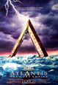

Atlantis, in the tradition of antiquity, a large island in the Western Ocean (the ocean to the west of the known world), near the Pillars of Hercules. The first recorded accounts of Atlantis, which is said to have been engulfed by the ocean as the result of an earthquake, appear in Timaeus and Critias, two dialogues by Greek philosopher Plato. According to the account in Timaeus, the island was described to Athenian statesman Solon by an Egyptian priest, who maintained that Atlantis was larger than Asia Minor and Libya combined. The priest further revealed that a flourishing civilization had reputedly centered on Atlantis about the 10th millennium BC, and that the nation had conquered all the Mediterranean peoples except the Athenians. In Critias, Plato records the history of Atlantis and depicts the nation as a utopian commonwealth. Although Plato's descriptive material and history are probably fictional, the possibility exists that he had access to records that have not survived.
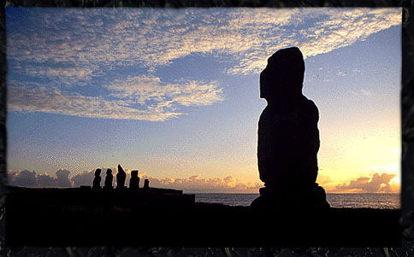
The tradition that a lost island such as Atlantis once flourished has always fascinated the popular imagination, and the tradition continues today. In the 20th century some oceanographers advanced the theory that Atlantis was once a Greek island in the Aegean Sea. Some associate the legend of Atlantis with the Greek island Thíra (Thera), which, according to geologists, experienced a massive volcanic eruption about 1640 BC. Other theories have been based on archaeological discoveries. Scholars have variously identified the island with Crete (Kríti), the Canary Islands, the Scandinavian Peninsula, and the Americas.

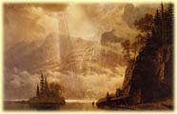

engulf | to surround and cover completely | The flames rapidly engulfed the house.
timaeus
critias
flourish | to grow or develop successfully | Nothing seems to flourish in my garden - perhaps the soil's too poor.
reputedly |  | He's reputedly (= is said to be) the strongest man in Britain.
commonwealth | a country or part of a country that is governed by its people or representatives elected by its the people
descriptive |  | In the exam we had to write one descriptive essay and one discussion essay.
depicts | to represent or show (something) in a picture, story, etc.; to portray | Her paintings depict the lives of ordinary people in the last century.
eruption |  | a volcanic eruption.
scholar | a person who studies a subject in great detail, esp. at a university | Dr Miles was a distinguished scholar of Russian history and government.

