EARTH'S ENCOUNTER WITH MARS CLOSEST IN 50,000 YEARS

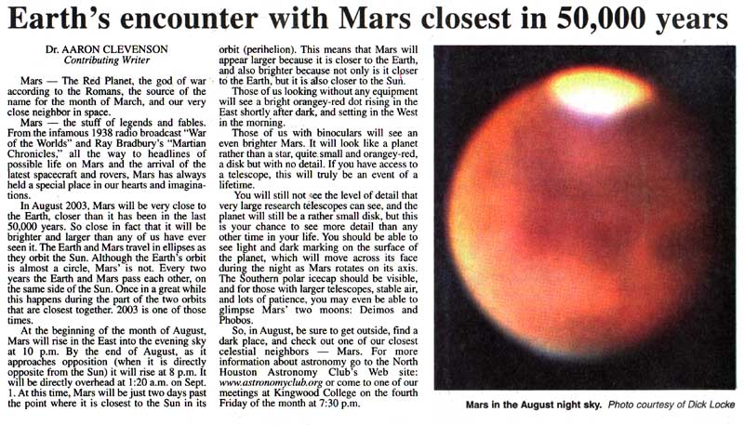

CONTRIBUTE - VERB - To give something, especially money, in order to provide or achieve something together with other people. – prispevati

FABLE - NOUN - A short story which tells a general truth or is only partly based on fact, or literature of this type. - basen, bajka; izmišljena zgodba

HEADLINE - NOUN - A line of words printed in large letters as the title of a story in a newspaper, or the main points of the news that are broadcast on television or radio. - naslovna vrsta v časopisu

ROVERS - ???

HELD - TRANSITIVE VERB - Past simple and past participle of hold. - držati, obdržati

ALTHOUGH - CONJUNCTION - Despite the fact. - čeprav, četudi

DURING - PREPOSITION - From the beginning to the end of a particular period. - med, za časa

OPPOSITION - NOUN - Strong disagreement. - odpor, nasprotje

OVERHEAD - ADJECTIVE ADVERB - Above your head, usually in the sky - nadzemeljski, zgornji, oz zgoraj, nad glavo

DOT - NOUN - A very small round mark – spot. – pika

AXIS - NOUN - A real or imaginary straight line which goes through the centre of a spinning object. - (navidezna) os

ICECAP - NOUN - A thick layer of ice that permanently covers an area of land. - ledenik; ledena odeja

GLIMPSE - VERB - To see something or someone for a very short time or only partly. - bežno zagledati

CELESTIAL - ADJECTIVE -Formal of or from the sky or outside this world. - nebesno telo, nebesnina

