LUCY WHO?

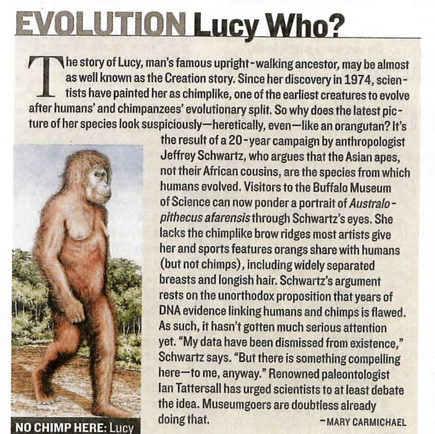

UPRIGHT – ADJECTIVE describes something which is taller than it is wide Pokončen, navpičen

ANCESTOR – NOUN a person, plant, animal or object that is related to one existing at a later point in time Prednik

CREATURE – NOUN Bitje, stvor, človek
1 any large or small living thing which can move independently
2 used to refer to a life form that is unusual, unknown or imaginary

EVOLVE – VERB to develop gradually, or to cause something or someone to develop gradually Razvi(ja)ti (se), nasta(ja)ti

CAMPAIGN – NOUN a planned group of especially political, business or military activities which are intended to achieve a particular aim Bojni pohod, vojskovanje, politična gonja

ARGUE – VERB to speak angrily to someone, telling them that you disagree with them Pričkati se

PONDER – VERB to think carefully about something, especially for a noticeable length of time Premišljati, razmišljati, pretehtati

LACK – NOUN lack of sth the absence of something or when there is not enough of it Pomanjkanje, stiska

RIDGE – NOUN a long narrow raised part of a surface, especially a high edge along a mountain Gorski greben, hrbet, sleme, sedlo

UNORTHODOXE – ADJECTIVE different from what is usual or expected in behaviour, ideas, methods, etc Nepravoveren, neortodoksen

FLAW – NOUN a fault, mistake or weakness, especially one that happens while something is being planned or made, or which causes something not to be perfect Napaka, hiba, pomanjkljivost

COMPEL – VERB to force someone to do something (pri)siliti; podrediti

RENOWN – NOUN the state of being famous Sloves, velik ugled, slava

SUSPICIOUS – ADJECTIVE feeling lack of trust or doubt in someone or something Sumljiv, sum zbujajoč

