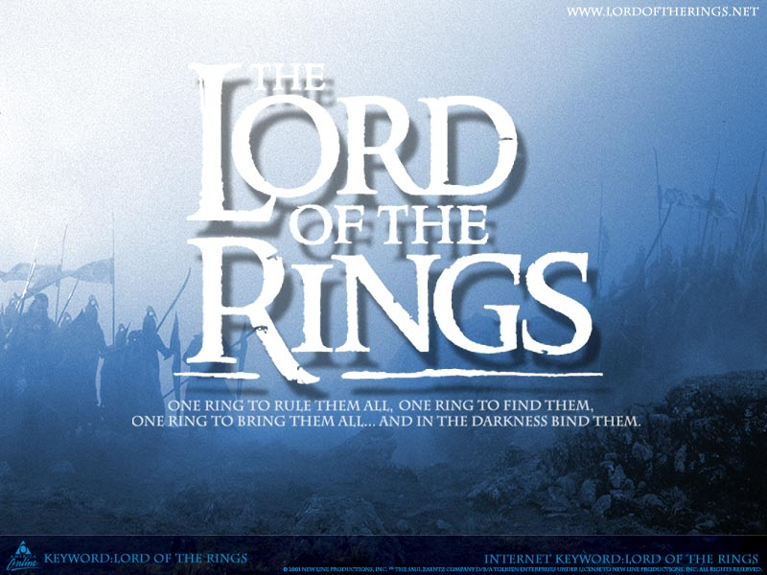

### The Fellowship of the Ring

The One Ring finds it's way into the hands of Frodo Baggins, a hobbit. From Gandalf the Grey, a wizard, he learns of the vital importance of destroying the One Ring to save Middle-earth.

In the end, it destroys Frodo as well. Frodo sets out to Rivendell. There, in the Council of Elrond, they decide to destroy the Ring. Frodo is designated the Ring bearer, and with the Fellowship of the Ring, made up of Gandalf the Gray, Frodo, Merry, Sam, Pippin, Aragorn, Legolas, Gimli, and Boromir, they set out to destroy the ring.

They must destroy the ring by throwing it into the Cracks of Doom in Mordor. Gandalf falls into an abyss in the mines of Moria after fighting the Balrog.

At the end of the first book, Boromir has been killed by orcs. Pippin and Merry have been captured, and Frodo and Sam have started their way to Mordor alone.

|  |  |  |
| --- | --- | --- |
|  |  |  |
| Legolas | Strider |  |

|  |  |  |
| --- | --- | --- |
| **vital** | necessary for the success or continued existence of something; extremely important | Most people view the existence of a strong opposition as vital to a healthy democracy. |
| **importance** |  | The health report stresses the importance of fresh food in a diet. |
| **designated** | to choose (someone) officially to do a particular job or to state officially that (something or a place) has a particular character | The president traditionally has the right to designate his or her successor. |
| **Ring (bearer)** |  | Why are you always the bearer of (= the person who brings) bad news? |
| **abyss** | a very deep hole which seems to have no bottom | Space is like an abyss. |