THE TWO TOWERS
Aragorn, Legolas, and Gimli discover that Pippin and Merry have been captured, and decide to go after them instead of helping Frodo destroy the One Ring. Meanwhile, Pippin and Merry escape the orcs that have captured them and enter Mirkwood.
Treebeard, an Ent, discover them and Pippin and Merry tell what they know to him. He and his fellow Ents storm Isengard, where the evil Saruman was.
They destroy Isengard. Meanwhile, Aragorn, Legolas, and Gimli found that Gandalf survived the fall and he rejoined their party. They meet up with Pippin and Merry at Isengard. Frodo and Sam come slowly forward to Mordor, and find Gollum, who Bilbo, Frodo's uncle, got the One Ring from. 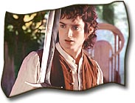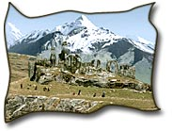

He serves as their guide, hoping to get "my precious" (the One Ring) from Frodo. He leads them to Cirith Ungol, a pass to get to Mordor. In it, a huge spider that has been in Middle-earth since the Elder Days, attacks Frodo.
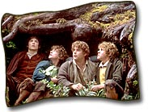He becomes unconscious and Sam takes the One Ring. Orcs capture Frodo. Frodo was alive but taken by the Enemy.

precious | of great value because of being rare, expensive or important | Clean water has become a very precious commodity in many parts of the world.
Ungol
Elder | an older person, esp. one with a respected position in society | They consulted the village elders.
unconcious

