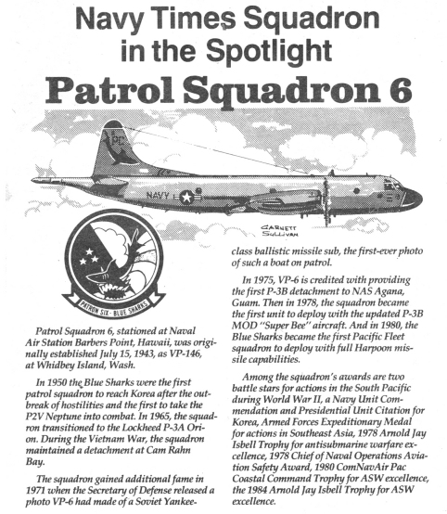

ESTABLISHE – VERB To start a company or organization that will continue for a long time Ustanovitev, osnovanje; odobritev

PATROL – VERB To go around an area or a building to see if there is any trouble or danger Patrulja, obhodna straža, obhodnica

HOSTILE – ADJECTIVE - Unfriendly and not liking or agreeing with something
Sovražen - Connected with the enemy in a war

COMBAT – NOUN A fight, especially during a war Boj, borba

SQUADRON – NOUN A unit of one of the armed forces, especially (in Britain) the air force or the navy Eskadron (120 - 200 vojakov)

SPOTLIGHT – NOUN A lamp whose beam can be directed Svetloba (luč) reflektorja

DETACHMENT – NOUN A group of soldiers who are separated from the main group in order to perform a particular duty Ločitev, odcepitev; oddelek

TRANSITION – NOUN A change from one form or type to another, or the process by which this happens prehod, prehajanje; prehodna doba

GAIN – NOUN An increase in something such as size, weight or amount Dobiček, korist, dobitek, pridobitev, prirastek, izboljšanje

ADDITIONAL - ADJECTIVE

BALLISTIC MISSILE – NOUN A missile which is powered to direct it on its flight, but which continues and falls towards its target Balistična raketa

DEPLOY – VERB - To use something or someone, especially in an effective way
- To move soldiers or equipment to a place where they can be used when they are needed
Razviti (se), razvrstiti (se) (čete); na boj se pripraviti

CAPABILE – ADJECTIVE Able to do things effectively and skilfully, and to achieve results Zmožen, sposoben

AMONG – PREPOSITION In the middle of or surrounded by other things Med, izmed

CITATION - ??? Navajanje, navedek

WARFARE – NOUN the activity of fighting a war, often including the weapons and methods that are used Vojskovanje, vojna, vojno stanje

