PRINCE WILLIAM

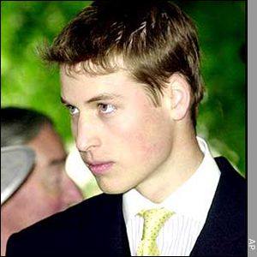

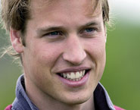 |  | PRINCE WILLIAM  Prince William Arthur Philip Louis was born on 21 June 1982 at St Mary's Hospital, Paddington, in London. He was christened by the Archbishop of Canterbury at Buckingham Palace.  Prince William began his education at Mrs Mynor's Nursery School in west London in September 1985, aged 3. In January 1987, William was enrolled at Wetherby School, also in London, and was a pupil there until July 1990.  He spent five years at Ludgrove School from September 1990 until July 1995, and then attended Eton College, Windsor, where he studied Geography, Biology and History of Art at A Level after sitting 12 GCSEs.  After passing his A Levels, Prince William took a gap year, spending time on manoeuvres in Belize, working on a farm in the United Kingdom, helping in community projects with other young people in a remote area of Chile, and visiting countries in Africa.  After returning to the UK Prince William studied at the University of St. Andrews, Scotland. In June 2005 he completed his four-year course, graduating with a 2:1 in his Master of Arts (Honours) Degree in Geography.  Prince William is a keen sportsman and prefers football, rugby, tennis, swimming and water polo. At Ludgrove, he was rugby and hockey team captain and represented the school at cross-country running.  Prince William is also a crack clay pigeon shooter, winning the school's prize in 1994. He acted in school plays, and enjoys reading and film-going.  Prince William's first public appearance was on a visit to Wales on St David's Day (1 March), at a service at Llandaff Cathedral, aged 8.  In May 1995, Prince William accompanied his mother, father and brother to the 50th anniversary of VE (Victory in Europe) commemorations in Hyde Park. He also accompanied his family to the VJ (Victory in Japan) Day 50th anniversary commemorations in front of Buckingham Palace and in the Mall in August 1995.  Following the death of Diana, Princess of Wales, Prince William attended his mother's funeral at Westminster Abbey on 6 September 1997. In the same year he made another official appearance at Westminster Abbey, when he attended the service of thanksgiving to mark the Golden Wedding of The Queen and The Duke of Edinburgh in November 1997.  In 2002, Prince William attended engagements in London to mark the Golden Jubilee of his grandmother, The Queen.  In July 2005 Prince William visited New Zealand, supporting the British and Irish Lions rugby team on their tour to New Zealand, and representing The Queen in Wellington and Auckland at events to commemorate the end of the Second World War.  In September 2005 Prince William took on his first patronage, becoming Patron of Centrepoint, the UK's leading youth homelessness charity.
  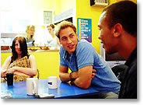

SUMMARY

Prince William Arthur Philip Louis was born on 21 June 1982 in London. He began his education when he was only 3 years old at Mrs. Mynor's Nursery School in London. He was in a lot of different schools, and during the studying he took a gap year and went on a farm in the UK, to help in community projects and he visited countries in Africa. He prefers to play football, rugby, tennis, swimming and water polo. He was also in hockey team, and he represented school at cross-country running.

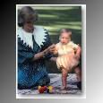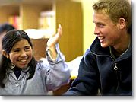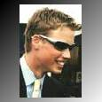

EXPLANATION OF UNKNOWN WORDS

CHRISTEN (v) = to give a baby a name at a Christian ceremony and make him or her a member of the Christian Church. (KRSTITI, IME DATI)

ENROLL (v) = to put yourself or someone else onto the official list of members of a course, college or group. (VPISATI V SEZNAM)

PUPIL (n) = a person, especially a child at primary school, who is being taught. (UČENEC)

GAP YEAR (n) = a year between leaving school and starting university which is usually spent traveling or working. (LETO, MED KONČANO ŠOLO IN UNIVERZITETO)

MANOEUVRE (n) = a cleverly planned action which is intended to obtain an advantage. (VELIKA VOJAŠKA VAJA)

COMMUNITY (n) = the people living in one particular area. (SKUPNOST)

REMOTE (adj) = far away in distance time or relation. (ODDALJEN, OSAMLJEN)

COURSE (n) = a set of classes or a plan of study on a particular subject, usually resulting in an exam or qualification. ( )

GRADUATE (v) = to complete a first university degree successfully. (DIPLOMIRATI)

ACCOMPANY (v) = to go with someone (POSPREMITI)

ANNIVERSARY (n) = the day on which an important event happened in a previous year. (OBLETNICA)

FUNERAL (n) = ceremony for burying or burning the body of a dead person. (POGREB)

SUPPORT (v) = to help someone emotionally or in a practical way. (PODPORA)

COMMEMORATE (v) = to remember officially and give respect to a great person or event, especially by a public ceremony. (POČASTITI SPOMIN)

PATRONAGE (n) = the power of a person to give someone an important job or position (PODPIRANJE, POKROVITELJSTVO)
WORD FORMATION

REMORTE (adj)
–» remotely (adv)
–»remoteness (n)b

COURSE (n)
–»course (v)
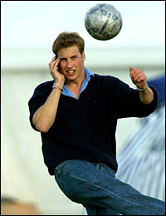
–» course book (n)
–» coursework (n)

GRADUATE (v)
–»graduate (n)
–» graduation (n)
–»graduate school (n)
–»graduated (adj)

ACCOMPANY (v)
–»accompanying (adj)
–»accompaniment (n)
–»accompanist (n)

SUPPORT (v)
–»support (n)
–»supporter (n)
–»supportive (adj)
–»supportively (adv)
–»supportiveness (n)
–»supportable (adj)

MY OPINION

For me Prince William is the most beautiful prince ever!! I think he is very intellectual, because he was visiting so many schools. First time when he went to school was when he was only 3 years old! He is very sport-loving, he was playing at least 5 sports, and I think this is very incredible for one prince. I think he wants to live normal life, but because he is the part of royal family, this can’t happen. But fame is not always gut, this shows the death of his mother Princess Diana, because of that he suffered a lot.

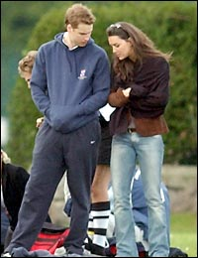

Prince William
& his girlfriend
Kate Midletton

