PROBLEMS DOG BARON

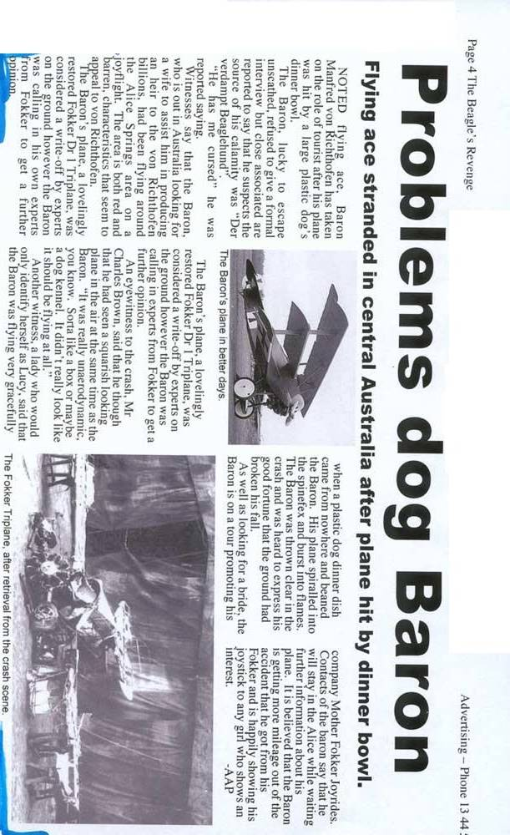
STRAND – NOUN a thin thread of something, often one of a few twisted around each other to make a cord or rope Vrv, konopec

BOWL – NOUN a round container that is open at the top and is deep enough to hold fruit, sugar, etc., or the rounded inside part of something Skleda, posoda čaša

ROLE – NOUN the position or purpose that someone or something has in a situation, organization, society or relationship Vloga, funkcija

UNSCATHED – ADJECTIVE without injuries or damage being caused Nepoškodovan, nedotaknjen

REFUSE – VERB To say that you will not do or accept something Odkloniti, odbiti, zavrniti

CALAMITY – NOUN a serious accident or bad event causing damage or suffering Nesreča, beda, nadloga

COURSE – NOUN the direction in which a vehicle, especially an aircraft, spacecraft or ship, moves, or the path along which a river flows Smer

WITNESS – NOUN a person who sees an event happening, especially a crime or an accident Priča, očividec, prečevalec

BARREN – ADJECTIVE not productive Neploden, pust, suhoparen

SQARISH ???

KENNEL – NOUN a small, usually wooden shelter for a dog to sleep in outside Uta, pasja hišica

GRACEFULLY – ADVERB behaving in a polite and pleasant way Ljubkost, ljubek, lep, privlačen, eleganten

BANE – NOUN a cause of continual trouble or unhappiness Strup, poguba,nesreča

FORTUNE – NOUN a large amount of money, goods, property, etc Usoda, premoženje, sreča

