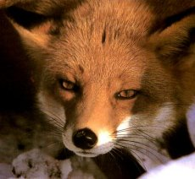

Description - This small, doglike animal is rusty-red with white underparts, chin and throat. The ears are prominent and the tail is long and bushy with a white tip. Backs of the ears, lower legs and the feet are black. The fox goes through colour phases of black, silver, and mixed.
Distribution - The red fox prefers the edges of forests, tilled fields and near marshes but they can be found on farmland, beaches, prairies, woodlands and both alpine and arctic tundra. They thrive throughout most of British Columbia.
Biology - After a 51-53 day gestation period, up to 10 kits are born. Because of its well-developed sense of hearing, sight, and smell the red fox is an efficient and lethal predator; being an omnivore it eats whatever is available including corn, berries, apples, grasses, birds and mammals. The fox has many enemies including coyote, lynx, and humans. It is also susceptible to rabies

underparts-
throat-Your throat is the back of your mouth and the top part of the tubes that go down into your stomach and your lungs. (n)
PROMINENT-Something that is prominent is very noticeable or is an important part of something else. (n)
Distribution-The distribution of something is how much of it there is in each place or at each time, or how much of it each person has. (n)
marsh-Marsh is a wet, muddy, area of land. (n)
PRAIRIERS-
THRIVE-If someone or something is thriving, they do well and are successful, healthy, of strong. (v)
GESTATION-Is a process in which babies grow inside their mothers’ body before they are born. (n)
LYNX-Is a wild animal similar to a large cat. (n)
SUSCEPTIBLE-If you are susceptible to a disease or injury, you are very likely to be affected by it. (n)

