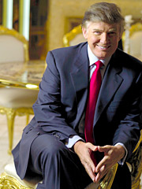

Biography of Donald Trump

Donald John Trump was born June 14, 1946, in New York, NY. The third generation in a family of businessmen, Donald has his father, Fred Trump, to thank for his deal making and entrepreneurial skills.
Fred Trump was forced to help support his family due to his father's death early on. As a result, Fred started his own business and recognized the money to be made in real estate. Donald inherited the skill of recognizing a good deal when he saw it, since Donald would assist his father in his business ventures when he was still young.
on his own
After completing his education at a military academy, Trump headed out to study finance at the University of Pennsylvania's Wharton School. With an innate eye for business, and the additional training he received in school and while working for his father, Trump knew what he wanted to do with his life, and whatever it was, he knew it would be big.
But big couldn't occur where he was raised -- in Queens -- so he packed up his belongings and moved to Manhattan on his own. His bank account and wallet were a far cry from the fortune he has today (he was practically broke), but that didn't stop him from becoming a member at an exclusive club in New York.
Trump used his negotiating skills and smarts to join the club, which was not open for "regular" folk -- on the condition that he kept his hands off the wives of other members (his womanizing skills must have been apparent early on). He didn't intend to play polo and sail in yachts as a member, rather he used his membership as a way to make contacts, and that he did.
Trump had transformed himself into one of the most powerful real-estate moguls of the '80s, with ownership of buildings such as Trump Tower on 5th Av., Trump Parc, the Plaza Hotel, and the New Jersey Generals. He also penetrated the casino business in Atlantic City and New Jersey, and transportation with the Trump Shuttle airline.
duck, donald, duck!
Even though he studied business, he often went against the basic principle behind economics: lower prices when there's competition. When Trump had competitors, not only did he not lower prices, but he also raised them. Despite his knack for making deals and recognizing a good investment when he saw one, Trump's billion-dollar empire crumbled in 1990, when he was forced into bankruptcy for over $2 billion bank loans that he couldn't pay.
Although he handed over most of his holdings to the creditor banks, he remarkably managed to bounce back by the end of the 1990s. He shared his story in the book, The Art of the Comeback, and has done more work in the publishing world as he has co-authored several books about none other than himself.
"The Donald," as he is nicknamed, has also ventured into television as the Executive Producer of Miss USA, and is presently the Producer of the Miss Universe pageant. He has also made countless cameo appearances as himself in shows such as Roseanne, Suddenly Susan, Spin City, The Nanny, The Fresh Prince of Bel-Air, and The Job, as well as films like Home Alone 2: Lost in New York, Celebrity and 54.
the trump troupe
Real estate, transportation, casinos, and entertainment weren't enough for "Trump Daddy": in 1999, he announced that he was considering running for President, as a Reform Party candidate in 2000. Incidentally, he revealed in The Art of the Comeback that he wouldn't have made a good President: he has trouble shaking others' hands as he is a germophobe, and worst of all, he is honest.
Honest or not, one thing's for sure: Trump is known as a womanizer, and his two failed marriages have been tabloid fodder for the past 2 decades. His marriage to Ivana Trump ended in 1990, but he has 4 children to show for it: 2 sons and daughter Ivanka, an up-and-coming model. Trump then wed Marla Maples in 1993. The couple had a daughter, Tiffany, and then divorced 6 years later. Now he is married with Melania Knows, and they have a child together.
He is always seen with different women in the tabloids, so it's hard to track his present romantic record.
Single or not, the father, mogul, and flamboyant figure has proved that whether you're on your way up or down, it pays to think big.
Thanks to the hit NBC reality series The Apprentice, in which 16 contestants vie for a position at one of Trump's corporations, The Donald can add another success to his Trump report card. What else do you need to know?
SUMMARY

Donald John Trump was born June 14 in 1946, in New York. Fist he worked in fathers company, but after completing his education at a military academy, Trump headed out to study finance at the University of Pennsylvania's Wharton School. When he finished school, he packed up his belongings and moved to Manhattan on his own. His bank account and wallet were a far cry from the fortune he has today. Trump's billion-dollar empire crumbled in 1990, when he was forced into bankruptcy for over $2 billion bank loans that he couldn't pay, but remarkably managed to bounce back by the end of the 1990s. Now he is one of the most powerful millionaires on the world.

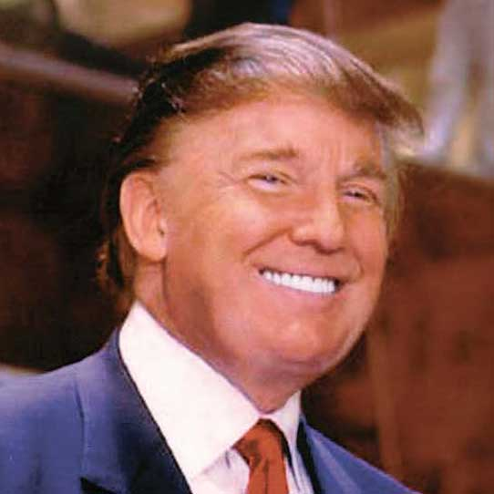

EXPLANATION OF UNKNOWN WORDS
- INNATE (adj)= An innate quality or ability is one that you were born with, not one you have learned (PRIROJENO)

- BANK ACCOUNT (n)= An arrangement with a bank where the costumer puts and removes money (BANČNI RAČUN)

- PENETRATE (v)= To move into or through something (VDRETI)

- INVEST (v)= To put money into something to make a profit (VLOŽITI denar)

- BANKRUPTCY (n)= When company don’t have money any more (BANKROT)

- WOMANIZER (n)= Someone who has a lot of woman’s (ŽENSKAR)

- FLAMBOYANT (adj)= Very confident in behavior (SIJAJEN, RAZKOŠEN)

- FORTUNE (n)= a large amount of money (BOGASTVO)

- NEGOTIATE (v)= to have formal discussion with someone in order to reach an agreement with them (POGAJATI SE)

- REAL-ESTATE (n)= Property in the form of land or building (NEPREMIČNINE)

WORD FORMATION

NEGOTIATE (v)
- NEGOTIABLE (adj)
- 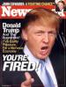NEGOTIATOR (n)
- NEGOTIATION (n)

INVEST (v)
- INVESTMENT (n)
- INVESTOR (n)
- INVESTIGATE (v)
- INVESTIGATION (n)
- INVESTIGATIVE (adj)

BANKRUPTCY (n)
- 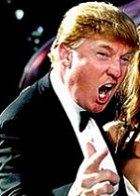BANKRUPT (adj)
- BANKRUPT (v)
- BANKRUPT (n)

WOMANIZER (n)
- WOMANIZE (v)
- WOMANIZING (adj)
- WOMANISER (n)

FLAMBOYANT (adj)
- FLAMBOYANCE (n)
- FLOMBOYANTLY (adv)

MY OPINION

For me Donald Trump one of the most intelligent person on the world. He went to his own with no money and became millionaire. We believed in his dreams and made it true. He is very hard working man. Although his bankruptcy, he soon recover and complete with work. He didn't intend to play polo and sail in yachts as a member, rather he used his membership as a way to make contacts, and that he did. Because of that he made a lot of business agreements. He is not as other millionaires; he loves his work and enjoys every minute of it.

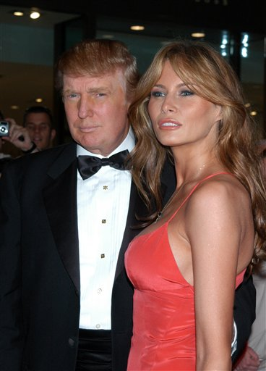

Donald Trump with his wife Melania Knaws

