USS ESSEX

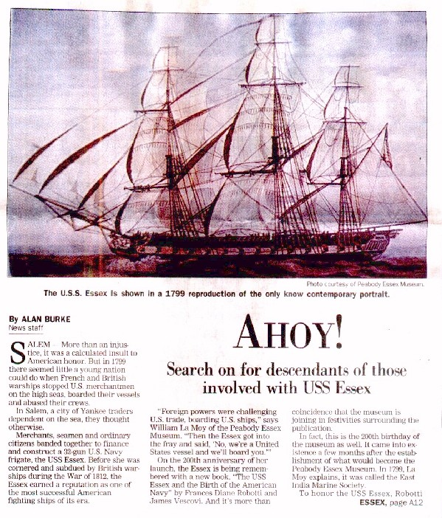

REPRODUCTION – VERB To produce a copy of something, or to be copied in a production process Reprodukcija, ponovno proizvajanje

CONTEMPORARY – ADJECTIVE Bonging to the same or a stated period in the past Sodoben, sočasen

DESCENDANT – NOUN A person who is related to someone and who lives after them, such as their child or grandchild Potomec, potomka

INJUSTICE – NOUN Lack of fairness and lack of justice Nepravičen

INSULT – VERB To say or do something to someone that is rude or offensive Žalitev, sramotenje

MERCHANT – NOUN A person whose job is to buy and sell products in large amounts, especially by trading with other countries Trgovec, veletrgovec

VESSEL – NOUN A large boat or a ship Ladja, plovni objekt

ABUSE – NOUN When someone uses or treats someone or something wrongly or badly, especially in a way that is to their own advantage Zloraba

BAND – NOUN A group of people who share the same interests or beliefs, or who have joined together for a special purpose Tolpa, četa, truma, skupina

FRIGATE – NOUN A small fast military ship Fregata

SUBDUE – VERB To reduce the force of something, or to prevent something from existing or developing Podvreči, podjarmiti

REPUTATION – NOUN The opinion that people in general have about someone or something, or how much respect or admiration someone or something receives, based on past behaviour or character Sloves, ugled

FRAY – VERB If your temper frays or your nerves fray, you gradually become upset or annoyed Ponositi; razrvati (živce)

ANNIVERSARY – NOUN The day on which an important event happened in a previous year Obletnica; jubilej

COINCIDENCE – NOUN An occasion when two or more similar things happen at the same time, especially in a way that is unlikely and surprising Sovpad, hkratnost; naključje

ESTABLISHMENT – NOUN A business or other organization, or the place where an organization operates Ustanovitev, osnovanje

HONOR – (USED FOR HONOUR) NOUN A quality that combines respect, pride and honesty Čast, spoštovanje

