THE FIRST SCHOOL DAY

* **a kindergarden**
* **a primary school**
* **a secundary school**
* **a school uniforms**
* **in front of school**
* **strangers**
* **run aut of**
* **play graund**
* soap – milo

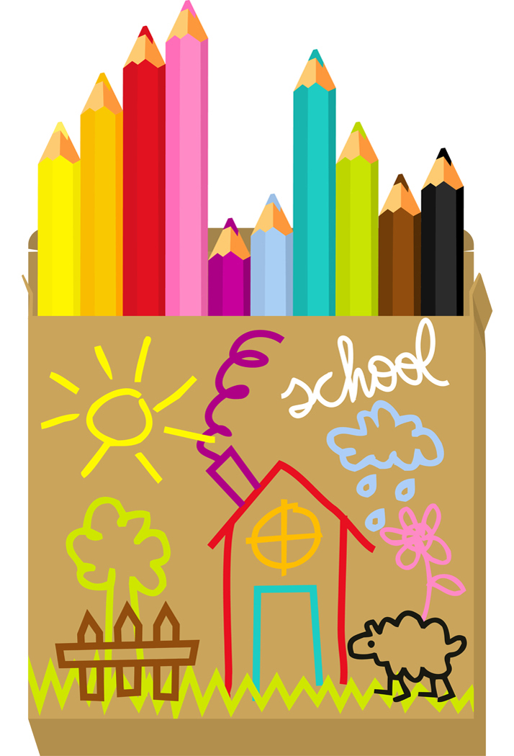

* strict – biti strog
* a term – termin
* a time-table – urnik, vozni red
* cross-legged – sedeti poturško
* be amberassed – biti osramočen
* a fish 🡪 10 fish !!! (nepravilna množina)

**How old were you?**

**Who went with you?**

**What did you wear?**

**How did you feel and why?**

**What was the school like (high, old, white building)**

**Where were the school?**

**Your first classteacher (name, strict, fiendy).**

**What did you do?**



End of summer it was approaching quickly and with that school – my first day of primary school. Sometimes I coudn't wait and the other time I did't want to go, I was scared. But I had to go. I did't have other chance. One week before school I had my 7th birthday and for birthday presend from my grandparents I got rely nice school bag with horses. In front of school I went with my mother and some friend from kindergarden. There I met some strangers with who's I become rely good friends in school years. We did't wear a uniform. I wear blue skirt and white bluse. I did't like the bluse but I wear it because I want to do an impression. When we stand in front of school I was very [nervous](javascript:IzberiBesedo2(0,1)" \o "Označi besedo in ponudi alternativne prevode besede in stavka.), because I did't know what to expect. Scool was in center od Dravograd, next to the shop with school needed things and it was very nice and big. I remember some brown scolpture in front of school, on whitch I always sat on when I were waint my dad to came for me. When we [entered](javascript:IzberiBesedo2(0,2)" \o "Označi besedo in ponudi alternativne prevode besede in stavka.) in a classroom we got a cake and classteacher set that her name is. She was nice and friendy too, but I did't like her, because one time she did't want to help me with my homework and she was strict. We ate the cake and when we were leaving the classroom we got yellow kerchiefs. My first day of school was very nice and I like to remember it.