HOW YOUNG PEOPLE USE THEIR MOBILE PHONES?

1. Time spent on mobile phones
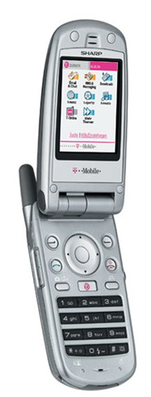Over half people in group have spent less than one hour on their mobile phones over last week. The reason for this is that young people use their phones when they have to contact their parents that they will be late for home, stay in touch with friends, to discuss homework during the week. Some people in group have spent more than one hour on their mobile phones. Besides that they have used them for ordinary occasions, they have also used them for playing games, sending messages, to access to the internet etc.

2. Calls
Almost all people in the group have called the persons they know. For example their parents, relatives, friends, schollmates etc. Hardly any people have used their mobile phones to order food from restaurants or to order products from TV-shops.

3. Kinds of mobile phones
Aproximately 50% of people have used modern, efficient mobile phones, with digital camera, bluetooth and IR-filter. Other people have used with less functions, but they said that they are satisfied with their phones.

4. Conclusions
Most people use their mobile phones for ordinary occasions and spend less than one hour per week on their phones. Their phones are in most cases modern and efficient.

