You Are What You Eat
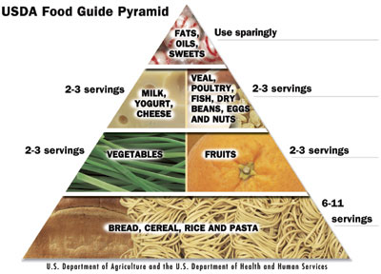 A balanced diet mainly consists of complex carbohydrates. We also have to eat a lot of fruit and vegetables, because we get vitamins, minerals and fibre from them. A big part of our diet should be protein. A lot of people think fat is bad; however it’s essential for us. Sugar should be in our diet too, although we shouldn’t eat too much of it.

The food pyramid
Firstly, at the bottom of the pyramid there are carbohydrates (they should be the biggest part of our diet), then come vegetables and fruit, they are second most important food in our diet. Then come protein and at the top of the pyramid come sugar, oils and fats (we shouldn’t eat them often).Secondly, I would make a different pyramid. I agree with the bottom row, but I would switch vegetables with protein. Then I would make sweets more important. I would also include fizzy drinks. I know that would make it less healthy, but I think everyone would like it more.
Our body basically needs five things: carbohydrates, protein, vitamins, minerals and fibre.
We get carbohydrates from bread, pasta, cereal and potatoes. Protein comes mostly come from meat, cheese, fish and eggs. For vitamins, minerals and fibre we have to eat a lot of vegetables like carrots, cabbage, tomatoes… and fruit like oranges, apples, pears…

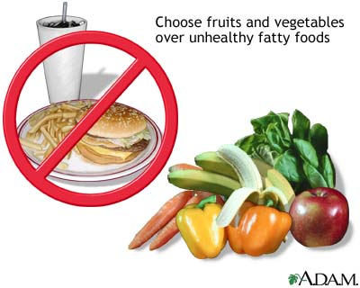Healthy diet

Healthy diet isn’t just about healthy and unhealthy food. It’s about eating different food and avoiding very big meals and junk food. It’s good to eat fruit and vegetables, but not too much of it.

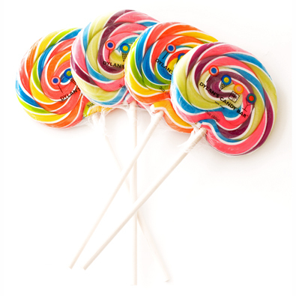Usually I don’t eat breakfast at home, except on weekends and holydays. It’s not healthy, but I’m just not hungry. My first meal is at school at 10 am. We normally get a slice of bread and something on it like pate or butter and jam. We also get a cup of tea or juice. I eat lunch at school too. It’s not very good, but I still eat it. It’s mostly some meat and potatoes prepared in different ways. Sometimes I even like it. For dinner I’m not usually hungry, however if I am my mum makes pasta or we get a pizza. Between the meals I usually eat energy bars or salty snacks. I’m also addicted to lollipops. I especially like the big, colourful ones you can’t get in normal stores. I almost always drink orange juice. I like fizzy drinks too, but I can’t drink them in winter because I have a sore throat after them.

I think my diet is very unhealthy, especially because I eat a lot of sugar and no breakfast. For a more healthy diet I should eat breakfast, amount of sugar I eat and eat less for dinner; however I’m not going to do that because I like my diet just the way it is.

