AMSTERDAM



DESCRIPTION

Amsterdam is the capital of Netherland. It lies on the west of the Netherland. It has 725.000 inhabitans. The language is Netherlands. The surface is 200km2. The name had got by the first dam on the river Amstel that was built in the year 1000. The city is built on a pales and it lies under the sea level and that's why we name it a lot of times the Northern Venice. It's constructed by 165 channels, 1281 bridges and narrow streets and above this streets are lifting up houses from wood with 4 or 5 floors. The houses are coloured in the style of 15. century and it has funny sculptures. In the ground floor of this houses are small shops and coffe shops.

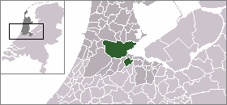

SIGHTS

Amsterdam has got about 400.000 bicycles and it's the only city in the world, where is more bikes than cars. Every inhabitan should have one bike. Sterdam is known after tulips, channels, bridges, chees, harbours, windmills, museums and cannabis. The most important museum is Vincent van Goghs museum, where is on show 206 his pictures. In this city is always something going on. In the summer are organized concerts at the channels. Every day is organized about 400 concerts. For the fanciers of the antiques is very interesting quarter Jordaan. The amsterdam jews changed this city into one of the biggest centre for grinding diamonds on the world. Amsterdam's [Hortus Botanicus](http://en.wikipedia.org/wiki/Hortus_Botanicus_%28Amsterdam%29), founded in the early 1600s, is one of the oldest [botanical gardens](http://en.wikipedia.org/wiki/Botanical_garden) in the world, with many old and rare specimens.

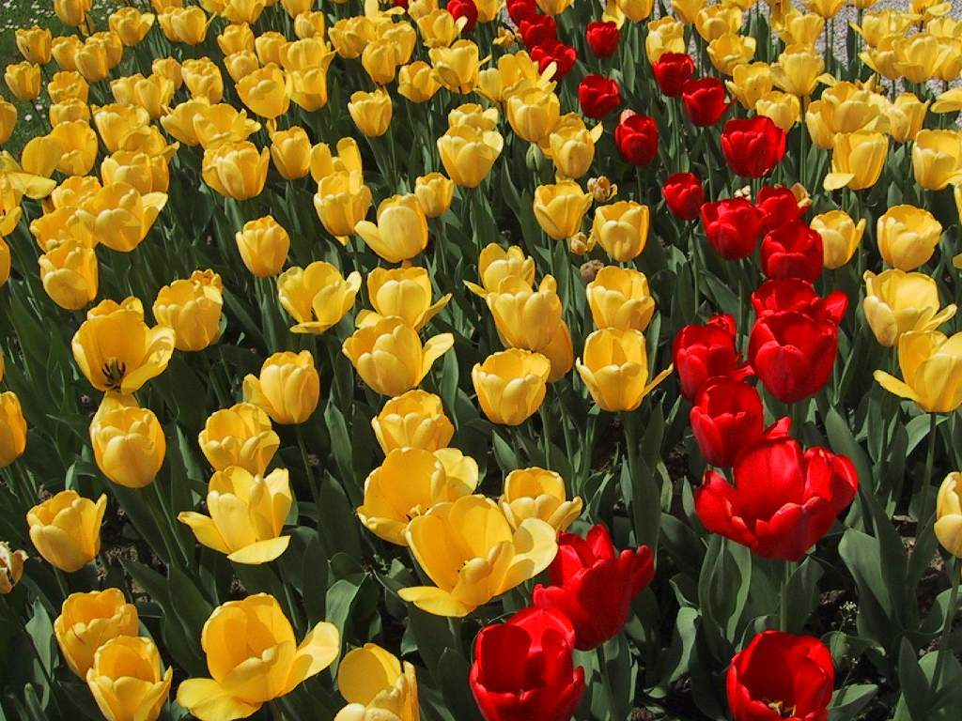

HISTORY

In the history, the German tribes lived here. Because the Dutch were a good sailors, it early originate a social class of merchants, possessors, shipowners, bankers. A big part of the popilation was occupying with farming and fishing. In the seventeenth century Amsterdam was the most important port of the world. Amsterdam was founded as a fishing village in the [13th century](http://en.wikipedia.org/wiki/13th_century). According to legend Amsterdam was founded by two [Frisian](http://en.wikipedia.org/wiki/Frisian) fishermen, who landed on the shores of the Amstel in a small boat with their dog. The damming of the river [Amstel](http://en.wikipedia.org/wiki/Amstel) gave it its name. It was given [city rights](http://en.wikipedia.org/wiki/City_rights_in_the_Netherlands) in [1300](http://en.wikipedia.org/wiki/1300) or [1301](http://en.wikipedia.org/wiki/1301).

- 1928 the olympic games were in Amsterdam

- 1980 became Amsterdam the capital of the Netherlands

REMARKABLENESS

Industries:

- the shipbuilding industry

- the metallurgy

- the chemical industry

Sport:

- In Amsterdam is the most popular Kind of sport football. The best association is Ajax Amsterdam. From Amsterdam come also numerous football legends.

Museums:

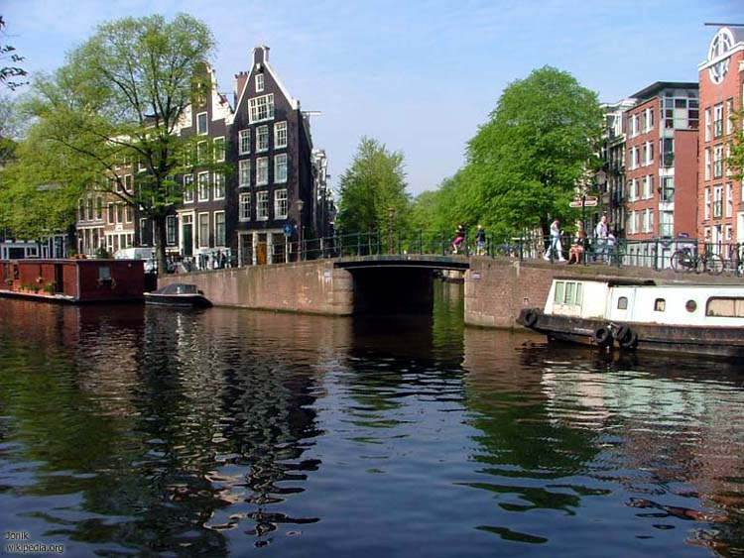

- the Rijksmuseum

- the Van Gogh museum

- the Scheepvaart museum

-Stedelijk museum

-[Rembrandt House Museum](http://en.wikipedia.org/wiki/Rembrandt_House_Museum)

 -the Anne Frank house

Theatres:

-Concertgebouw

-Stadsschouwburg

Churches:

            - Westerkerk

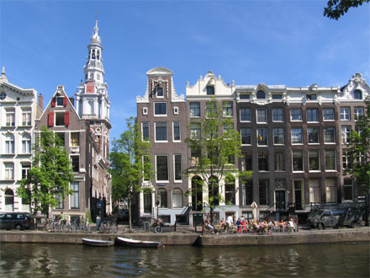

         - Amstelkerk

- Oude Kerk

       - Nieuwe Kerk

Universities:

-[University of Amsterdam](http://en.wikipedia.org/wiki/University_of_Amsterdam)

-[Vrije Universiteit](http://en.wikipedia.org/wiki/Vrije_Universiteit)

Other interesting things:

-their typical houses

-numerous "[coffee shops](http://en.wikipedia.org/wiki/Coffee_shop)" selling [cannabis](http://en.wikipedia.org/wiki/Cannabis_%28drug%29)