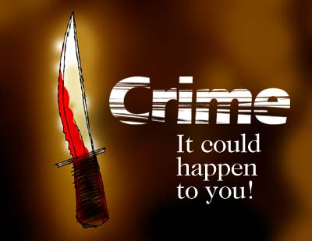

**CRIME-CRIMINALS**

|  |  |  |
| --- | --- | --- |
| **arson**  **(n)**  **požig** | **the crime of intentionally starting a fire in order to damage or destroy something, especially a building** | ***A cinema was burnt out in north London last night. Police suspect arson.*** |
| **assault**  **(n) napad** | a violent attack | *He was charged with****sexual****assault.* |
| **blackmail**  **(v)**  **izsiljevanje** | to get money from someone by blackmail | *They used the photographs to blackmail her****into****spy****ing****for them.* |
| **burglary**  **(n)**  **vlom** | the crime of illegally entering a building and stealing things |  |
| **fraud**  **(n)**  **goljufija** | the crime of getting money by deceiving people | *He is fighting extradition to Hong Kong to face trial on fraud****charges*** |
| **hijacking**  **(v)**  **ugrabitev** | to take control of an aircraft or other vehicle during a journey, especially using violence | *Two men hijacked a jet travelling to Paris and demanded $125 000.* |
| **hooliganism**  **(n)**  **huliganstvo** | a person who acts in a violent way without thinking and causes damage | *Hooligans had sprayed paint all over the car* |
| **kidnap**  **(V) ugrabitev** | to take a person away illegally by force, usually in order to demand money in exchange for releasing them | *The wife of a businessman has been kidnapped from her home in Surrey.* |
| **mugging**  **(n)**  **oropanje** | An act of attacking someone and stealing their money | *Police are concerned that mugging is on the increase.* |



**CRIMES**

|  |  |  |
| --- | --- | --- |
| **murderer**  **morilec** | **someone who illegally and intentionally kills another person** | ***A convicted murderer was executed in North Carolina yesterday*** |
| R**obber**  **ropar** | someone who steals | *The robbers shot a policeman before making their getaway.* |
| **shoplifter** | the illegal act of taking goods from a shop without paying for them | *Shoplifters will be prosecuted.* |
| **terrorist**  **terorist** | someone who uses violent action, or threats of violent action, for political purposes | *Several terrorists have been killed by their own bombs.* |
| **thief**  **tat** | a person who steals | *A post office was broken into last night, and the thieves got away with £120 000.* |
| **vandal**  **vandal** | a person who intentionally damages property belonging to other people | *Vandals smashed windows and overturned cars in the downtown shopping district.* |



**CRIME-JUSTICE SYSTEM**

|  |  |  |
| --- | --- | --- |
| **appeal**  **poziv** | **when a lot of people are asked to give money, information or help** | ***They're launching*(= starting)*an appeal to raise money for famine victims*** |
| **caution**  **pozor** | UK a spoken warning given by a police officer or official to someone who has broken the law | *As it was her first offence, she was only given a caution* |
| **court**  **sodišče** | a building where trials and other legal cases happen, or the people present in such a room, especially the officials and those deciding whether someone is guilty | *Protestors gathered outside the court to await the verdict.*  *He's due to appear****in****court again on Monday.* |
| **death penalty**  **smrtna kazen** | the legal punishment of death for a crime | *She would like to see the return of the death penalty in Britain.* |
| **defense**  **obramba** | argument or explanation which you use to prove that you are not guilty of something | *The judge remarked that ignorance was not a valid defence.* |
| **fine**  **denarna kazen** | an amount of money that has to be paid as a punishment for not obeying a rule or law | *The maximum penalty for the offence is a $1000 fine.* |
| **gaol, jail**  **zapor** | a place where criminals are kept to punish them for their crimes, or where people accused of crimes are kept while waiting for their trials | *The financier was****released from****jail last week.*  *They spent ten years****in****jail****for****fraud.* |
| **guilty**  **počutiti se kriv** | feeling guilt | *I feel so guilty****about****forgetting her birthday.* |
| **imprisonment**  **zaporna kazen** | to put someone in prison | *He was imprisoned in 1965****for****attempted murder.* |
| **innocent**  **(a)**  **nedolžen človek** | not guilty of a particular crime, or having no knowledge of the unpleasant and evil things in life, or (of a thing) not intended to harm anyone | *She has such an innocent face that I find it hard to believe anything bad of her.* |
| **judge**  **sodnik** | a person who is in charge of a trial in a court and decides how a person who is guilty of a crime should be punished, or who makes decisions on legal matters | *a British high-court judge* |
| **justice**  **pravičnost** | fairness in the way people are dealt with | *There's no justice in the world when people can be made to suffer like that.* |
| **lawyer**  **odvetnik** | someone whose job is to give advice to people about the law and speak for them in court | *I want to see my lawyer before I say anything.* |
| **offence**  **prekršek** | an illegal act; a crime | *Driving without a licence is an offence.* |
| **sentence**  **Sodba/obsodba** | a punishment given by a judge in court to a person or organization after they have been found guilty of doing something wrong | *The offence****carries****a****jail/prison/life/5-year****sentence.* |
| **prison**  **zapor** | a building where criminals are forced to live as a punishment | *He's spent a lot of time****in****prison.* |
| **probation**  **pogojna kazen** | a period of time when a criminal must behave well and not commit any more crimes in order to avoid being sent to prison | *The judge****put****him****on****probation for two years.* |
| **prosecution**  **kazenski pregon** | the lawyers in a trial who try to prove that a person accused of committing a crime is guilty of that crime | *His plea of guilty to manslaughter was not accepted by the prosecution* |
| **punishment**  **kazen** | when someone is punished | *Many people think that the death penalty is too severe a punishment****for****any crime.* |
| **solicitor**  **odvetnik** | a type of lawyer in Britain and Australia who is trained to prepare cases and give advice on legal subjects and can represent people in lower courts | *a firm of solicitors* |
| **trial**  **sojenje** | the hearing of statements and showing of objects, etc. in a court of law to judge whether a person is guilty of a crime or to decide a case or a legal matter | *Trial****by jury****is a fundamental right.* |
| **verdict**  **razsodba** | an opinion or decision made after judging the facts that are given, especially one made at the end of a trial | *The jury****reached/returned****a****unanimous****verdict of****(not) guilty*** |
| **witness**  **priča** | a person in a law court who states what they know about a legal case or a particular person | *Ten witnesses are expected to testify at the trial today.* |

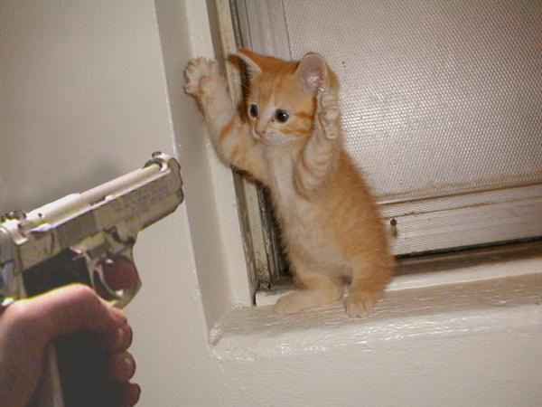

**CRIME-VERBS**

|  |  |  |
| --- | --- | --- |
| **Arrest**  **aretacija** | **to stop or interrupt the development of something** | ***He was arrested when customs officers found drugs in his bag.*** |
| **Ban**  **prepovedan** | to forbid (= refuse to allow), especially officially | *The film was banned*(= the government prevented it from being shown)*in several countries.* |
| **Break out**  **uiti** | to escape from prison | They broke out **of** prison and fled the country |
| **burgle**  **vlomite** | to illegally enter a building and steal things | *When they got back from their holiday they found that their home had been burgled.* |
| **Charge**  **strošek** | to ask an amount of money for something, especially a service or activity | *They charge you $20 just to get in the nightclub.* |
| **escape**  **beg** | to get free from something, or to avoid something | *A lion has escaped****from****its cage.* |
| **get away**  **uidite** | to leave or escape from a person or place, often when it is difficult to do this | *We walked to the next beach to get away from the crowds.* |
| **Get away with**  **uiti pred** | to succeed in avoiding punishment for something | If I thought I could get away with it, I wouldn't pay any tax at all. |
| **hold up**  **vzdržite** | to remain strong or successful | *hope the repairs hold up until we can get to a garage.* |
| |  | | --- | | **investigate** | |  |   **preiščite** | to examine a crime, problem, statement, etc. carefully, especially to discover the truth | *Police are investigating allegations of corruption involving senior executives.* |
| **rob**  **ropajte** | to take money or property illegally from a place, organization or person, often using violence | *The terrorists financed themselves by robbing banks.* |
| **Steal**  **kraja** | to take something without the permission or knowledge of the owner and keep it | She admitted stealing the money **from** her employers |

**CRIME-OTHER RELATED WORDS**

|  |  |  |
| --- | --- | --- |
| **armed**  **oborožen** | **using or carrying weapons** | ***These men are armed and dangerous, and should not be approached.*** |
| **alarm**  **alarm** | a warning of danger, typically a loud noise or flashing light | *The first two bomb alerts were****false****alarms, but the third was for real.* |
| **Legal**  **zakonito** | connected with the law | your legal rightslegal action/proceedingsmy legal representatives (= my lawyers) |
| **Illegal**  **nezakonito** | against the law; not allowed by law | ***It****is illegal****to****drive a car that is not taxed and insured.* |
| **private detective**  **zasebni detektiv** | a person whose job is discovering information about people. A private detective is not a government employee or a police officer | *She****hired****a private detective to find out if her husband was having an affair.* |
| **weapon**  **orožje** | any object used in fighting or war, such as a gun, bomb, sword, etc | *The youths were dragged from their car and searched for weapons.* |

