**December 9, 2001  
See sidebar for Parts 1 and 2 of current update.**

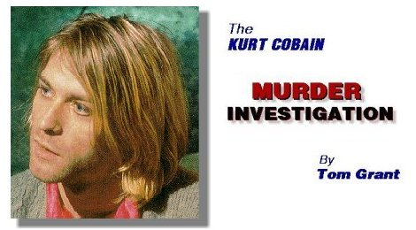

**Kurt Cobain left a drug rehab center in Marina Del Rey California on April 1, 1994 and was later reported missing. As you probably know, he was found dead just seven days later.**

**My name is Tom Grant. I'm a California state licensed private investigator and former detective with the Los Angeles County Sheriff's Department. On April 3, 1994, I was hired by Courtney Love, (who was in Los Angeles at the time), to locate her husband after he left a drug rehab center in Marina Del Rey, California. Ms. Love stayed in Los Angeles while I flew to Seattle to search for Cobain with his best friend Dylan Carlson. In fact, Carlson and I had been in the Cobain residence the night before Kurt's body was discovered in the room above the garage.**

**The police immediately concluded "suicide." I wasn't so sure. Neither was Rosemary Carroll, Courtney Love's own entertainment attorney. Ms. Carroll was also a close friend to both Courtney and Kurt.**

**Something was wrong here... terribly wrong.**

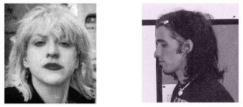

**After several months of intensive investigation, including dozens of taped interviews with Cobain's closest friends and family members, I reached the conclusion that Courtney Love and Michael Dewitt, (the male nanny who lived at the Cobain residence), were involved in a conspiracy that resulted in the murder of Kurt Cobain.**

**It appears this was not the first attempt on Cobain's life by Courtney Love. It was, however, the first to succeed.**

**In December of 1994, I began speaking publicly about the suspicious circumstances surrounding Cobain's death. Attempts to inform the public about this case have been met with physical threats as well as threats of legal action against anyone in the media who "gives Tom Grant a platform."**

**Motivated by profit, not truth, Courtney Love, her attorney's and the symbiotic "rock press" have engaged in an effort to keep the public from learning the true facts of this case. In spite of all the hot air, this investigation has received coverage in hundreds of major magazines, television and radio talk shows around the world. As I predicted when I first began telling what I knew, no legal action has been taken against myself or anyone in the media who has covered this story. The pathetic cowards of this world can only blow smoke. Once they've been exposed, they run and hide**

**The events surrounding the death of Kurt Cobain are filled with lies, contradictions in logic, and countless inconsistencies.**

**Here's just some of...**

**WHAT YOU WERE NEVER TOLD:**

**COURTNEY LOVE WAS FACING A DIVORCE**

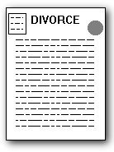

**Kurt was in the process of leaving Seattle and his wife Courtney, when he was found dead.**

**Courtney knew Kurt wanted out of the marriage. Just weeks prior to his death, she asked one of her attorneys to get the "meanest, most vicious divorce lawyer" she could find.**

**SOMEONE WAS USING KURT'S CREDIT CARD**



**One of Kurt's credit cards was missing when his body was discovered.**

**Someone was attempting to use the missing credit card *after* Cobain died, but the attempts stopped when his body was discovered.**

**COBAIN WAS IN FEAR OF HIS LIFE**



**The shotgun found at the scene was purchased *BEFORE* Cobain left for rehab in Los Angeles, *NOT AFTER* he fled the rehab as reported by misinformed media sources.**

**The shotgun was fully loaded with *three* shells. It was purchased and loaded for *protection,* not suicide.**

**The police claim there were *no legible fingerprints* on this shotgun!**

**The truth is, the shotgun wasn't even checked for fingerprints until May 6th, nearly *one month* after Cobain's body was found.**

**THERE WAS NO "SUICIDE" NOTE!!**



**The note found at the scene by the police was immediately labeled as a "suicide note." The police report states it was "apparently written by Cobain to his wife and daughter, explaining why he had killed himself."**

**But this note was *not* addressed to Kurt's wife and daughter and it says *nothing* about "killing himself!" This note was clearly written to Cobain's *fans* telling them he was quitting the music business. There was only a short footnote to Courtney and Frances and the handwriting contained in those lines has been questioned by several handwriting experts.**

**COURTNEY HAD *ANOTHER* NOTE SHE KEPT IN SECRET!**



**Courtney was in possession of a *second* note after Kurt's body was found! SHE DIDN'T TELL ANYONE about this second note until several months later when information about it slipped out during an interview with Rolling Stone Magazine.**

**The second note, the one that Courtney kept in secret, clearly defines the first note which was found at the scene of Cobain's death. The "second note" from Kurt plainly states he was leaving Courtney and he was leaving Seattle. He was NOT leaving the planet!**

**COBAIN WAS INJECTED   
WITH 3 TIMES A LETHAL DOSE OF HEROIN!!**

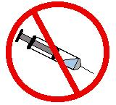

**Cobain's heroin, (morphine), blood level was 1.52 mgs per liter. This would require a minimum injection of 225 mgs of heroin, three times a lethal dose, even for a hardcore heroin addict! The drug Diazepam, was also found in Cobain's blood system.**

**THE OBVIOUS QUESTIONS:**

**1. If Cobain injected himself with a deliberate heroin overdose, why would he ALSO shoot himself in the head with a shotgun, leaving his baby daughter - the love of his life - with horrific visual images to remember him by? Why not just "go to sleep" on the overdose and never wake up?**

**2. IF Cobain injected three times a lethal dose of heroin, COULD he then pick up a shotgun and shoot himself? Wouldn't he have been immediately incapacitated?**

**Based on the heroin, (morphine), blood levels found in Cobain's body, preliminary research indicates Kurt Cobain would have been immediately incapacitated. He could not have picked up that shotgun. He could *not* have pulled that trigger!**

**IN ADDITION...**

**Cobain was *not* barricaded inside the room as reported by misinformed media sources.**

**The stool which was supposedly wedged" against the door was actually just sitting in front of the two unlocked doors that only led out to a balcony.**

**Cobain did *not* leave his Driver’s License out for identification as reported by misinformed media sources.**

**The first police officer on the scene found Cobain's closed wallet, opened it to remove Kurt's driver's license, and displayed it in order to take a photograph.**

**THE FACT IS...**

**The police and the Medical Examiner have no forensic evidence that proves Cobain's death was a suicide. On the other hand, there's a substantial amount of evidence for murder.**

**The official verdict of "suicide" was simply a rush to judgement which eventually painted the authorities into a corner as reports of so-called "copy-cat" suicides began making the news.**

**As you examine this case carefully, you're going to discover there's much more to the events surrounding Cobain's death than what you've been told.**

**Page Links To:  
Additional Cobain Case Information**

|  |  |
| --- | --- |
| [**THE SUMMARY OF EVENTS**](http://www.cobaincase.com/summary.html) **The days before and after Kurt Cobain's death** | **Nick Broomfield's** [**"KURT AND COURTNEY"**](http://www.cobaincase.com/k&c.html) **Film Review** |

**Get your copy of the**[**COBAIN CASE STUDY MANUAL**](http://www.cobaincase.com/manual.html)

**Go to the Cobain Investigation**[**MESSAGE BOARD**](http://www.bulletinboards.com/view.cfm?comcode=CobainBB) **to post your comments**