**DISCRIMINATION**

1)

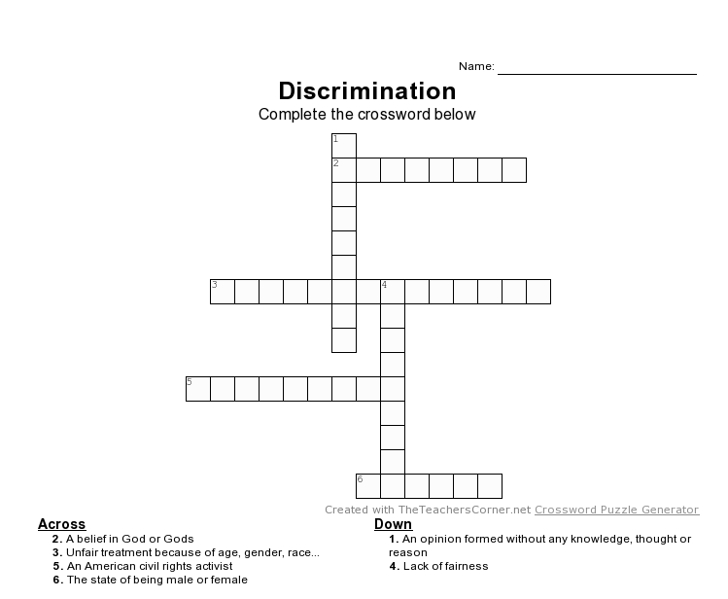

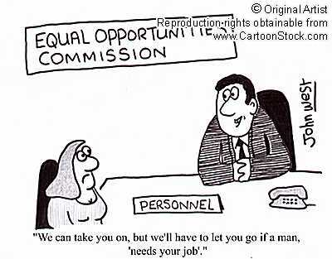2) Why are these people being discriminated? Write your answers on the lines below the photos.

3) Have you ever been discriminated against? What was the reason?

4) What would you do to stop discrimination?