EU
12 stars in circle symbolize the ideal of unity, harmony, solidarity…
9. may – Europe day
27 member countries
Croatia, Macedonia, turkey – have applied for eu membership
Ode to joy – national anthem – the melody comes from the ninth symphony composed by Beethoven
Moto – united in diversity

It has reunited the fractured continent
It has brought the frontier-free market and a single currency – euro
It has brought political stability and economical prosperity to its citizens
It is the world’s biggest donor of development aid to poor countries
The eu population is nearly half a billion
It is a major economic and commercial power
Through richly diverse, the eu countries are united in their commitment to peace, democracy, the rule of law and respect for human rights

The eu began life in 50s as European Economic Community with 6 founding countries: Belgium, Germany, France, Italy, Luxembourg and the Netherlands
they created a new way coming together to manage their joint interests, based essentially on economic integration.
Less than a half the size of usa, but it’s population is over 50%larger
The eu population is the world’s third largest after china and india
It covers more than 4 million km and has 495 mio inhabitants
France – biggest
Malta – smallest
Life expectance is rising
Education is the key to success – for individuals and for the eu as awhole
The subjects:
Men: science, computing, engineering,
Women: arts, law, humanities
Better education means better job prospects
Information tehnology – an essential tool

Eu mission in the 21st century:
Provide peace, prosperity, stability for its people
Overcome the divisions on the continent
Ensure that its people can live in safety
Promote balanced economic and social development

Peace and stability
Before becoming a political objective, the idea of united Europe was just a dream
Between 45 and 50 a handful of courageous statesmen set about persuading their people to enter new era. New structure would be created in western Europe, based on shared interests.
Enlargement process continue to this day
Entry negotiations began with turkey and Croatia..

Safety and security

The eu has to take effective action to ensure the s and s of its members
It must also protect its military ans strategic interests (working with nato)
Making the eu an area of freedom, security and justice is a new challenge that requires close cooperation between governments

Economic and social solidarity
Eu countries must ensure the economic growth to compete on the worlds stage with other major economies, because no individual eu country is not strong enough by itself

Identity and diversity in a globalised world
Standards of living have risen steadily
There are significant gaps between rich and poor and one of the following tasks of the the eu is to narrow those gaps.
Europeans cherish their:
Rich heritage of values which includes: a belief in human rights, social solidarity, free enterprise, a fair distribution of the fruits of economic growth, the right to a protected environment, respect for cultural, linguistic and religious diversity and a harmonious blend of tradition and progress.

Institutions

European parliament
Elected by citizens of the eu since 1979
It started in 50s
Elections – every 5 years
Last elections were in june 2009
It has 736 members from all 27 countries
On the 14th of july 09, jerzy buzek was elected president of the ep and will hold that position for 2 years
Slo has 7 seats in ep
Brussels, Luxembourg, Strasbourg
Three main roles:
Passing European laws – jointly with the council
Exercises democrating supervision over the other eu institutions and has a right to censure a commission as a whole
The power of the purse – authority over the spending
It has to give its assent to international agreements negotiated by the commission and to any proposed enlargement of the eu
It can throw out proposed legislation if an absolute majority vote against (more than a half)

Two main stages:
Preparing for the plenary sessions
Plenary sessions itself:
One week per month – stras.
Two days – brus.
At sessions ep examines proposed legislation and votes on amendments

The council of the eu
Main decision –making body
One minister from each country
Which minister attend on which meeting depends on the subject:
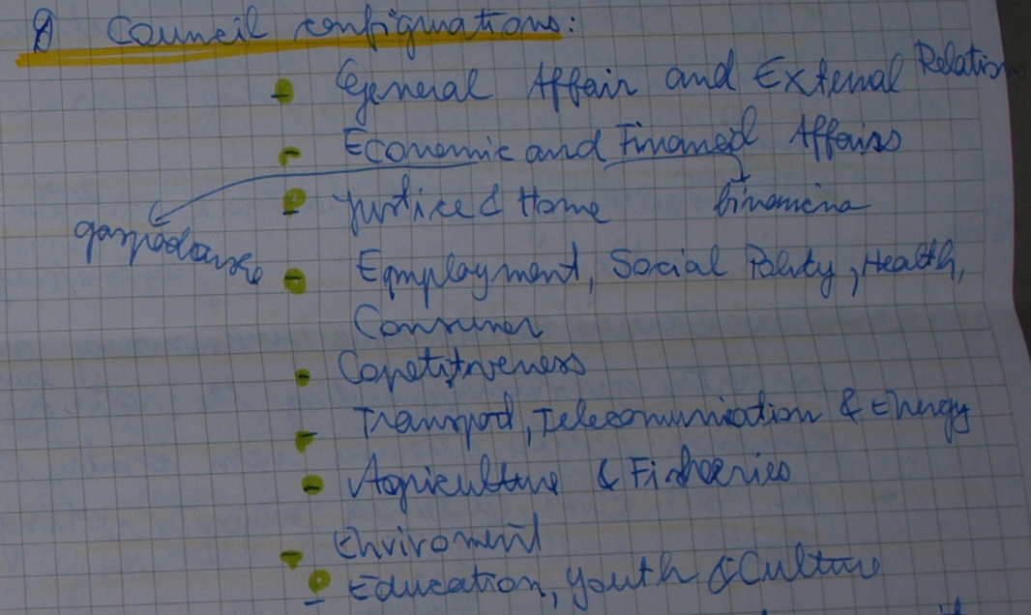

The ministers signature is the signature of the whole government..
Each minister is answerable to his national parliament and citizens that parliament represents
6 key responsibilities:
Passing European laws – jointly with the ep
To coordinate the board economic policies of the member states
To conclude agreements between the eu and other countries
To approve the eu’s budget, jointly with the ep
To develop eu’s common foreign and security policy based on guidelines set by the eu council
To coordinate operation between the national courts, police forces in criminal matters

The presidency of the council rotates every 6 months
Tho council has to agree unanimously on important questions
In most cases, qualified majority voting is used

The European council

Meets 4 times a year
It’s chaired (voden) by the president or prime minister holding the presidency
Deals with pressing international issues
Initiator os union’s major policies

The European commission
3rd part of the decision making triangle
27 members – from each country
Appointed for 5 year term by agreement between the member states
Answerable to the parliament
It attends all the sessions of parliament
It’s independent; it represents upholds the interests of the eu
Drafts proposals for new eu laws – presents them to the ep and the council
It’s the executive arm, responsible for implementing the decisions of ep and council
Seat – Brussels, but also offices in lux. And other capitals
4 main roles
To propose legislation to parliament and the council
To manage and implement eu policies and the budget
To enforce European law – jointly with the court of justice
To represent eu on the world stage
The court of justice
Based in lux.
Makes sure that eu’s legislationis interpreted and applied in the same way in the whole eu
Makes sure that eu states and institutions do what the eu law requires and that treaties are correctly interpreted and applied
One judge per member state
Assisted by 8 advocate – general (državni pravobranilec)
Those are people which impartiality is not doubted.

The court of auditors
Set up in 1975 – lux
It checks that eu funds are spent legally, economically and for the intended purpose
27 members – appointed for 6 years by the council – renewable term

