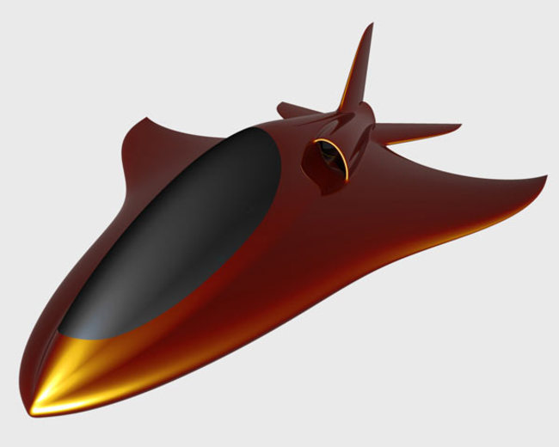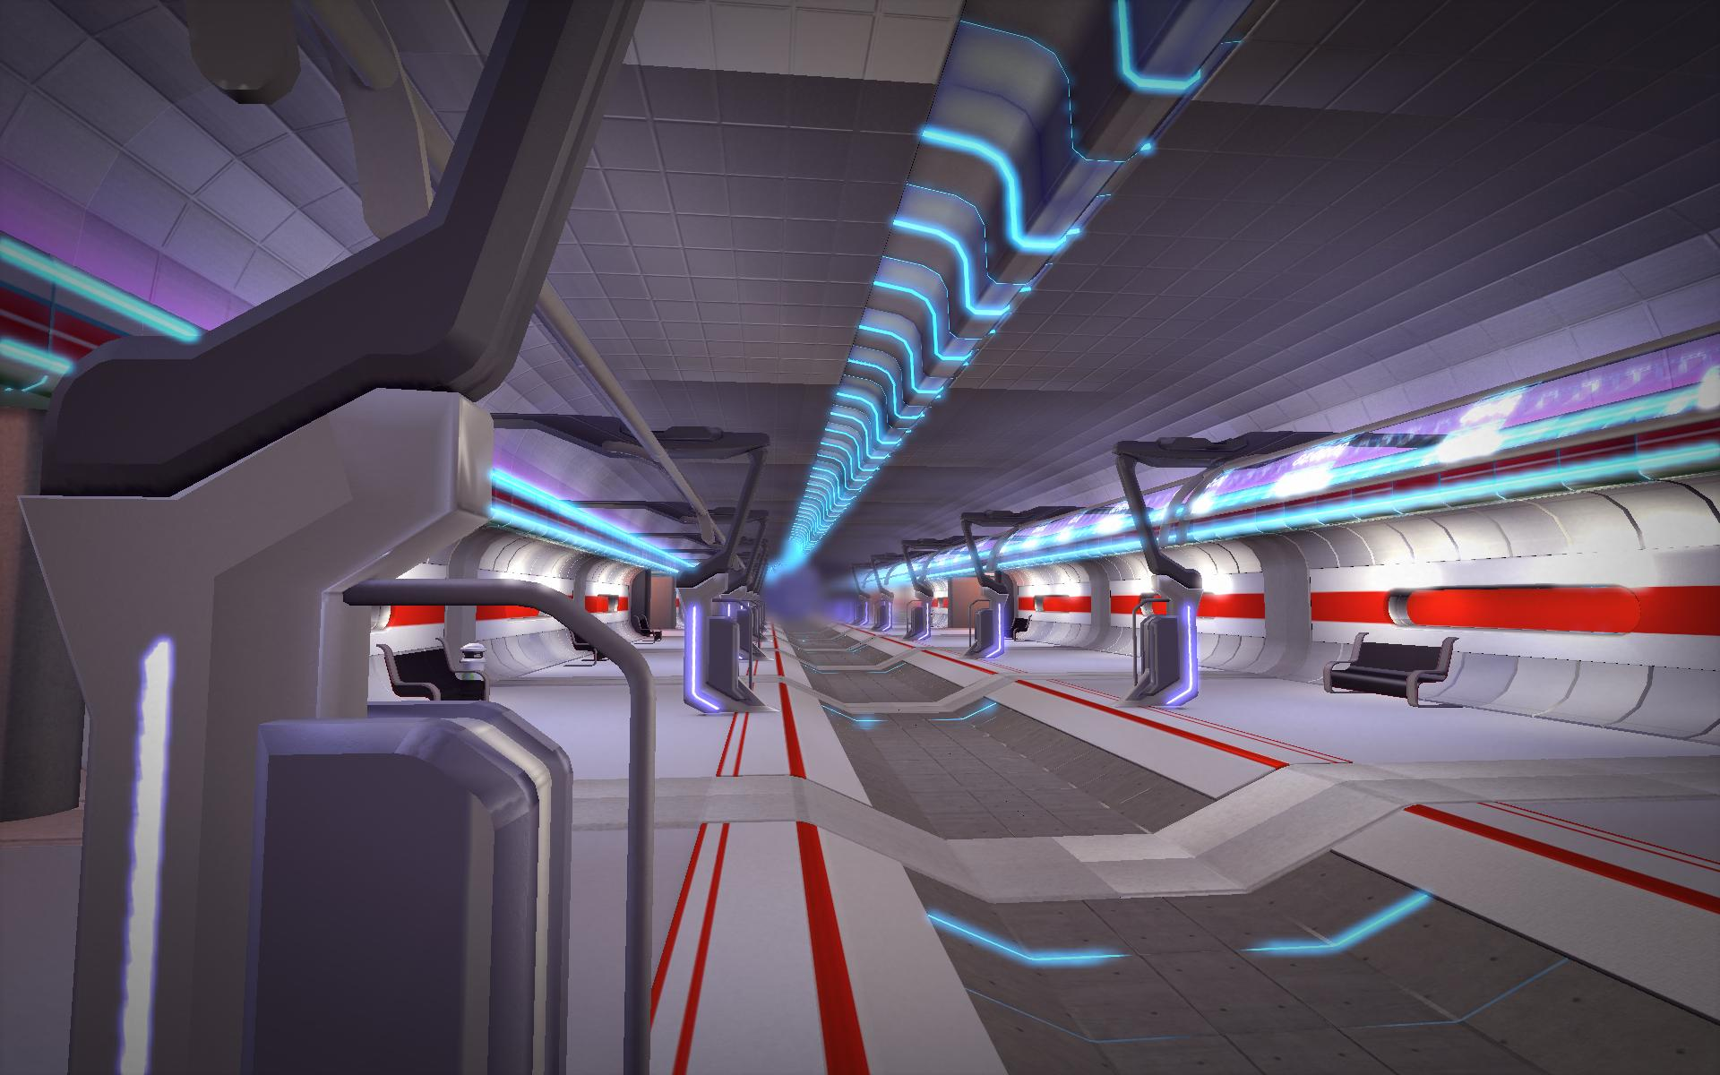

**THE**

**FUTURE**

**TRANSPORT IN FUTURE**



After a while World will be completely different. With him it will change travel too. We’ll have strange cars or something like flying bunch of metal.

Cars will fly on sky roads. They will be special, because we won’t have any more accidents. That will be very good for people who are traveling on the ground a lot.

Yes. Because it will be ground traffic so perfect, we won’t travel on the water any more. We will fly over Atlantic but ships won’t disappear. They will fly like cars too.

Air traffic will be faster. All the passenger planes will fly with supersonic speed. From Slovenia to America we will arrive in 3 hours. Airline tickets will be cheaper and airports will be bigger.

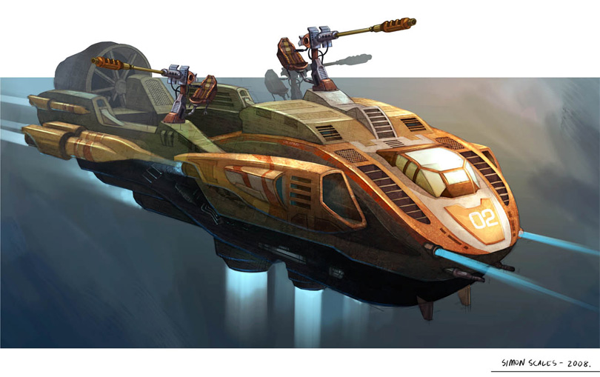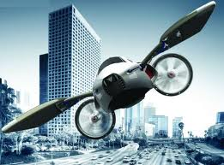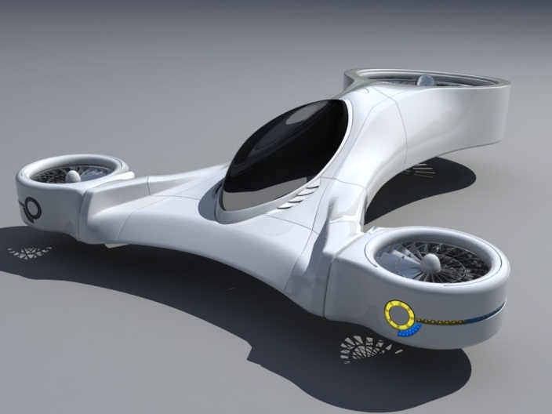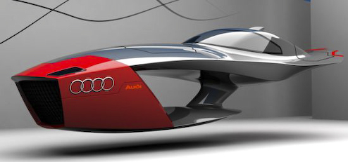

**WORK IN FUTURE**

I think in the future it will be industry much more advanced. All people will have jobs in big factories and all human workers will have a robot helper.

Robots will help to do difficult things which people can’t do. Work will be easier and more friendly to people. More time they will spend with their families. That will be great!

Also housewives works very much today, but this will change. Wherever you will look, you’ll see the robots. They will cook and clean the house. I hope they will clean my room. This would be awesome!

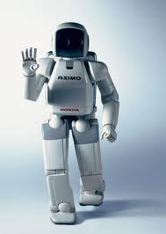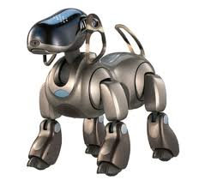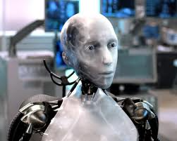

**SPORT**

I think sports won’t be the same in the future like we know them today. Also today sports are fantastic but the future sports it will be more than that.

If you will have a wish for some sport, you won’t need to go to sports centers or something like that. You will simply click on the button and in front of your face will appear virtual world. In this world it will be possible do all sports which exist in the world. You will stay at home and do your exercise. We will use strange accessories for some sports.

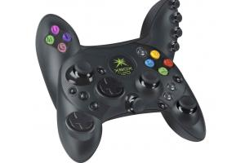

**HOLIDAYS**

Holidays in future will be much different like today. We’ll go to the other planets or galaxies. At first that kind of holidays will be really expensive, but then will be more and cheaper.

All people like holidays. After some time we will take holidays in space. Like we go to hotel now, later we can go to SPACE hotel. These will be on the surface of some planets. There you’ll get all the things you need on holidays. There you will go with space shuttle.

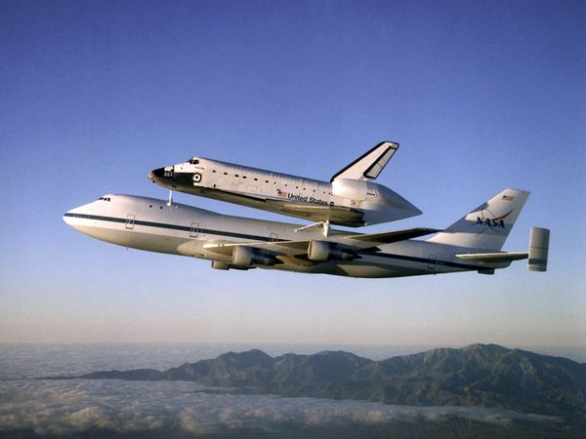

**MY FUTURE**

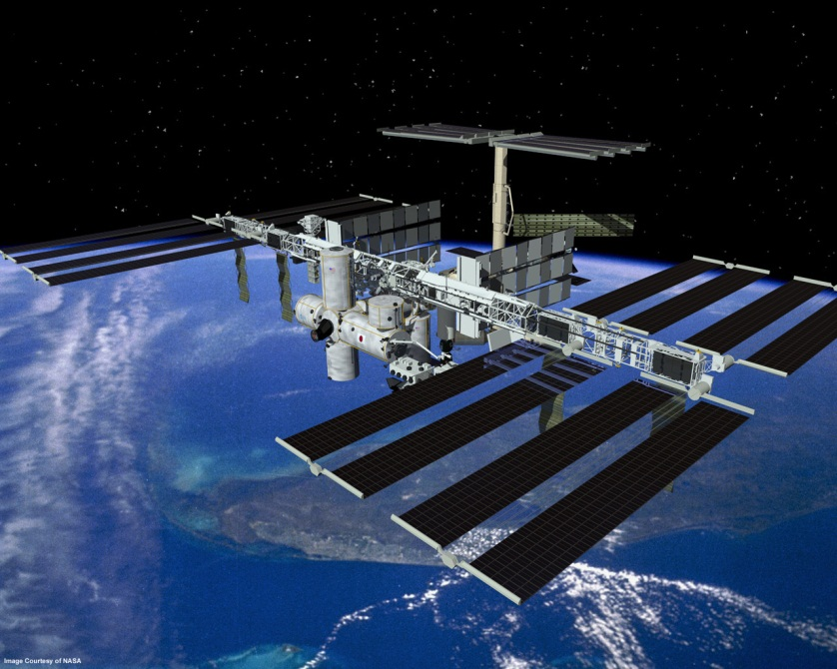

I'm young and I don’t know really jet what I want to be. I like work with computers and I hope I’ll find a job where I can fixed it or where I will develop programs and computer games. I wish I’ll find a nice; smile and friendly woman and I’ll marry her. I want she will give me children. We will live in Slovenia probably in Maribor. I wish my family will be happy.

