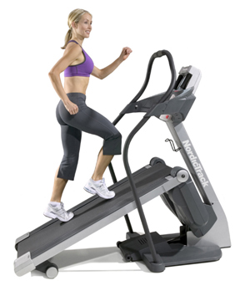

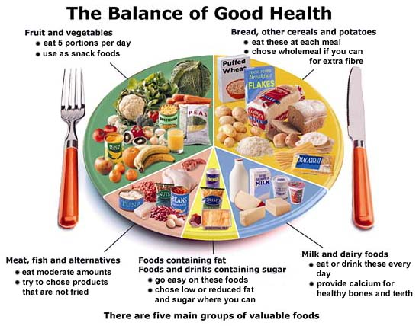

Health is one of the really important things in our lives. Food doesn’t react only on our body, but also on our mind. Everyone wants to be healthy and we can only be healthy if we eat healthy food and if we exercise enough. Our body needs five important things and those are carbohydrates, protein, fibre, vitamins and minerals. If we don’t have these five things, our body immune system will collapse. Our body needs energy, which it gets from food. Food provides energy and energy gives our body the possibility to work, exercise, think… So… our body uses food like some kind of fuel. But if we eat too much… our body gets over weight! So to use enough food but still have enough minerals, hydrates … you must also exercise a lot and the best exercise is fitness!

A lot of people think that healthy food means vegetables and fruit, but that’s not a half of it. A healthy meal includes all five things we mentioned before. We should have 5 meals a day! 1st one is the most important! It’s breakfast. We shouldn’t miss breakfast because it gives us strength for the whole day! Next we must have a snack it shouldn’t be big, but just a fruit or some yogurt! They say a perfect lunch is a palm-sized piece of any kind of meat (if you don’t like fat too much, the best is lean meat or fish), some vegetables like peas and beans or just a salad (with no extra sauces) and pasta or rice. Of course we shouldn’t forget to drink a lot of water through the day. We must drink over two liters of water and if we don’t our body will dehydrate. Dehydration causes dehydrated skin and other unpleasant things. This meal doesn’t contain any fruit because fruit should be a free meal. We should eat meals every three hours, but not meals as big as lunch, but smaller snacks. We also shouldn’t eat after 6 in the evenings.

Bread, cereals and potatoes:
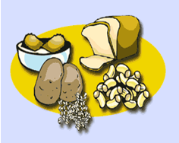
Apart from potatoes, all the foods in this group began life as a grain, such as wheat, rye, corn, rice or barley. Potatoes and grains are very healthy and filling. This food group also contains pasta, rice and noodles. Cereals and cereal products are an important source of energy, carbohydrate, protein and fibre. They also contain a range of micronutrients such as vitamin E, some of the B vitamins, sodium, magnesium and zinc. Wheat and rice are the most important crops world-wide as they account for over 50% of the world’s cereal production.

Fruit & vegetables:

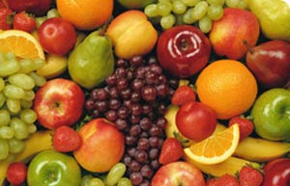We get vitamins, minerals and fibre from fruit and vegetables.
Fruit is the ultimate brain fuel. Fruit has a positive effect on our brains and makes you recall information easier and faster... Fruit also doesn't contain much cholesterol, but contains a lot of vitamins our body definitely needs. Some even say that eating a lot of fruit can have a mysterious healing effect on human beings. They say fruit makes you feel better. Fruit is food that has been made by plants and it’s the most natural food.
We have different types of fruit:

Acid fruit (oranges, pineapples, sour apples, sour plums, lemons, grapefruits, sour peaches, lemons…)

Low-acid fruit (apricots, blueberries, huckleberries, strawberries, nectarines, raspberries, blackberries, mangos, elderberries, olives, fresh figs, sweet apples, cherries, sweet peaches, sweet plums…)

Sweet fruit (sweet grapes, pears, raisins, figs…)

Melons (watermelons, honey dew…)

Starchy fruit (bananas, peanuts, pumpkins…)

Non-starchy fruit (cucumber, sweet pepper, egg plant…)

Protein containing fruit (olives, avocadoes…)

Olives and avocados are extremely healthy fruits. They contain a lot of different nutritious elements and even scientists don't know what they exactly contain. There are some fruits that are bad for you and those are acid fruits. Acid fruits are oranges, sour plums, sour apples, pineapples, grapefruit, lemons… They should be avoided when you have the flu because your body can react badly and make you even sicker. Also we know a group of fruit named sweet fruit. We shouldn’t eat more than one banana a day if you gain weight easily. We can rehydrate dried fruit by soaking it overnight in a jar of water. Melons are like all other fruits excellent food. What's very special about watermelons is that they contain as much iron as spinach. Watermelons are very good for our body because they contain an enormous amount of water. We must eat 5 to 9 pieces of fruit in one day. We get a lot of vitamins from fruit especially vitamin C. Vitamins builds the immune system and it has an enormous part in health because it defends us from diseases like flu or just a cold.

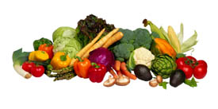Along with fruits, vegetables are the only right nutrition for the human body. Vegetables contain amino acids and antioxidants in forms that do not occur in other foods. You can eat unlimited amounts. Vegetables are most nutritious when eaten raw. They are especially important to eat for their protein contents. By eating vegetables we can control blood pressure and cholesterol, too.

Seeds and nuts are also good for us, but we shouldn’t eat too much. Seeds are a good source of minerals and oils. Nuts and seeds are a good source of protein as well. Nuts are always best when eaten raw right out of their shell. Many people think of nuts as just another junk food snack. Some nuts are really good for our skin and even for our heart. Researches have shown that people who eat a lot of nuts are less likely to have heart attacks or die because or a heart disease than others who rarely eat them. Brazil nuts are a spatiality or Brazil.

Milk & dairy products:

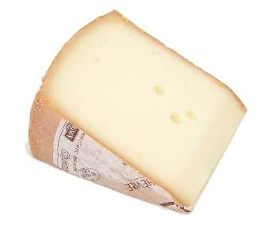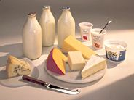This food group includes milk, cheese, yoghurt and other dairy products, but not butter, margarine or cream, which belong in the fat and sugar group. The foods in this group contain many different types of nutrients but are particularly rich in calcium, protein and magnesium. Calcium is a mineral that strengthens our bones and teeth and makes sure that everything runs smoothly with your muscles and nerves. It's especially important for growing. That’s why children and teenagers must have enough calcium. Calcium can add strength to our bones. Most milk is cow milk, but there are different milks, too like goat milk or ewe milk. Most milk undergoes some form of heat processing such as pasteurization, sterilization or ultra high temperature (UHT) treatment. This is to ensure that any harmful micro-organisms are destroyed before the milk is consumed and to improve keeping qualities. Mostly, when we talk about dairy products we think of cheese. There are different kinds of cheese (hard cheese, mould-ripened cheeses, fresh cheeses…) as a result from different methods of production. Most milk and milk products should be stored in a refrigerator to slow down the growth of micro-organisms. If we are keeping an eye on your weight, it is good to know that you don't have to go for the full-fat versions of the above to get your calcium intake. There is exactly the same amount of calcium in skimmed milk as there is in whole milk, and the same goes for yoghurt and cheese.

Meat, fish, eggs and alternatives:

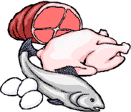This group contains meat, beans, nuts, seeds, soy .They're grouped together because they're all rich in protein. This food group includes meat, poultry, fish, eggs and alternatives (see below). Meat products include bacon, salami, sausages, beef burgers and paté. Fish includes frozen and canned fish such as sardines and tuna, fish fingers and fish cakes. Alternatives include nuts, tofu, mycoprotein, textured vegetable protein (TVP), beans and pulses such as lentils. These foods provide protein, fibre and iron but unlike those listed above are not a rich source of zinc and generally provide no vitamin B12 (unless fortified). Eggs are a protein-rich food and provide vitamin A, vitamin D, niacin and vitamin B12. Although eggs contain cholesterol, it is thought that healthy adults can consume an egg a day without adversely affecting blood cholesterol.

Sweets & fat:
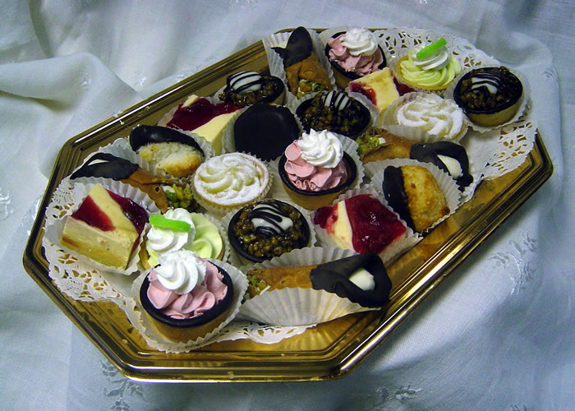
Fat is an important contributor to good health and they produce a big amount of energy. Foods containing fat include margarine, butter, spreading fats, low fat spreads, cooking oils, oil-based salad dressings, mayonnaise, cream, chocolate, crisps, biscuits, pastries, cakes, puddings, ice cream, rich sauces and gravies... Sweets and fats are a kind of food that does the biggest damage because people eat too much of them. A lot of people eat too much fat and as a consequence they have a big amount of cholesterol or their heart becomes weaker. A lot of people are also eating too many sweets and some of them are even addicted. These people are usually overweight and have bad teeth. Sugar isn’t bad but we mustn’t eat too much of it! If we eat sugar, it is very important to use natural, often brown sugars instead of white sugars. Brown sugars are healthier and less caloric. Sweet things like jam, sweets, cakes, chocolate, soft drinks, biscuits and ice creams belong to this group too. Children and teenagers also eat more and more fast food. Fast food is really unhealthy. A lot of people just go to some fast food restaurant every day and eat there. The fast food shouldn’t replace meals.

Drinks:
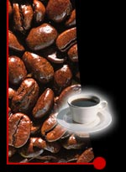
Drinks include water, fruit juices, canned drinks, tea, and coffee. A lot of people drink coffee every day. Some are also addicted. Fruit juices aren’t all healthy because they hold a lot of sugar. Water is the best and most refreshing drink. Some people drink alcohol. That’s very bad for our stomach and liver.

Fitness and exercising:

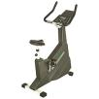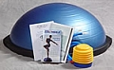People need to exercise a lot as well as eat healthy if they want to be healthy or fit. We have different types of exercising like walking, swimming, climbing, cycling, rollerblading, running and playing different games like football or basketball. Exercising is important for our body and our mind. It’s really healthy and also fun. Fitness is also a type or exercise. When we’re talking about fitness we think about weight-lifting. Weight- lifting is a type of exercise usually preformed by men. With weight-lifting we give strength to our body mussels. People can go to fitness clubs and exercise there on their fitness machines. A lot of people visit fitness every day, but those are not just men, more and more women are going to fitness clubs, too. However, more men are visiting fitness currently, but no one knows what will happen next… Some people even have their own personal trainers who train them and are responsible for what they eat and when. Some trainers say their clients must also eat steroids and things like that, but that isn’t healthy for sure. The most important thing for people who want their mussels to be perfect must always eat after the training because the mussels burnt all the energy. The human body with a lot of mussels became an object of admiration. A lot of teenagers are visiting fitness more often too just because of that. But, teenagers grow and if teenagers body build too much, they can stop growing. Fitness centers don’t have only fitness. A lot of fitness centers have also special large rooms for tennis, badminton, squash… There are special group programs in fitness centers named Les mills. That’s an aerobics program for all ages. It contains group exercises of stretching, weight-lifting, fighting… Les mills is very popular and it’s in Slovenia for over 10 years. Aerobics is done in order to improve fitness, burn calories, shape the body, strengthen physical well-being, and maintaining fitness. Your bodyis always burning some fat but if you want to lose weight, you need to increase your activity to the point where your body starts to let go of some of its fat reserves. That means sustaining some activity. There are many machines that companies are selling and advertising. They have just invented a new exercise ball, called BOSU. The BOSU ball is a versatile piece of equipment that can be used for everything from sports drills to cardio workouts and a useful addition to any home gym. They’re already showing it on TV. There are other machines, too. Like a room fitness-bike or an Orbi-track or something like that. People buy it and then exercise at home while watching their favorite soap opera or film.

