**⊿ SREDNJA ŠOLA TEHNIŠKIH STROK ŠIŠKA**

**Hydraulic pump**

**Hydraulic pumps** are used in hydraulic drive systems and can be hydrostatic or hydrodynamic.

Hydrostatic pumps are positive displacement pumps while hydrodynamic pumps can be fixed displacement pumps, in which the displacement (flow through the pump per rotation of the pump) cannot be adjusted, or variable displacement pumps, which have a more complicated construction that allows the displacement to be adjusted.

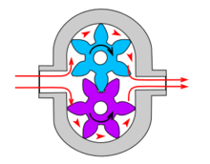

**Hydraulic pump types**

**Gear pumps:**

[Gear pumps](http://en.wikipedia.org/wiki/Gear_pump) (with external teeth) (fixed displacement) are simple and economical pumps. The swept volume or [displacement](http://en.wikipedia.org/wiki/Engine_displacement) of gear pumps for hydraulics will be between about 1 cm3 (0.001 litre) and 200 cm3 (0.2 litre). They have the lowest [volumetric efficiency](http://en.wikipedia.org/wiki/Volumetric_efficiency) ( ) of all three basic pump types (gear, vane and piston pumps) These pumps create pressure through the meshing of the gear teeth, which forces fluid around the gears to pressurize the outlet side. For lubrication, the gear pump uses a small amount of oil from the pressurized side of the gears, bleeds this through the (typically) hydrodynamic bearings, and vents the same oil either to the low pressure side of the gears, or through a dedicated drain port on the pump housing. Some gear pumps can be quite noisy, compared to other types, but modern gear pumps are highly reliable and much quieter than older models. This is in part due to designs incorporating split gears, helical gear teeth and higher precision/quality tooth profiles that mesh and unmesh more smoothly, reducing pressure ripple and related detrimental problems. Another positive attribute of the gear pump, is that catastrophic breakdown is a lot less common than in most other types of hydraulic pumps. This is because the gears gradually wear down the housing and/or main bushings, reducing the volumetric efficiency of the pump gradually until it is all but useless. This often happens long before wear causes the unit to seize or break down.

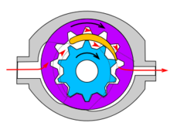

**Screw pumps:**

[Screw pumps](http://en.wikipedia.org/wiki/Screw_pump) (fixed displacement) are a double [Archimedes' screw](http://en.wikipedia.org/wiki/Archimedes%27_screw), but closed. This means that two screws are used in one body. The pumps are used for high flows and relatively low pressure (max 100 bar). They were used on board ships where the constant pressure hydraulic system was going through the whole ship, especially for the control of [ball valves](http://en.wikipedia.org/wiki/Ball_valve), but also for the steering gear and help drive systems. The advantage of the screw pumps is the low sound level of these pumps; the efficiency is not that high.

The major problem of screw pumps is the hydraulic reaction forces which is transmitted axially opposed to the flow direction,

there are two ways to overcome this problem:

1- put a thrust bearing beneath each rotor.

2- make a hydraulic balance with directing a hydraulic force to a piston under the rotor.

Types of screw pumps:

1-single end.   
2-double end.  
3-single rotor.  
4-multi rotor timed.

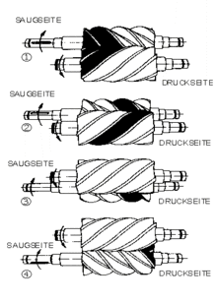

5-multi rotor untimed.

**Bent axis pumps:**

[Bent axis pumps](http://en.wikipedia.org/w/index.php?title=Bent_axis_pump&action=edit&redlink=1), axial piston pumps and motors using the bent axis principle, fixed or adjustable displacement, exists in two different basic designs. The Thoma-principle (engineer Hans Thoma, Germany, patent 1935) with max 25 degrees angle and the Wahlmark-principle (Gunnar Axel Wahlmark, patent 1960) with spherical-shaped pistons in one piece with the piston rod, piston rings, and maximum 40 degrees between the driveshaft centerline and pistons (Volvo Hydraulics Co.). These have the best efficiency of all pumps. Although in general the largest displacements are approximately one litre per revolution, if necessary a two-liter swept volume pump can be built. Often variable-displacement pumps are used, so that the oil flow can be adjusted carefully. These pumps can in general work with a working pressure of up to 350–420 bars in continuous work.

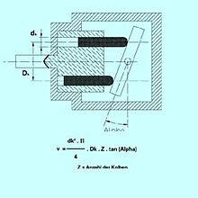

Key words: pumps, screw pumps, bent axis pimps, gear pumps, pressure, hydravlic, volume, gear, motor, oil

VIR: www.wikipedia.org