Leisure activities
Leisure activities are all the activities that people do in their free time when they don’t have to think about their business, work and obligations. There are some exceptions when some people do work-oriented tasks for pleasure such as cooking. These activities include hobbies, sports, different entertainment etc.

Leisure activities are important so people can relax and forget about their problems, but also to socialize with other people and maintain contacts through various activities.

Hobbies
Leisure is usually referenced to hobbies. A hobby is a regular activity or interest that is undertaken for pleasure. There are a lot of different groups of hobbies such as:
- Collecting (stamps, coins, trading cards, comics, badges, postcards, DVDs...)
- Outdoor recreation hobbies (hill walking, hiking, backpacking, climbing, caving…)
- Performing arts (singing, acting, juggling, magic, dancing…)
- Creative hobbies (woodworking, photography, jewelry making, photoshopping…)
- Work-oriented hobbies (gardening, hunting, fishing…)
- Reading

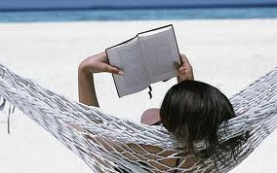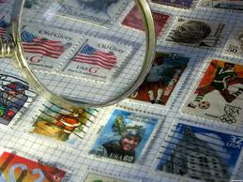

Entertainment
Entertainment is any kind of activity that entertains people. Here is just a short list of what counts as entertainment:
- Television and computer
- Cinema and theatre
- Comics and books
- Dance and music
- Games (card games, children’s games, board games, computer games…)
- Concerts
- Sports
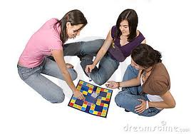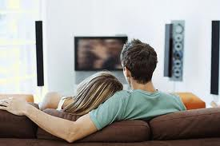

Sport
Sport is one of the most common form of entertainment especially among male population. One can be entertained either by viewing a sport by participating in one.

Popularity of sports depends on the culture or tradition of the individual country. Sport may be professional or amateur. There are many different sports like winter sports, ball sports, individual or team, no contact or full contact sports.
