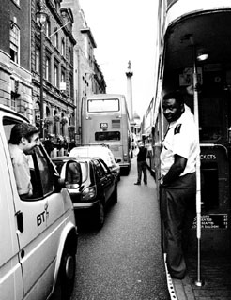
Red taxies, buses nad telephone boots
Projektna naloga pri angleščini

When someone says London, you automatically think of red double-deckers, black or red telephone boots and old-fashioned (but new) taxies. Londons has a long tradition, and throught all the centuries it has become city with so many particularities, you can't count. It's just such a uniqe city, when you visit it you want more: more traffic on the wrong side, more beautiful parks and more english people.

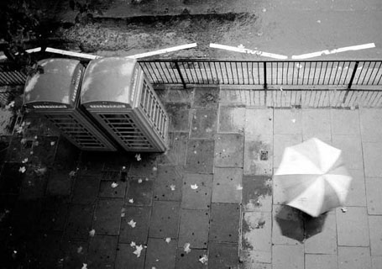
Things you must SEE when you're in London

- Tower of London
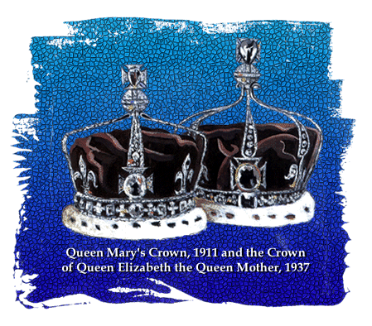
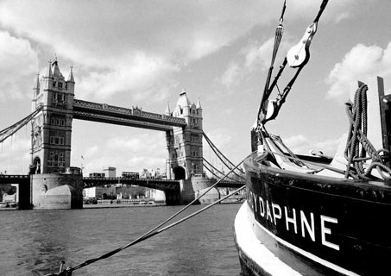The Tower of London is by far one of the most famous and well preserved historical buildings in the world. Since the first foundations were laid more than 900 years ago the castle has been constantly improved and extended by the addition of other smaller towers, extra buildings, walls and walkways. The Royal Crown Jewels are kept here.

- Tower Bridge

The Tower Bridge was built from 1886 til 1894, the plans was made by Horace Jones. It's made of stone nad irony, and it's build in victorian style. This is a great symbol of London, crossing the Thames.

- St.Paul's Cathedral

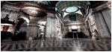There has been a choir of boys and gentlemen at St Paul's Cathedral for over nine centuries. The first St Paul's Cathedral was built in 604, than in 675 the first cathedral is burned down. In 1087, Old St Paul's is built in a grand Norman style. BUT, in 1666 happens The Great Fire of London and destroys Old St Paul's. The new cathedral was completed in 1710. Since than there was a lot of funureals and weddings of people from royal family.

- 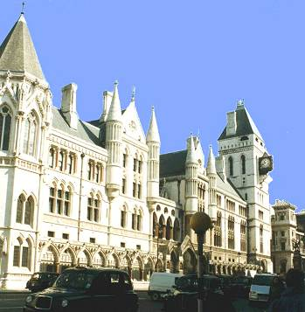Royal courts of justice

Covering a 5.25 acre site and using 35 million bricks, is the vast Royal Courts of Justice, impressive with its Victorian Gothic exterior, the Law Courts house the Supreme Court of Justice for England and Wales, where major civil cases are tried.
Completed in 1881, the Law Courts have been called, "the last great Gothic public building in London."

- Houses of Parlament

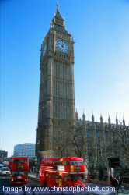The Houses of Parlament with Big Ben which is the name of the bell, not of the clock which strikes the hours. The palace was built in the 11-th century by King Edward the Confessor, compeletely destroyed by fire in 1666 and rebuilt in 1835.The British parlament is made up of the House of Commons and the House of Lords. The people choose 650 men and women 4 the House of Commons every 5 years. The House of Lords has over 1000 members, who are not elected, but are members of the nobility, heads of the Church of England, head judges and people chosen by the Prime Minister.

- Westminister Abbey

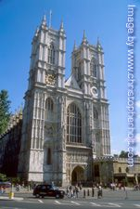An architectural masterpiece of the thirteenth to sixteenth centuries, Westminster Abbey also presents a unique pageant of British history - the Confessor’s Shrine, the tombs of Kings and Queens, and countless memorials to the famous and the great. Today it is still a church dedicated to regular worship and to the celebration of great events in the life of the nation.

- Buckingham palace

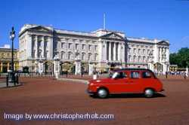Buckingham Palace has served as the official London residence of Britain's sovereigns since 1837.Today it is The Queen's official residence. The State Rooms of the Palace are open to visitors during the Annual Summer Opening in August and September. They are lavishly furnished with some of the greatest treasures from the Royal Collection - paintings by Rembrandt, exquisite examples of Sèvres porcelain, and some of the finest English and French furniture in the world.

- Albert memorial

The Albert Memorial is one of the great sculptural achievements of the Victorian era. The composition has a large statue of Albert seated in a vast Gothic shrine, and includes a frieze with 169 carved figures, angels and virtues higher up, and separate groups representing the Continents, Industrial Arts and Sciences.

- Nelson's column
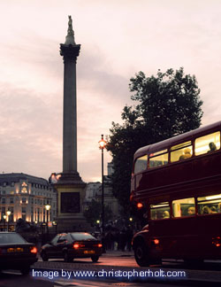
Nelson's Column is the focal point of Trafalgar Square. Admiral Nelson was one of Britain's best-loved heroes, who fought valiantly for his country and won four notable naval battles, at the personal cost of losing an arm and one eye.

Things you must VISIT when you're in London

- Madame Tussaud's and London planetarium

Madame Tussaud's Waxwork Museum is the world famous collection of wax figures of famous people. Mingle with the famous at the world-renowned collection of wax figures in theme settings which include The Garden Party, 200 Years, Hollywood Legends and Superstars, The Grand Hall, The Chamber of Horrors, Sporting Heroes and The Spirit of London.
The planetarium is quite new, and it's great – you can see all the stars there.

- British museum

- Covent Garden

It's one of the most known theatres in the world. All the great ballet-performances happens there, and it's quite hard to get the tickets-you have to reservate them months before the show. But it's worth it!

- Globe theatre

A theatre, which was build in 18th century, and the Shakespeare's playes were acted there in the time of his life.

- Royal national theatre

- Royal festval hall

- National gallery

- Imperial war museum

- National history museum

- Science museum

- Victoria&Albert museum

Things you must DO when you're in London

- To go on a ride with a London eye
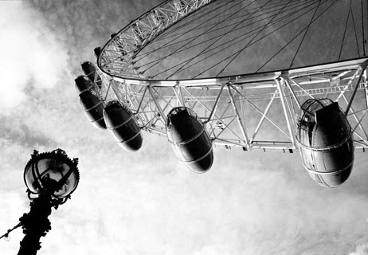
A London eye is a 135 meter high attraction built over the Thames close to County Hall. The world's highest observation wheel (Ferris Wheel), it provides a 30 minute slow moving flight over the capital. The London Eye, sponsored by British Airways is the ultimate way to view the magnificent and beautiful city of London.

- To go on a walk in a park

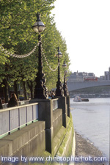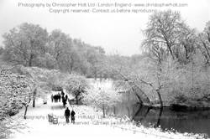London has many many parks, but they are all in one part of the city. Here are some of the biggest: Regent's park (there is also a big london ZOO), Hyde park and the Kensington gardens and Green park (with Hyde park corner) with St.James's park near the Buckingham palace (they make a one big park). You just can't resist the temptation , you must walk trough the beautiful greenery or have a picnic, if a weather is right.

Traffic

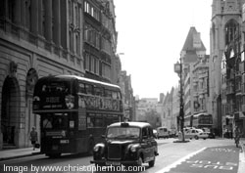Traffic in London is really something special. They drive on left side of the street, not on the right one like we do. If you want to go anywhere in London, you can go with the undergroun, you can drive with doubledecker or you can take a cab – it's your choice. You can alway walk, but London is very big and it's hard to walk on thi other side of the city.

Muffins & coffee

What I love about London the most, are all those small places where you can drink coffee and eat the best chocolate (or some other) muffins in the world. It's just so cosy and the ambient is great. The English people are also known for their huge breakfasts: warm bread, sausages, egg sunny-side up, ham, marmalade and butter, crossiants…and tea, of course. No meal is not complete without a cup of tea. They really know how to enjoy the life.

Shops

Shops in London are great – there are all the best and the famous ones shops, but they are really pricey. The most known department store is probably Harrods, they say you can get there everything from a lipstick to the piano. The must-go is Oxford street, street where are only shops. Heaven!

