making a backpack.)
I haven't got a backpack like this since high school.. I always thought that it was hard to make! Turns out that it needs some time but it can happen.. step by step as everything :) First of all choose your fabric and the lining. The lining could be the same fabric that you'll make the bag.
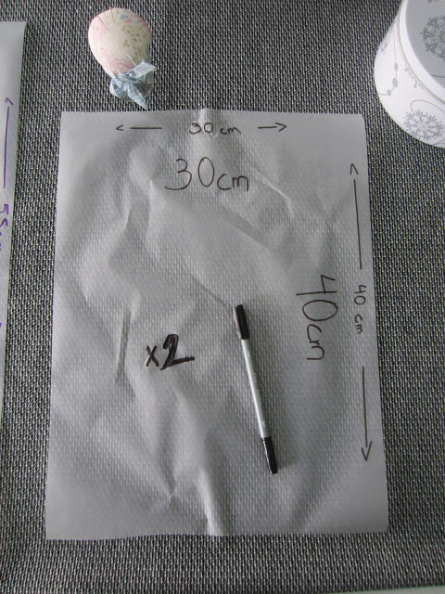
front and back (x4 if this is your lining)

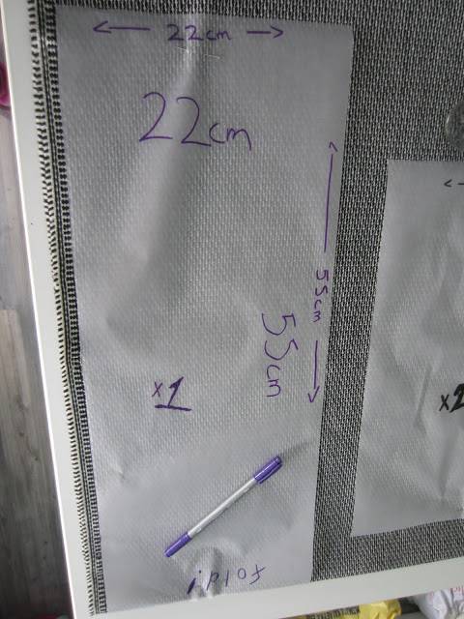
sides and down sides ( x2 if this is your lining)
Cut leaving 1cm for the seams...
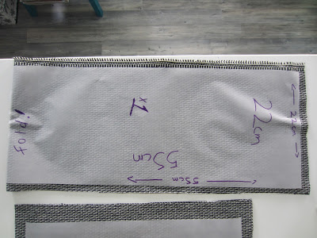
fold!!

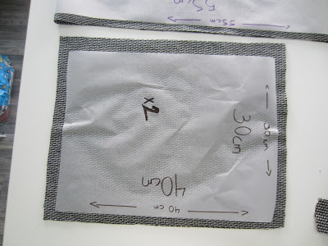
Cut the cover of the bag and the cover of the front pocket..
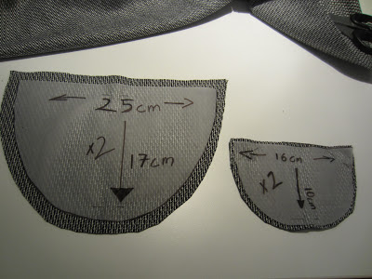
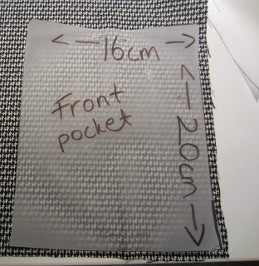
..and cut 2 rectangles, one for the front pocket and one for inside pocket.
And finally the stripes with the width and the length that you prefer.
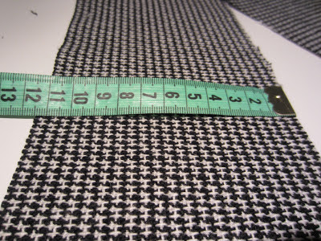
I cut it 12cm so as to be almost 6cm.
And now the sewing part!! First of all, sew the pockets (inside and front) now that all parts are open and sew the cover of the front pocket as well.
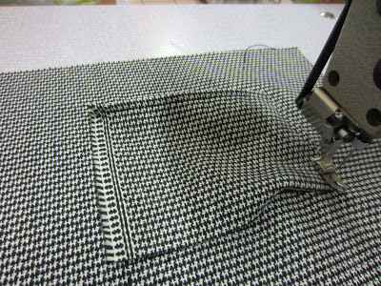
front pocket
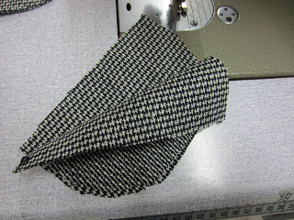

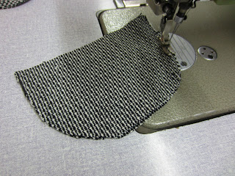
sew together

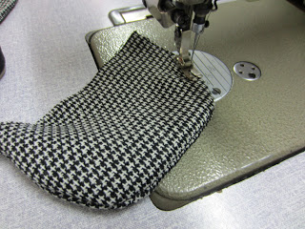
turn inside out and sew again.
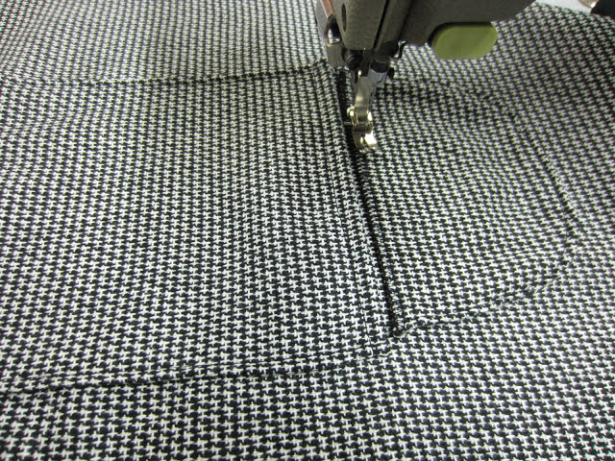

And now the main part of this backpack. We have 2 rectangles and 1 long piece. Sew them together so as to have this result:
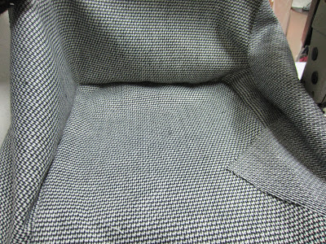
sew with a little bit of roundness at the corners.
This step will be repeated on the lining too. I used the same fabric for lining.
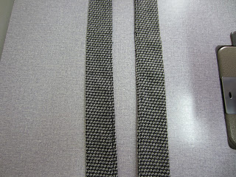
Then make the stripes and iron them.. Υou can sew the stripes out side or inside the bag but if you want them to be inside you have to sew them one step before. The stripes must have a smaller distance on the top.Put the lining inside the bag and cut one more stripe Sew that stripe on the top of the bag
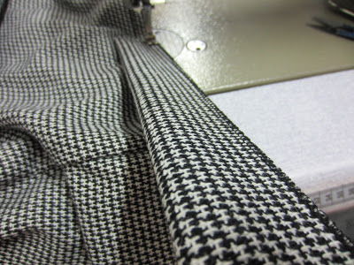

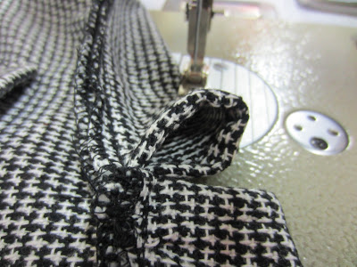

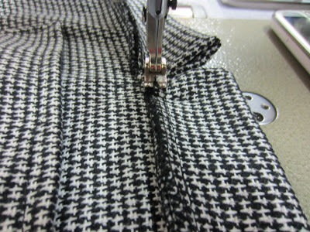

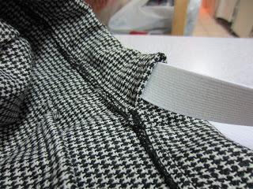
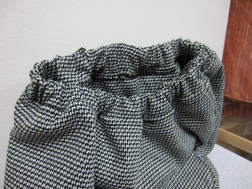
so as to pass through an elastic. When you sew the elastic together you must have this result.
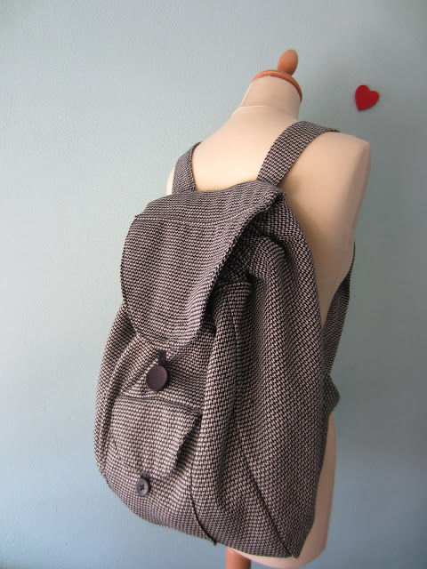
Put the cover on the bag. Choose the way that you prefer to close and to open your bag, add it and you are ready to go!!

How To Sew A Custom Chalkbag
This chalkbag design is inspired by Krieg chalkbags, a super company that will make you a custom chalkbag at a killer price. It’s a simple barrel design, but one of my favorites because it allows for full-hand dipping. Chalk up with one of these bad boys and I guarantee that you’ll increase your onsight grade a full number. Well, maybe not, but at least you’ll look wicked cool. You will need the following materials:
- Outer Fabric Material – 7″ x 14″
- Bottom Fabric Material – 4.5″ diameter circle
- Inner Fleece Material – 8.5″ x 11.5″
- 2″ fine-weave webbing – 20″ in length
- 30″ of elastic cord
- Barrel lock for 1/4″ cord
- Grommet Kit
I make the inner fleece bag first. Take the fleece material, fold it in half and cut out two notches on either side. The goal is to create a square-bottomed bag out of the fleece material that will hold the chalk. I notched about 1.5″ x 2.5″ from either side, but you may have to play around with the measurements to get a good fitting bag. Sew the side, bottom and then the notches together to form an H at the bottom.
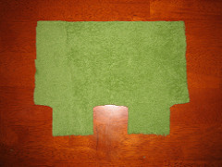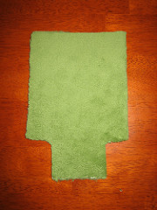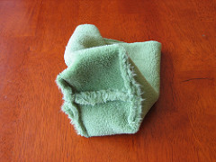
Next, sew the outer fabric material into a tube. I stop stitching the tube before the end to help with fitting the bottom onto the tube, sometimes you have to add or remove material to make the circular bottom fit correctly. Cut the circular bottom out (I found a Primus gas canister is the perfect size for this) and stitch it to the bottom of the tube.
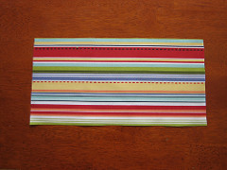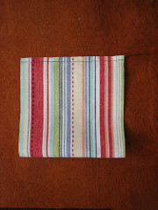
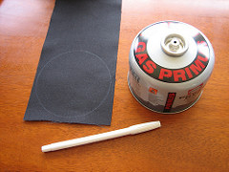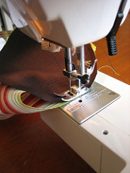
Add a grommet to the outer bag with a grommet kit. The hammer and anvil type of grommet kits work much better than the style that use the pliers, and brass grommets seem to fit nicer than the aluminum ones. Add a small patch of fabric behind the grommet to add a bit of strength. Assemble the bag with a fleece lining and the elastic cord placed temporarily around the lining.
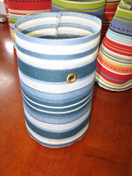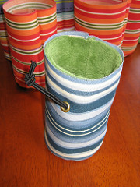
Cut the 2″ webbing into two lengths – 14″ and 6″. The 6″ piece is the belt loop and the 14″ piece is the rim of the chalk bag. Iron the 14″ piece in half and pin it onto the rim of the chalkbag. Place the 6″ piece at the back of the chalkbag, opposite the grommet and underneath the rim. Sew around the rim of the bag. I bartacked the ends of the webbing to provide some extra strength.
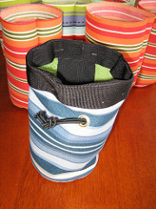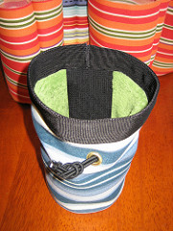
At this point, pull the elastic cord up around the lining until the cord follows the rim of the bag. Pin the cord into place at the back where it will be held by the belt loop. Bring the belt loop up from inside the bag, give it a fold and stitch it into place where it will hold the elastic cord and prevent it from coming out. Stitch the bottom of the belt loop completely through the bag and lining.
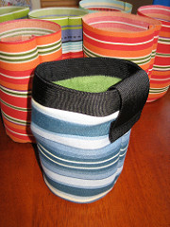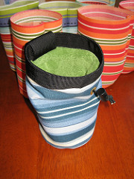
Install the barrel lock on the elastic cord and trim the cord to length. You’re done! I made several chalk bag belts using some 3/4″ flat webbing and buckles (hanging your chalk bag from a carabiner is weak sauce). If you are trad climbing, a length of 1/2″ supertape with a bail ring on it in place of the belt makes a great emergency rap anchor, and doesn’t weigh much more than the belt.
