How We Make Felt
The felt used in Festive Fibers products is made using age-old techniques.

1. Make friends with the wool producers. Felt is made from wool fiber.  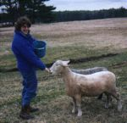 | 2. Visit sheep farms early in the season, and pet all the sheep in order to pick out the softest of the wools.  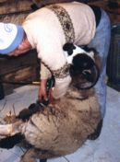
3. Give the sheep a haircut. Sheep are kept well fed and healthy to produce wool year after year.  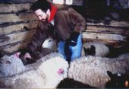 | 4. Pick debris from the raw wool. This is called "skirting" the wool.  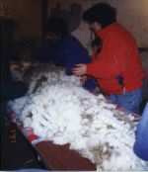
7. Send the raw wool off to be washed and combed, removing the natural lanolins and debris  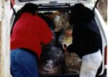 | 8. Mix the dyes. The dyes are cooked into the wool fiber on the stovetop.  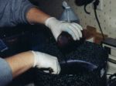
9. Nicole hand dyes the clean wool fiber with colorfast dyes creating her unique color palette.  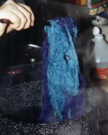. | 10. Two formats of processed wool are known as batting and roving. In the picture the batting is the wide flat light green piece of wool. (Batting is what is used to stuff Sleeping Bags, Quilts, etc) Roving is long strands of processed wool, here rolled into balls. (Roving is what is used to spin into yarn on the spinning wheel.)  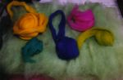
12. After setting the color palette, a pattern of roving is layed out on top of three layers of batting. This pile is 4-6 inches thick.  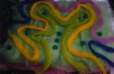 | 13. Felting is caused by heating and agitating wool fibers so that they lock together. There are many methods to do this. Sticking a wool sweater in the hot washing machine is one. Another, shown here, is to spray warm sudsy water on the wool fiber, and roll it up in a straw mat. Roll the mat like a rolling pin until your arms fall off.  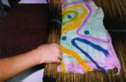
14. Microscopic scales on the wool fibers lock together. The top pattern layer becomes part of the background layers using no glue or sewing!  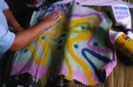 | 15. The finished pieces of felt can then be cut and sewn to make beautiful pieces such as this felt upholstered chair.  

