**Research work**

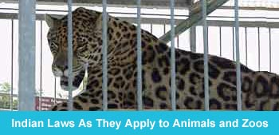

**Animal Testing**

115 million animals are experimented on and killed in laboratories in the U.S. every year.

Animal experimentation is a multibillion-dollar industry fueled by massive public funding and involving a complex web of corporate, government, and university laboratories, cage and food manufacturers, and animal breeders, dealers, and transporters. The industry and its people profit because animals, which cannot defend themselves against abuse, are legally imprisoned and exploited.   
  
Fortunately for animals in laboratories, there are people who care. Some of them work in labs, and when they witness abuse, they call PETA. Thanks to these courageous PETA's undercover investigators and caseworkers, who sift through reams of scientific and government documents, have exposed what goes on behind laboratory doors.

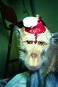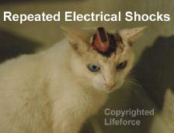

**Life in a Laboratory**

Imagine living locked inside a closet without control over any aspect of your life. You can't choose when and what you eat, how you will spend your time, whether or not you will have a partner and children, and if you do, who that partner will be. You can't even decide when the lights go on and off. Think about spending your entire life like this, even though you have committed no crime. This is life in a laboratory for animals. It is deprivation, isolation, and misery.

Chimpanzees, in their natural homes, are never separated from their families and troops. They spend hours together every day, grooming each other and making soft nests for sleeping each night. They are loving and protective parents and baby chimps will live close to their mothers for many years. But in a laboratory, chimpanzees are caged alone. There are no families, no companions, no grooming, and no nests. There are only cold, hard steel bars and loneliness that goes on for so many years that most chimpanzees sink into depression, eventually losing their minds.   
  
Rats and mice are denied a place to dig and hide. Dogs and cats are deprived of exercise, affection, and the homes that they long for with families to care for them. Rabbits have no room to leap. Pigs cannot root in the ground or build their nests. Even when the cages are clean–and this is not always the case–the animals are not allowed to engage in any normal behavior.  
  
On top of the deprivation, there are the experiments. Animals are infected with diseases that they would never normally contract–tiny mice grow tumors as large as their own bodies, kittens are purposely blinded, rats are made to suffer seizures. Experimenters force-feed chemicals to animals, conduct repeated surgeries on them, implant wires in their brains, crush their spines, and much more, usually without any painkillers.

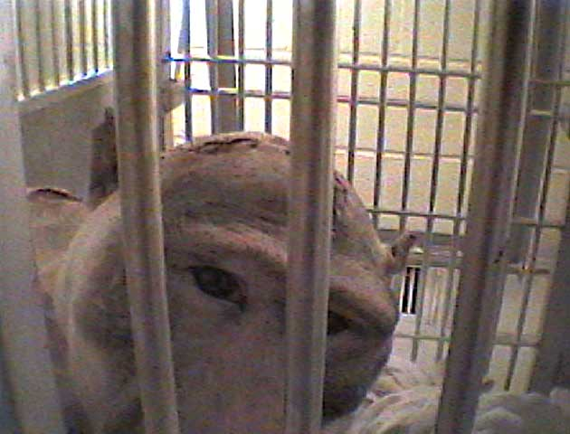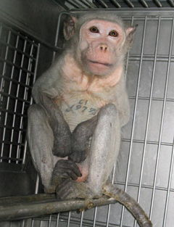

**Animals kept in zoos**

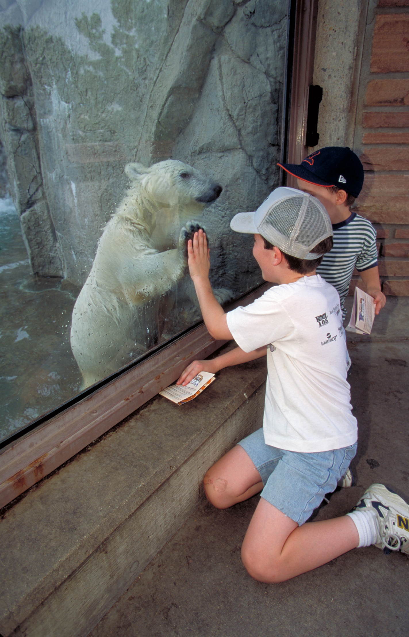

Animals in cages are a sad sight. Animals in the cage are fed by men and in due course they loose their capacity to hunt. They need enough space to move about and they should be allowed to live in their own habitat. Rules say these creatures should be let to their natural habitat after one year. But it is not followed. Once you release these animals in the forest they die soon of starvation. They cannot hunt. All animals including man have a habitat to live which is Nature's creation and no body can violate the rule of the Nature.

Animals are kept at zoos for several reasons. One is to preserve, protect or try and repopulate animal species. Another reason is to teach people about them and their environment. This helps protect them as well. I personally don't think keeping animals in zoos are horrible. Yes they cannot be in their own environment and they have limited space but it helps both our and their species in several ways. We can learn a lot from animals. And the more we learn about them the more we can protect them....and us. It is really important to understand the world we live in. Endangered species have even been repopulated because of keeping them in captivity.

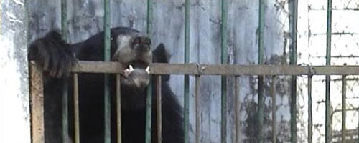

**Circuses**

**Transport & Life on the Road**

Touring circuses may cover thousands of miles a year, carrying animals from site to site in transporters and cages on the backs of lorries known as beast wagons. Moving location each week means they spend most of the year in temporary accommodation.

The animals may be confined for hours, even days, in their traveling cages, with their only respite being either limited time in an exercise cage, being rehearsed, or performing. It is impossible for a traveling menagerie to provide circus animals with the facilities they need.

In the wild, elephants are extremely social, living in large groups or herds and travel on average 25kms per day. In the circus, they spend most of each day chained by a front and a hind leg, standing on a wooden or metal board in a tent. The chains on their legs mean they can only shuffle a pace or two backwards or forwards. If they are lucky, they will occasionally have access to a grassed electric fenced enclosure, but this will depend on the circus site.

Big cats, most commonly lions and tigers, live in beast wagons. Studies have shown that these animals spend most of the day in these small mobile cages. Some may be provided with 'exercise' cages, but often these are only slightly larger than the beast wagon itself, and they are only likely to have access at certain times of day.

Although, performing dogs could be kept as pets, living with a presenter, they are often kept in cages on tour or tied up when they are not performing.

Often, animals are kept together in inappropriate groups - for example territorial lions and tigers share the same cages. Zebras and llamas, will form groups or herds in the wild, but will often be solitary, or just in pairs in the circus.

**Training**

Training is very secretive; animals undergo training behind closed doors. There have been cases where brutal training methods have come to light.

The nature of training circus animals is revealed by the tools of the trade. Whips are seen in the ring but the use of screws hidden in the base of walking sticks, spikes concealed in tasseled sticks and hotshots or electric shock devices has been documented.

Some ex animal trainers or keepers have spoken out, to expose the cruel methods used to break and train circus animals. In the book 'Elephant Tramp' by George Lewis the story of a training routine for Sadie the elephant is told.

'Sadie just could not grasp what we were trying to show her. In frustration she attempted to run out of the ring. We brought her back and began to punish her for being so stupid. We stopped suddenly, and looked at each other, unable to speak. Sadie was crying like a human being. She lay there on her side, the tears streaming down her face and sobs racking her huge body'.

Another ex circus employee related how a little brown bear was treated.

'She was a sweet little innocent brown bear who never hurt anyone... but sometimes she had trouble balancing on the high wire. She was then beaten with long metal rods until she was screaming and bloody. She became so neurotic that she would beat her head against her small cage. She finally died'

**Performances**

In circuses, the audience can still see beautiful majestic animals like elephants ridiculed by their trainers, or big cats reduced to cowardly looking creatures by the cracking whip of the 'powerful' lion tamer.

Some circuses claim to be educational but there is no educational value in seeing such magnificent animals reduced to performing tricks. The idea of publicly humiliating an animal to prove that 'Man' is capable of this kind of dominance is not fun. Children should be taught to respect animals - circuses teach the opposite.

Circuses also claim to be involved in conservation, yet no animals from circuses have ever been released to the wild. Far from the suggested aim of conservation, most circus elephants have been taken from the wild.

The fact is, animals do not naturally ride bicycles, stand on their heads, balance on balls, or jump through rings of fire. To force them to perform these confusing and physically uncomfortable tricks, trainers use whips, tight collars, muzzles, electric prods, bull hooks, and other painful tools of the trade.   
  
We applaud trapeze artists, jugglers, clowns, tightrope walkers, and acrobats, but let’s leave animals in peace. [Sweden, Austria, Costa Rica, India, Finland, and Singapore have all banned or restricted the use of animals in entertainment](http://www.circuses.com/pdfs/AnimalActs_Legislation.pdf)

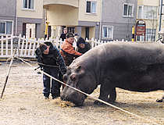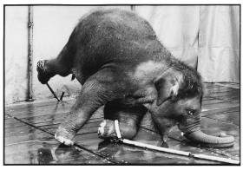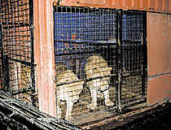

**Animals used for sports**

**1. What is dog fighting?**

Dog fighting is a sadistic "contest" in which two dogs—specifically bred, conditioned, and trained to fight—are placed in a pit (generally a small arena enclosed by plywood walls) to fight each other for the spectators' entertainment and gambling. Fights average nearly an hour in length and often last more than two hours. Dogfights end when one of the dogs will not or cannot continue. In addition to these dogfights, there are reports of an increase in unorganized street fights in urban areas.

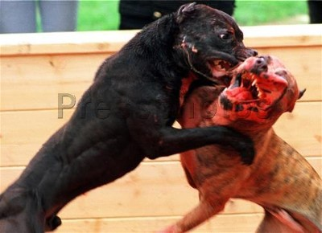

**2. How does it cause animal suffering?**

The injuries inflicted and sustained by dogs participating in dogfights are frequently severe, even fatal. The American pit bull terriers used in the majority of these fights have been specifically bred and trained for fighting and are unrelenting in their attempts to overcome their opponents. With their extremely powerful jaws, they are able to inflict severe bruising, deep puncture wounds and broken bones.

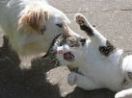

Dogs used in these events often die of blood loss, shock, dehydration, exhaustion, or infection hours or even days after the fight. Other animals are often sacrificed as well. Some owners train their dogs for fights using smaller animals such as cats, rabbits or small dogs.

**3. Are there other concerns?**

Yes. Numerous law enforcement raids have unearthed many disturbing facets of this illegal "sport." Young children are sometimes present at the events, which can promote insensitivity to animal suffering, enthusiasm for violence and a lack of respect for the law. Illegal gambling is the norm at dogfights. Dog owners and spectators wager thousands of dollars on their favorites. Firearms and other weapons have been found at dogfights because of the large amounts of cash present. And dog fighting has been connected to other kinds of violence—even homicide, according to newspaper reports. In addition, illegal drugs are often sold and used at dogfights.

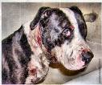

**4. What other effects does the presence of dog fighting have on people and animals in a community?**

Dogs used for fighting have been bred for many generations to be dangerously aggressive toward other animals. The presence of these dogs in a community increases the risk of attacks not only on other animals but also on people. Children are especially at risk, because their small size may cause a fighting dog to perceive a child as another animal.

**Hunting animals for fur**

Every year, hunting accounts for hundreds of millions of casualties world-wide - casualties among wild animals, foxes, wolves, cougars or deer, who die painful deaths because they are considered to be pests, have beautiful fur, or because of the "recreational value" their persecution provides. While the hunting fraternity maintains their long disproved claims that hunting helps to keep up the natural balance

The very concept of hunting is inseparably linked to pain and death, to families, packs and prides being ripped apart and destroyed, to animals becoming overly shy and unable to live their natural lives. Because a few people enjoy killing and hunting them even in their last refuges, wild animals in most places of the so-called civilized world see us all as enemies they have to avoid at any cost. Hunting upsets the natural balance by targeting animals for their value as trophies, by mercilessly slaughtering predators to minimize competition for their prey, and by disturbing or inhibiting the complex social systems of many species.

By abolishing hunting and ending this one-sided war of humans against nature, we want to make it possible for wild-living animals to lead more peaceful, more natural lives again, without permanent fear of cowardly snipers with ranged weapons and invisible traps. The examples of hunting-free countries and national parks clearly show the ecological and individual benefits of a ban on hunting: Wild animals are less shy and more willing to let humans approach; they have higher life expectancies, and they form more stable families and packs. In all, this results in healthy, well-balanced populations limiting their numbers by means of their own natural social system.

