OŠ DRAGOTINA KETTEJA

ILIRSKA BISTRICA

Project about sport star biography

He was born in 14. Jully 1987 in Rosario in Argentina. His full name is Lionel Andrés Messi.

He started to play football when he was 5 year old. He played for club Grandoli, which trainer was his father. In 1995 he started to play for club Newell's Old Boys. When he was 11 years old he got diagnose, that he's body didn't makes enough testosterone. At the same time club River Plate got interested for him, but they couldn't paid his treatment. But sports director of FC Barcelona has also recognized his talent and Barcelona has made a contract with him and they also paid his treatment and made him new life in Spain. Messi has moved to Spain with his family when he was 13 years old. After that he quickly show his talent in Barcelona and he soon came to first team.

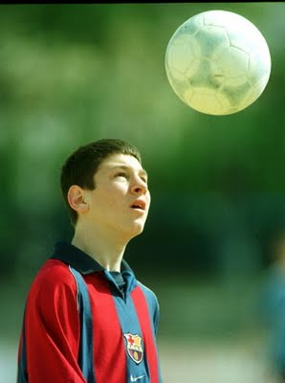

He's first unofficial match with Barcelona was opposite FC Porto in 16. November in 2003. 11 months later he played his first official match was opposite Espanyol in 16. October 2004. In this day he became the youngest player ever played in Spanian League called La Liga or Primera Division. He was also the youngest scorer in La Liga, he was start 17 years, 10 months and 7 days when he scored his first goal for Barcelona.

He played his first match for Argentina U-20 national football team in June 2004 in Paraguay. In 2005 he was member of Argentina U-20 national football team in Nederland. He was the best player on the tournament.

In 4. August 2005 Messi was called in Argentina national footbal team. He played his first match in 17. August 2005 on match with Hungarian. He started play in 63th minute, but he didn't finish the game. First time he finshed the game was on the match with Paraguay in 3. September, where he played only last 8 minutes.

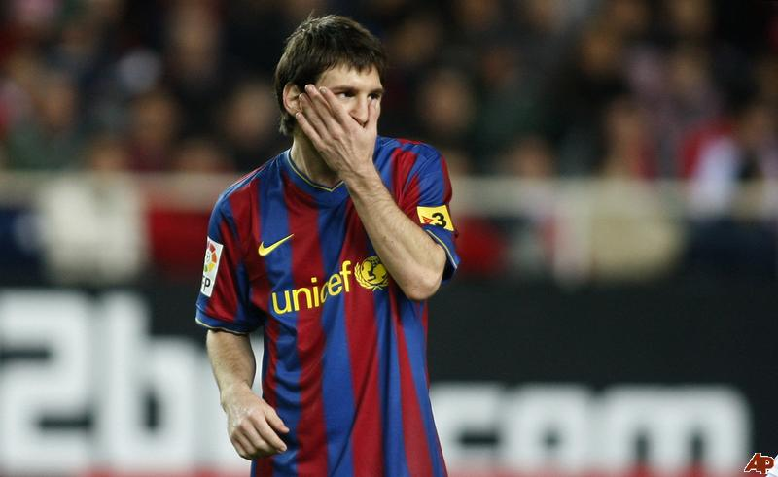

In 16. September FC Barcelona has renewed contract with Messi for bigger salary until year 2014.

His fir match in Champions Legaue was with Udinese. In the same year in December has Italian sport magazine declared »Goolden Boy« and with that he got an award for the best U20 footballer. He won before Wayne Rooney, Lukas Podolski and Christiano Ronaldo.

Messi scored 6 goals in 17 plays in Spanish League and 1 goal in Champions League. Messi end season 2005/06 earlier, because he injured his muscle.

Because he injured he didn't played football 2 monhts. After the end of the season he played in FIFA World Cup 2006 in Germany. He played very well in FIFA World Cup he was also the youngest footballer scored for Argentina and on this tournament.

In season 2006/07 he show his good form on El Clasico. He scored a hat-trick. He is the youngest player ever scored on El Clasico. With this match he started his best form in this club. He scored 11 goals in just 14 matches. Anyway Barcelona didn't win Spanish League.

Messi got nickname »New Maradona«, because he scored almost the same two goals as Diego Armando Maradona. The most famous two goals all the time. Spanish gave him nick name »Messidona«.

In season 2007/08 Messi has scored 5 goals in one week. He replaced injured Ronaldinho and scored two goals to Sevilla in 22. September, one to Lyon and two to Real Zaragoza.

He was choosen in FIFPro World XI Player Award in category of attackers. That Messi is the best player on Earth was think Ronaldinho, Eto'o, Frank Rijkaard, Victor Fernandez, Guti, Raul, Gianluca Zamnrotta, Francesco Totti, Diego Armando Maradona and others.

In season 2008/2009 Messi won with Barcelona La Liga, Copa del Rey, Champions League, Supercopa Espana, UEFA Supercup and FIFA Club world Cup. He was the best scorer in Champions League and he was choosen for the best player in the world, too.

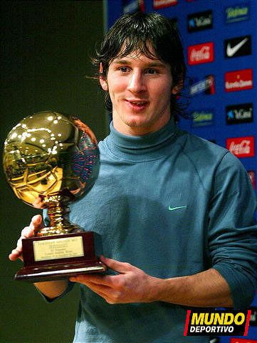

Messi was the best scorer in Spanish League in the last Season 2009/2010. He was the best player ont he world for this season. He played with Argentina in the end of the season in FIFA World Cup 2010 in South Africa. But Messi didn't scored any goals, anyway he played very well.

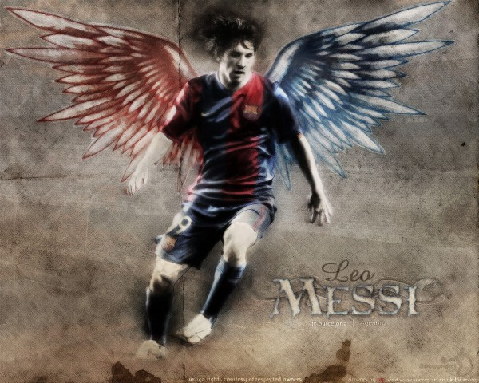

Now Messi is 23 years old he is probably best footballer yet. He is so good, that some fans called him god or king of the football. Season 2010/2011 has also start yet. And Messi is the best Barcelona scorer right now. We will see if Messi will continued with his great form.