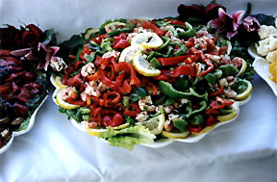
Mix lettuce

Ingredients:

Oil
Ordinary oil
Pumpkin oil
Vinegar
Sale
Water
Lettuce
Red pepper
Green pepper
Beans
Cucumber
tomatoes

Instructions:

First we cut lettuce and wash it. Then we cut tomatoes, red pepper, green pepper cucumber and beans wash it too.Then we all vegetables put in to bowl.Then we put in to bowl vinegat, sale, vater, pumpkin oil and ordinary oil.Then we mix all and put in to the table and eat.

