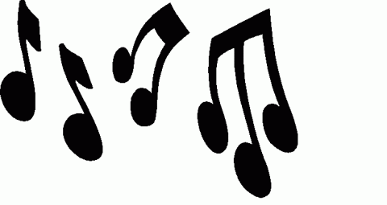

**1. What is** MUSIC?

• Music is an [art](http://en.wikipedia.org/wiki/Art) form consisting of [sound](http://en.wikipedia.org/wiki/Sound) and [silence](http://en.wikipedia.org/wiki/Silence) expressed through [time](http://en.wikipedia.org/wiki/Time). Elements of sound as used in music are [pitch](http://en.wikipedia.org/wiki/Pitch_%28music%29) (including [melody](http://en.wikipedia.org/wiki/Melody) and [harmony](http://en.wikipedia.org/wiki/Harmony)), [rhythm](http://en.wikipedia.org/wiki/Rhythm) (including [tempo](http://en.wikipedia.org/wiki/Tempo) and [meter](http://en.wikipedia.org/wiki/Meter_%28music%29)), [structure](http://en.wikipedia.org/wiki/Structure), and sonic qualities of [timbre](http://en.wikipedia.org/wiki/Timbre), [articulation](http://en.wikipedia.org/wiki/Articulation_%28music%29), [dynamics](http://en.wikipedia.org/wiki/Dynamics_%28music%29), and [texture](http://en.wikipedia.org/wiki/Texture_%28music%29).

• The creation, performance, significance and even [the definition of music](http://en.wikipedia.org/wiki/Definition_of_music) changes according to culture and social context. Music ranges from strictly organized compositions and performances to improvisational. Music is divided into [genres](http://en.wikipedia.org/wiki/Genres) and sub-genres, although the dividing lines and relationships between [music genres](http://en.wikipedia.org/wiki/Music_genres) are often unclear.

**2. History of MUSIC!**

• The history of music predates the written word and is tied to the development of each unique human [culture](http://en.wikipedia.org/wiki/Culture). The development of music among humans occurred because of [natural sounds](http://en.wikipedia.org/wiki/Natural_sounds) such as birdsong and the sounds other animals use to communicate. Prehistoric music, once more commonly called primitive music, is the name given to all music produced in [prehistory](http://en.wikipedia.org/wiki/Prehistory).

**3. Theory of MUSIC!**

• Music theory encompasses the nature and mechanics of music. It also analyzes the elements of music – [rhythm](http://en.wikipedia.org/wiki/Rhythm), [harmony](http://en.wikipedia.org/wiki/Harmony) (harmonic function), [melody](http://en.wikipedia.org/wiki/Melody), [structure](http://en.wikipedia.org/wiki/Structure), and [texture](http://en.wikipedia.org/wiki/Texture_%28music%29). People who study these properties are known as music theorists.

**4. Performance!**

• Performance is the execution of music. While music cannot technically exist without performance, we generally think of performance as being the exhibition of a musical work before an audience.

**5. 20TH century - MUSIC revolution!**

• The 20th century saw a revolution in music listening as the radio gained popularity worldwide and new media and technologies were developed to record, capture, reproduce and distribute music. The focus of [art music](http://en.wikipedia.org/wiki/Art_music) in the 20th century was characterized by exploration.

**6. Four of the most listening sorts of MUSIC!**

**Other types:**

- Classical

- [Alternative](http://www.mininova.org/sub/54)

- [Anime](http://www.mininova.org/sub/160)

- [Asian](http://www.mininova.org/sub/55)

- [Blues](http://www.mininova.org/sub/56)

- [Christian](http://www.mininova.org/sub/57)

- [Classic](http://www.mininova.org/sub/58)

- [Country](http://www.mininova.org/sub/59)

- [Drum N Bass](http://www.mininova.org/sub/60)

- [Electronic](http://www.mininova.org/sub/61)

- [Game Music](http://www.mininova.org/sub/62)

- [Gothic](http://www.mininova.org/sub/233)

- [Hardcore](http://www.mininova.org/sub/63)

- [Hip Hop](http://www.mininova.org/sub/64)

- [Industrial](http://www.mininova.org/sub/65)

- [Jazz](http://www.mininova.org/sub/66)

- [Karaoke](http://www.mininova.org/sub/67)

- [Punk](http://www.mininova.org/sub/71)

- [R&B](http://www.mininova.org/sub/72)

- [Rap](http://www.mininova.org/sub/73)

- [Reggae](http://www.mininova.org/sub/74)

- [Techno](http://www.mininova.org/sub/161)

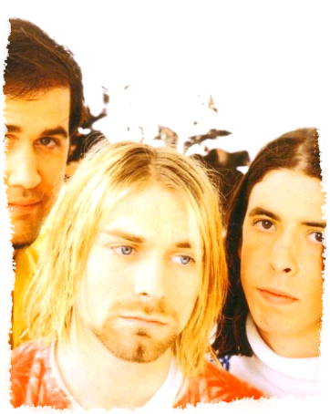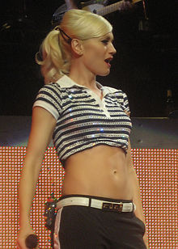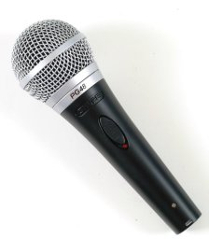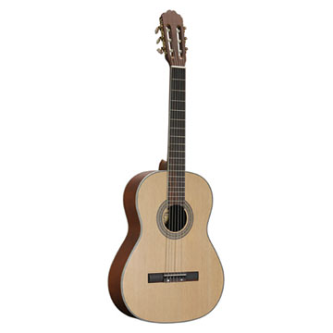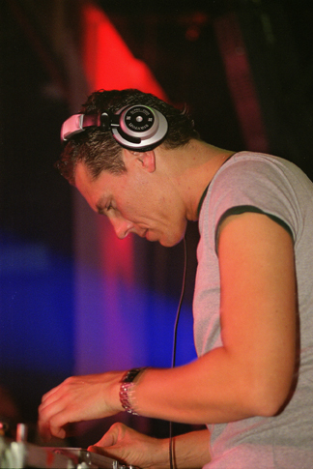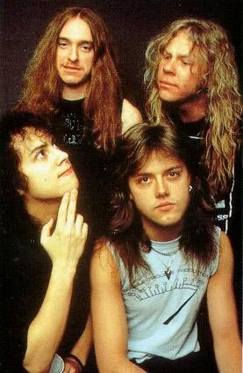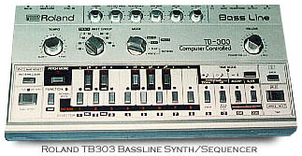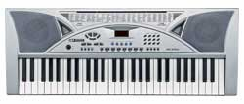

**7. Vocabulary!**

• Pitch(n) - the level or degree of sound - Višina tona

• Timbre (n) - a quality of sound which makes voices or musical instruments different from each other - Zven

• Prehistoric (adj) - describing the period before there were written records - Prazgodovina

• Encompasses (v) - to include, especially a variety of things - Vsebovati, Zajemati

• Execution (v) - to do or perform something, especially in a planned way - Izvedba

• Audience (n) - the group of people gathered in one place to watch or listen to a play… - Publika

**8. Word Formation!**

• exploration (n) - explorer (n) - explore (v) - exploratory (adj)

• music(n) - musical (adj) - musically (adv)

• performance (n) - performer (n) - perform (v)

• developer (n) - development (n) - develop (v) - developed (adj) - developing (adj)

• rhythm (n) - rhythmic (adj) - rhythmically (adv)