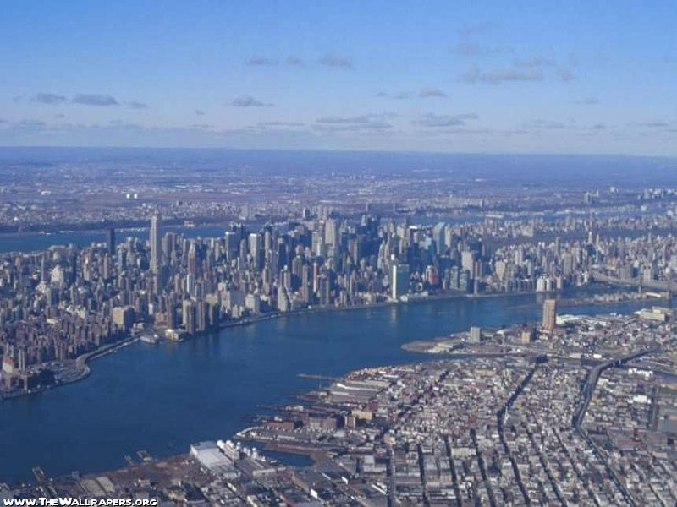

* NEW YORK

New York is not the capital city of the United States of America as some people think. But it is one of the biggest cities of the world. It lies between two rivers, Hudson river and East river.

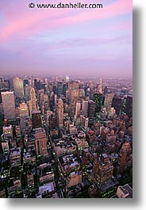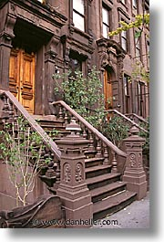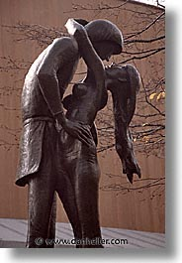

In New York city are lots of sights, statues, museums, buildings (especially high buildings), huge parks and a lot of streets. So every year more than 20 million people come from all over the world to visit the city New York. They are photographing the high buildings; they are sitting in parks, visiting the Central park Zoo; they take boat tripe to the Statue of Liberty and they visit a lot of museum and all the other sights.

* TRANSPORTATION

New York is a very big city. And in the city that size, with more than 18 million people and more than 30 million cars, it is really hard to get to some particularly places by car. The fastest way to get somewhere in time is to take New York underground train, called ‘subway’ but they are not very clean and in the night is very dangerous to travel with the subway.

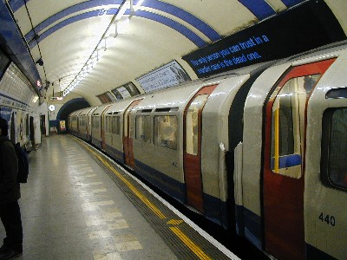

If you don't like to travel with underground train, you can still take a cab. Those are the famous ‘yellow cabs’. All the cabs in New York are yellow colour with black stripes. New York’s taxi drivers are not so kind and friendly. And if you would like to go somewhere unknown place, you should not expect a friendly answer. But if you don’t like to travel with the cab because it is expensive, you can always take a bus. You will travel longer and slower but it will take you to the right place.

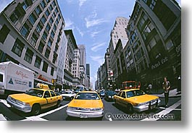

* SOME PLACES TO GO

*WORLD TRADE CENTER (WTC)* was the world’s biggest economic centre, until 11th September 2001, when two kidnapped planes crashed into buildings.

Before the attack:

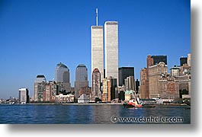

Now:

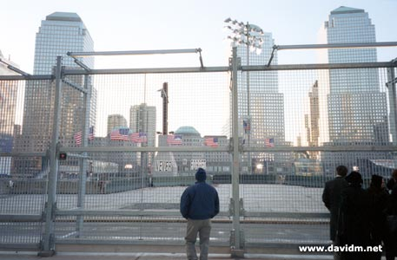

*ST. PATRICKS CATHEDRAL* is the largest Roman Catholic cathedral in the United States and one of the biggest tourist attractions in NYC, constructed between 1858 and 1879.

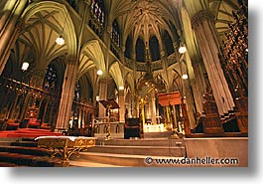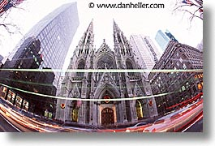

*BROOKLYN BRIDGE* is the longest and the first steel suspension bridge of its kind at the time.

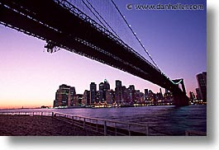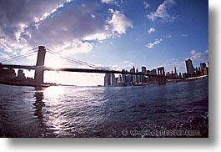

*STATUE OF LIBERTY* stands on the Ellis island. It is a worldwide symbol of freedom and it is called ‘lady liberty’. She is wearing flowing robes and the seven rays of her spiked crown symbolize the seven seas and continents.

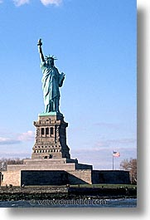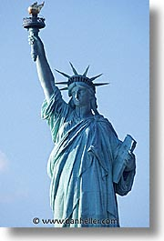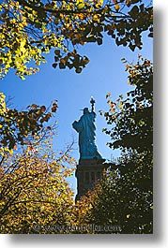

*EMPIRE STATE BUILDING* was completed in 1931 and it is the highest structure in the world.

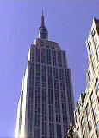

*NEW YORK PUBLIC LIBRARY* was constructed in 1911. This library building today contains over 6 million books and more than 3 million pictures.

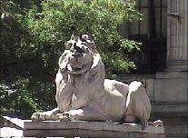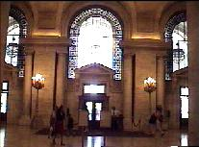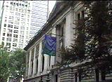

*WALL STREET* is the famous and biggest stock house in the world.

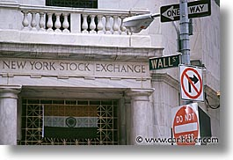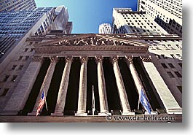

* SHOPS AND STREETS

New York is a very big city, with lots of streets, parks (Central park), squares (Times square) and different shops.

*5th AVENUE* is the most important street in New York. Here is the Warner Bros studio store, Plaza Hotel, Disney store,…

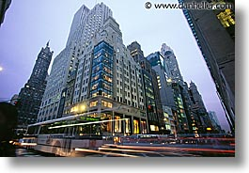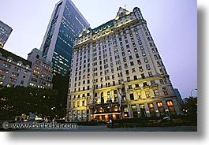

*TIMES SQUARE* is famous place in Broadway, New York. People are shopping here, going to dinner and do a lot of stuffs.

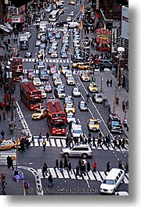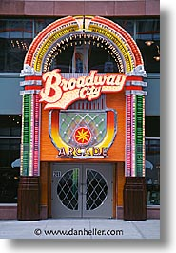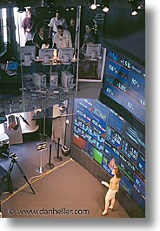

*ROCKEFELLER CENTER* is one of the biggest and noisiest places in New York.

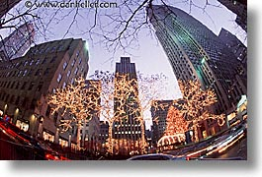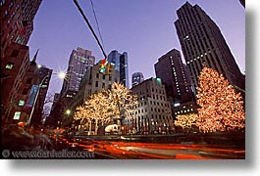

* PARKS AND BRONX ZOO

For all the larger cities is important that they have some places where people can relax and just enjoy in peace and quietness. So dose the New York city.

*CENTRAL PARK* is visited by over 20 million people each year. It took 16 years to build it. The park is also a home to over 200 species of birds.

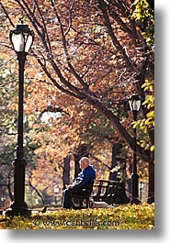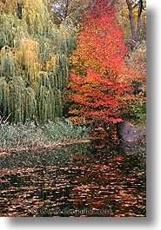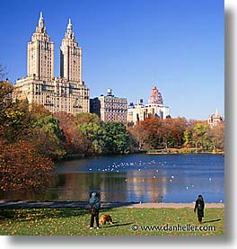

*NEW YORK BOTANIC GARDEN* isthe oldest and largest botanical gardens in the world.

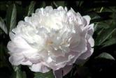

*BRONX ZOO* is the largest metropolitan zoo in the nation and has over 6,000 animals. The special thing is thatthe visit in the park is free on Wednesdays.

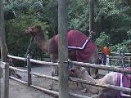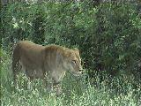

***New York*** *is very big and beautiful city, with some advantages and disadvantages, but however it is a city worth of visiting and seeing it.*

