Today, I'm going to present you my favourite boy band at the moment.

One Direction are an English-Irish group, consisting of members Niall Horan, Zayn Malik, Liam Payne, Harry Styles, and Louis Tomlinson. They signed with Simon Cowell's record label Syco Records after being formed and finishing third in the seventh series of British television singing competition The X Factor in 2010.
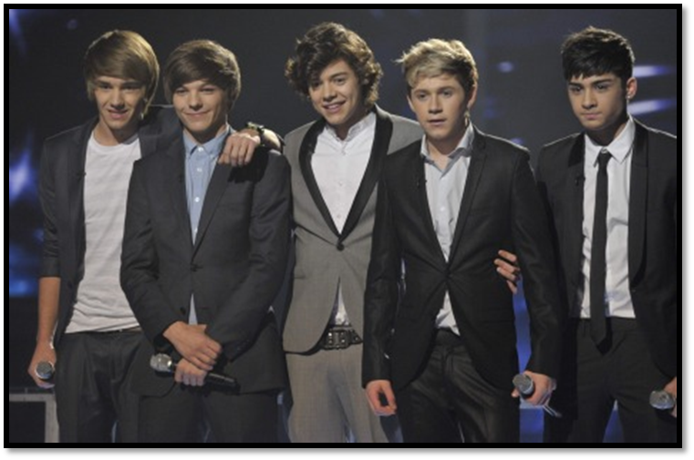
HISTORY

X-Factor 2010

In 2010, Niall Horan, Zayn Malik, Liam Payne, Harry Styles, and Louis Tomlinson auditioned as solo candidates for the seventh series of British television reality singing competition The X Factor. Failing to progress to the "Boys" category at "judges' houses", after a suggestion by guest judge Nicole Scherzinger, they were put together to form a five-piece boy band at Wembley Arena, London, England, July 2010, during the "bootcamp" stage of the competition, thus qualifying for the "Groups" category. Subsequently, the group got together for two weeks to get to know each other and to practise. Harry came up with the name One Direction For their qualifying song at "judges' houses", and their first song as a group, One Direction sang an acoustic version of "Torn". The group quickly gained popularity in the UK. One Direction finished in third place and immediately after the final, their song "Forever Young", which would have been released if they had won The X Factor, was leaked onto the internet. Shortly afterwards it was confirmed, One Direction had been signed by Cowell to a reported £2 million Syco Records record contract.

International breakthrough

Released in September 2011, One Direction's debut single "What Makes You Beautiful" bowed at number one on the UK Singles Chart, after becoming the most pre-ordered Sony Music Entertainment single in history. Subsequent singles "Gotta Be You" and "One Thing" both peaked within the UK Singles Chart top ten. In November 2011, they signed a record deal with Columbia Records in North America.
One Direction attended the 2012 Brit Awards at which "What Makes You Beautiful" won the BRIT Award for Best British Single. In April 2012, an American band who went by the same name, filed a trademark infringement lawsuit. According to the lawsuit, the US band had been using the name since 2009, recorded two albums and filed an application to register the trademark name in the US in February 2011
In December 2011, One Direction embarked on their first headlining UK concert tour, the Up All Night Tour. In early 2012, they announced Australian and North American legs concert tour, with dates from April to July 2012. The tour, resulting in 62 shows, was met with positivity both critically and commercially. A recording of a concert from the tour, Up All Night: The Live Tour, was released in May 2012.

Take me Home
One Direction's second studio album, Take Me Home, was released in November 2012. The Independent reported in April 2012 that Cowell had challenged music's "most successful" songwriters to compete for space on One Direction's second studio album.
One Direction performed "Little Things" at the 2012 Royal Variety Performance, in the presence of Queen Elizabeth II^{[62]} and headlined a sold-out show at New York City's Madison Square Garden on 3 December 2012.^{[63]} One Direction are set to embark on their second concert tour in February 2013, the 2013 World Tour

MEMBERS
One Direction consists of five members:

Niall Horan

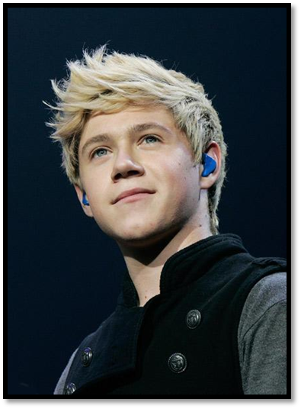
Niall James Horan, born 13 September 1993, is from Mullingard, Ireland. He’s the only Irish member of the band and the second youngest. Born to mother Maura Gallagher and father Bobby Horan, he has an older brother named Greg, with whom he doesn’t get too well along with. Their parents divorced when he was five. He and his brother lived between each of their homes for a few years before eventually deciding to live with their father in Mullingar. Prior to participating in The X Factor, he performed around his homeland, including as a support act for Lloyd Daniels in Dublin. Horan has been playing guitar since his childhood.
His natural hair colour is light brown and is bleaching it since he was 12. He’s known as ‘the funny one’ or ‘the cute one’ among his bandmates.
At the moment he's the most popular lad of the band, beating even Harry Styles.

Harry Styles

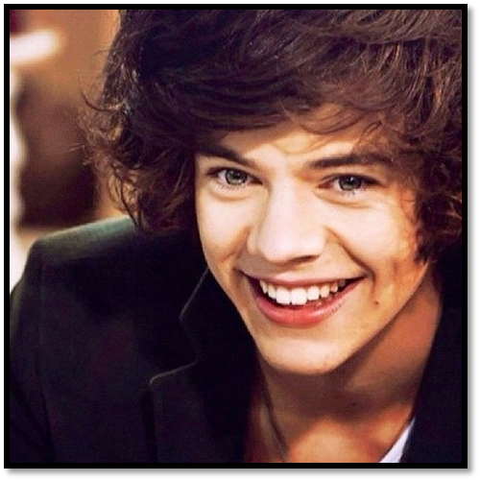
Harry Edward Styles, born 1 February 1994 is from the village of Holmes Chapel, Cheshire, England. He’s the youngest, yet the tallest member of One Direction. Born to mother Anne Cox and father Des Styles, he has an older sister, Gemma. He was seven when their parents divorced, his mother subsequently getting remarried. Following the divorce, Styles, his older sister and mother moved further out into the Cheshire countryside. At the age of twelve he moved back to Holmes Chapel. Prior to participating in The X Factor, the then sixteen-year-old Styles had a part-time job at the bakery in Holmes Chapel. Styles was the lead singer for the band White Eskimo. As a child, Styles loved singing, noting Elvis Presley as one of his influences.
He's mostly known for his messy, dark brown curls, trademark smirk, green eyes and raspy voice. Until the last 2012, he was known as the most popular member of One Direction. He’s ‘the leader’ of the group. It's also rumoured that he and his band mate, Louis Tomlinson are in committed relationship, what neither of them denied.

Louis Tomlinson
Louis William Tomlinson, born Louis Troy Austin on 24 December 1991 is from Doncaster, South Yorkshire, England. Born to mother Johannah Poulston and father Troy Austin, his parents split when he was young and he took on his stepfather Mark Tomlinson's name. He has five younger half-sisters. He had small parts in an ITV1 drama film If I Had You and BBC's Waterloo Road. He had a number of jobs, including at a Vue cinema and at Doncaster Rovers football stadium as a waiter in their hospitality suites. Tomlinson cites Robbie Williams as his biggest influence and idol.
Among band mates he's mostly known for his childish behaviour, although he's the eldest of them all. He's 'the drama queen' of the band and is mostly known for his fashion sense (one of his favourite suits were tight red jeans and stripped shirts, sometimes braces.)
As mentioned before, there are rumours going around for more than 2 years already about his and Harry Styles' relationship, who knew each other since summer 2009, thus knowing each other even before they were put together in a band.

Liam Payne

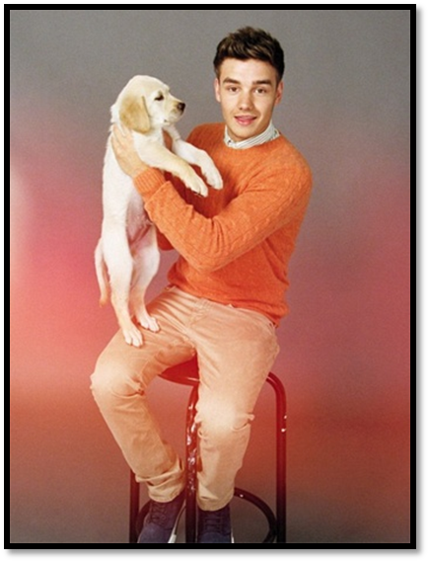
Liam James Payne, born 29 August 1993 is from Wolverhampton, West Midlands, England. Born three weeks early to mother Karen and father Geoff, he has two older sisters, Ruth and Nicola. Until the age of four, Payne had regular tests done in hospital as doctors noticed one of his kidneys was scarred and dysfunctional. To help cope with the pain, he had 32 injections in his arm in the morning and evening as a child. As a student, Payne was heavily involved in sports. Payne was bullied in secondary school and took up boxing lessons at the age of twelve. Payne had once performed in front of a 26,000 crowd at a Wolverhampton Wanderers' football match. Payne first auditioned in 2008 to The X Factor's series when he was fourteen.^{[115]} He made it to the judges' houses, but Cowell thought he was not ready for the competition and asked him to come back in two years. Payne cites Justin Timberlake as one of his biggest influences. He’s ‘the nice one' out of his band mates, known mostly about his responsibility and fatherly figure amongst others. He recently broke up with his long-time girlfriend, and shaved his hair completely off, for a charity. He's also most known for not drinking alcohol because of his kidney problems.

Zayn Malik

Zain Javadd "Zayn" Malik, born 12 January 1992, is from Bradford, West Yorkshire, England. Born to British Pakistani father Yaser and an English mother, Tricia Malik he has one older sister, Doniya, and two younger sisters, Waliyha and Safaa. Malik did not fit in at his first two schools due to his mixed heritage, and after moving schools at the age of twelve, Malik, states he started taking pride in his appearance. On auditioning for The X Factor, he stated: "I was looking for an experience". He cites urban music as his main musical influence, growing up, he was into R&Band rap. He as well as other members of One Direction further notes artists such as Bruno Mars, as a "dream collaborator." Malik is addicted to smoking cigarettes; in late 2011, he expressed his desire to quit. He's the second eldest member of the band and is mostly known for his vain personality, thus creating the nickname »The vain one.« or “The mysterious one.” In media, he’s often portrayed as ‘The Bad Boy’ of the group.

