THE SLOVENIAN PAINTER

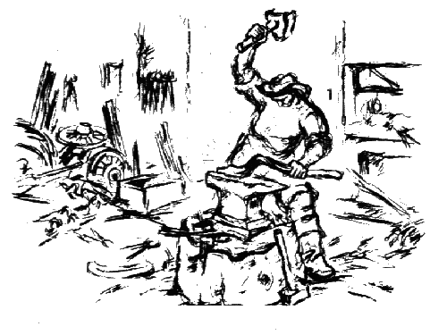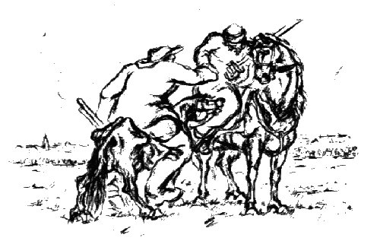Slovenian painter Lojze Perko was born On 21 April 1909. He was born in a poor family whit 12 children at Lož. He was a son of Dragotin Preko and Terezija Telešman. His father was a barber and Lojze became a barber, too. But he didn’t like that job and he helped a church painter. But the church didn’t have enough money for an assistant so he didn’t get this job. Then he became a photographer, but he didn’t like that job, too because he wanted to become an artist. When he was 27 years old he went to sculptural-painting department of the Trade school in Ljubljana, which he finished in two years. His teacher France Kralj introduced him to the world of art. In 1939 his mother died. In 1940 he made illustrations for book Martin Krpan. In that year he enrolled in the Academy of Fine arts in Zagreb, but he was not feeling well there, so he, sill in that year, went to Sophia, where he was very well received, but after the second world war he finished his studies in Belgrade in 1949. Then he came back home. For the next five years he lived between Kamnik and Ljubljana. He was looking for a suitable art studio. During this time he painted the picture Mother’s Happiness (1955), which is now placed in the Kamnik town hall in the wedding hall. This picture was dedicated to his mother and is a kind of apotheosis of family life. In 1968 the painter permanently settled in a former sexton’s house at Dolenja vas. The artist in principle finished his travelling and dedicated himself intensively to his profession. He devoted all his strength to the pure landscape, and landscape elements connected with the people who live on this land and from it. Perko realised his most beautiful painter’s dreams. He died on 19 June 1980 in Ljubljana, because of a traffic accident.

