France Prešeren

Date and place of birth: 3rd December 1800, Vrba in Gorenjska.
Date and place of death: 8th February 1849, Kranj.

France Prešeren is today known as one of the most important Slovene writers. One of his verses is 'Zdravljica', written in the year of 1844, which is also the Slovenian national anthem.
He was born on a farm. He went to study in Vienna and after finishing his studies he returned to Ljubljana, where he worked as a lawyer. Most of the poems he wrote were written there. His friend Matija Čop helped him with the writing and soon his quality in writing was as good as many other writers in Europe. He was in love with Julija Primič and he dedicated the 'Sonetni venec' and other romantic songs to her. Slowly, nearly all of his friends died one by one and his life became useless. To overcome his angryness he started drinking and with it came lots of pain and sickness, which was also the main reason for his early death.

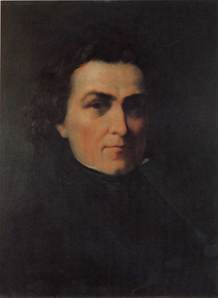
France Prešeren.
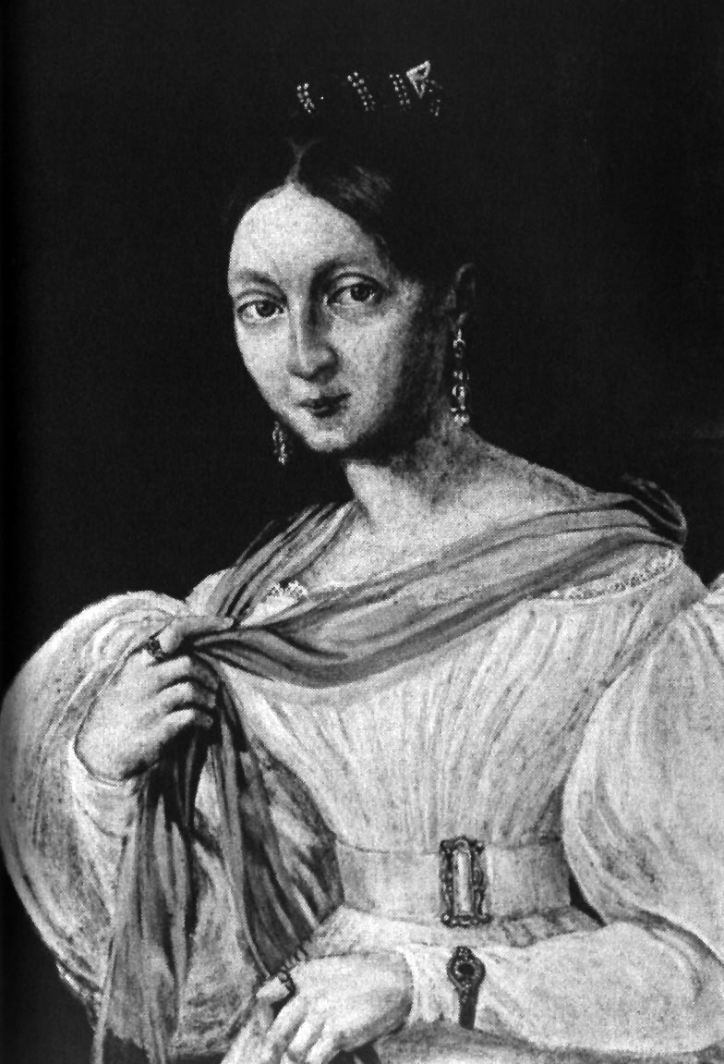
Julija Primič – a woman which he loved.
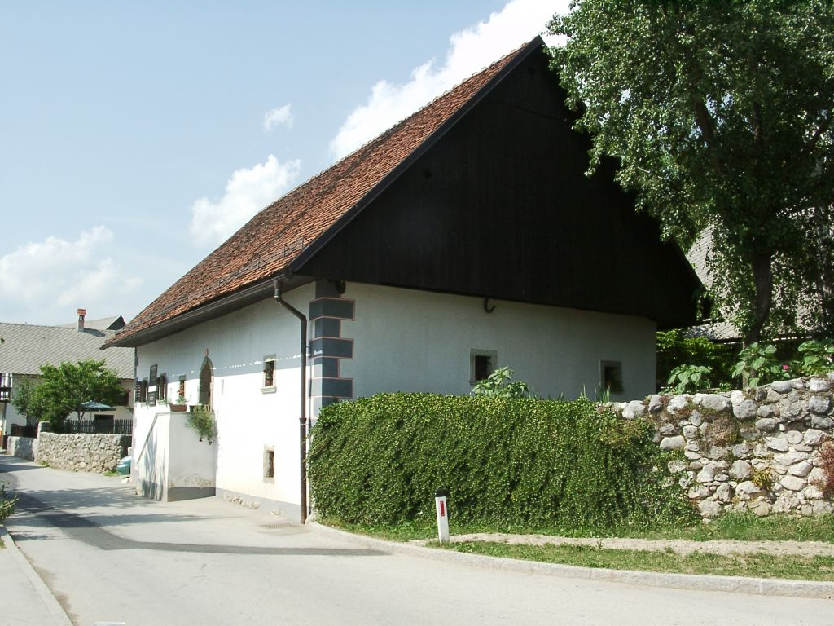
The house where France Prešeren was born.

