France Prešeren (3 December 1800 – 8 February 1849) was a Slovene Romantic poet. He is considered the Slovene national poet. Although he was not a particularly prolific author, he inspired virtually all Slovene literature thereafter.

Early life
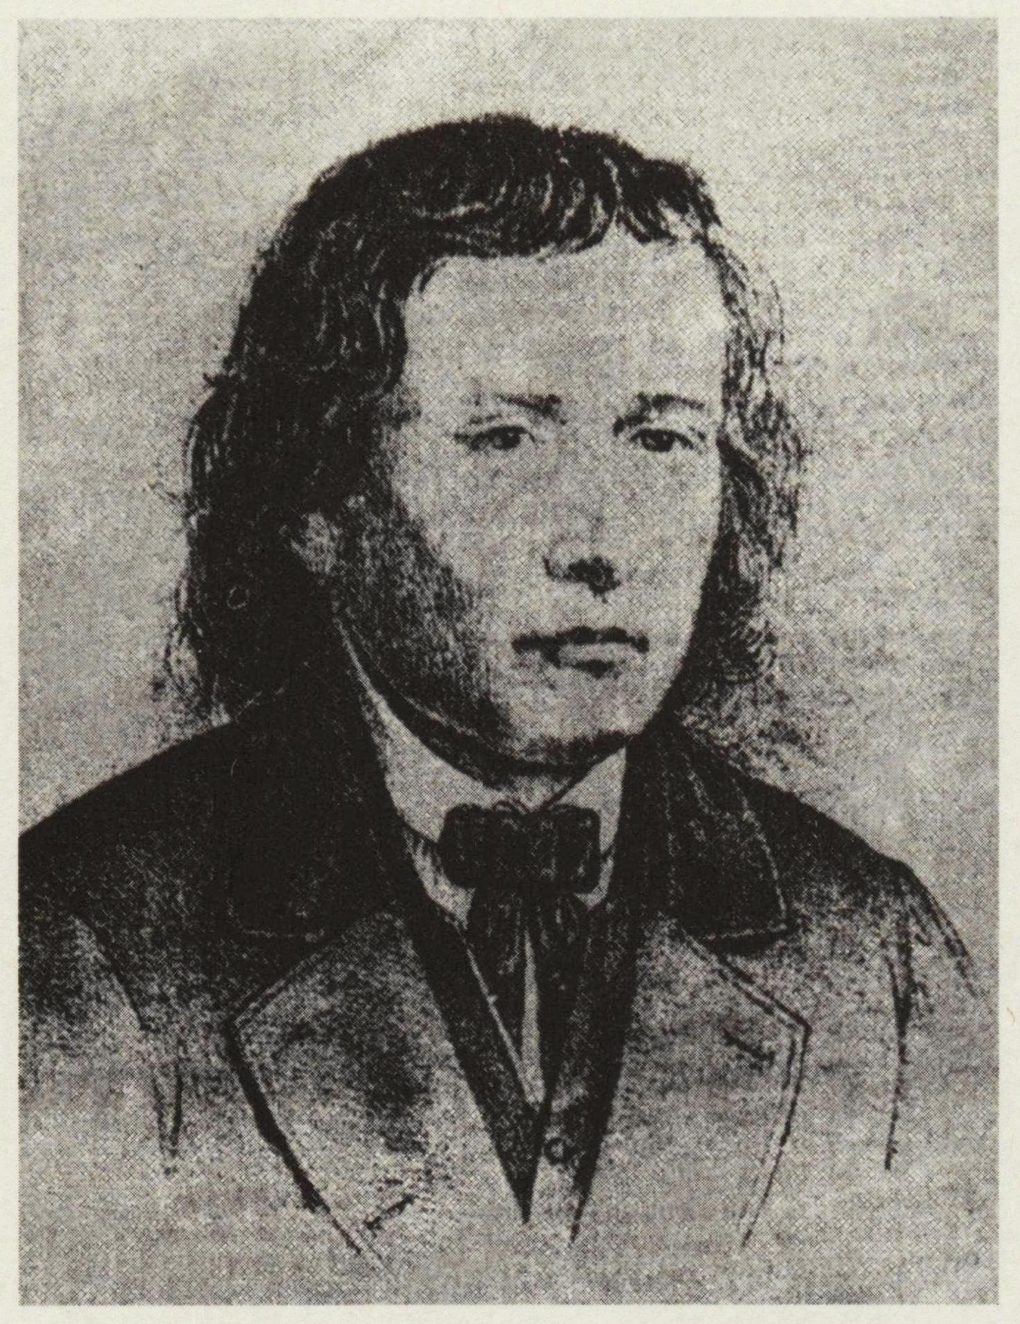
He was born 3 December 1800 (Saturday) in the Upper Carniolan village of Vrba, then part of the Habsburg Monarchy (today in Slovenia), to a relatively well-to-do peasant family. Already as a child, he showed considerable talent, so his parents decided to provide him with a good education. At the age of eight, he was sent to elementary schools in Grosuplje and Ribnica, run by the local Roman Catholic clergy. In 1812, he moved to the Carniolan provincial capital of Ljubljana, where he attended the State Gymnasium. Already at a very young age, he learned Latin, Ancient Greek, as well as German, which was then the language of education, administration and high culture in most areas inhabited by Slovenes.

Later life

After acquiring a law degree in 1828, he returned to Ljubljana, where he got employment as an assistant in the firm of the lawyer Leopold Baumgartner. He was constantly striving to become an independent lawyer by putting in as many as six applications, but he was not successful. In 1832, he shortly moved to Klagenfurt in the hope of furthering his career, but returned to Ljubljana after less than a year. In the spring of 1833, he met Julija Primic, the daughter of a rich merchant, who would become the unfulfilled love of his life. In 1834, he began working as an assistant to his friend Blaž CKarel Hynek Mácharobath who gave Prešeren enough free time to engage in his literary activities. In the same year, he met the Czech romantic poet and the Slovene-born Croatian poet Stanko Vraz and had long and fruitful discussions on poetry with them.[1]

The later years
After 1840, Prešeren was left without any interlocutor who could appreciate his works, but continued to write poetry, although much less than in the 1830s. He gradually departed from the typical romantic trend, adopting an increasingly diverse and innovative style. In 1843, an important breakthrough for Prešeren happened: Janez Bleiweis started publishing a new daily journal in the Slovenian language and invited Prešeren to participate in its cultural section. The two men came from rather different backgrounds: Bleiweis was a moderate conservative and staunch supporter of the ecclesiastical and imperial establishments and alien to the Romantic culture. He nevertheless established a fair relationship with the poet. Prešeren's participation in Bleiweis' editorial project was the closest he would come to public recognition during his lifetime.
In 1844, he wrote the patriotic poem Zdravljica ("A Toast"), the most important achievement of his late period. In 1847, a volume of his collected poems was published under the simple title Poezije dr. Franceta Prešerna ("Poems of Dr. France Prešeren").

