PROPOSITION of National Park KAMNIK-SAVINJA Alps

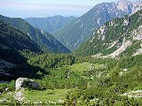
In Slovenia there are a lot of beautiful places. Some of them are really undamaged and some are in sorry plight. So I have decided to give you some information about our place in the Kamnik and Savinja Alps, which in my opinion could be protected as a National Park.
I think that it is a spectacular natural area with an interesting ethnologic history.
The Kamnik and Savinja Alps lie in the north of Slovenia and are at the end of Alps mountain rage. The area of the Kamnik Alps is 900km².
The landscape is full of different shapes and colours. There are also important hollows, waterfalls, rivers, stores of limpid water, a rich flora and animal world, rich ethnological and geologic history.
This world was hidden for centuries because of the impassability roads, it was it's own world with it's own culture.
The slopes are green and sheep breeding is still present. Because of sheep breeding in the past there are still thatched cottages with a rich collection of pastoral life. This is really special about these Alps. People there have special traditions, every year they have a sheep breeding festival at which they show other people how shepherds lived in past, they sell homemade cheese and wool and you can be also shepherd for three days.
There is also winter life. In winter there are a lot of ski slopes, the most known is Krvavec. There is also a Ski festival; everyone who comes there must ski with special old wooden skis. These skis were invented in the Kamnik-Savinja Alps. And we should protect them.
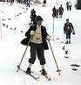
This is only a few of the important things there. All these things we should protect because they are piece of our history and our culture.
Many people there work in Celje (the nearest city) because in this area there are not enough jobs. But Celje is far away and it is very expensive for them. Most of them have a supplementary activity as sheep breeding, farms, fishing. I think that our country should do more for tourism there. People don’t know what they can do. There is a lot of possibility for good life.
I suggest that we protect this place because of the nature there. The water, forest and animal world there are almost undamaged.
But there are some problems:

- Every year there is more people and because the area is not protect and not well organised, tourists make a lot of damage
- People are leaving the area because there is no jobs
- The thatched cottages decay because young people are not interested in repairing them
- Slopes overgrow because is not so many sheep there anymore
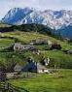
- No more farms because people there are to old
- Rich citizens are buying land there and they build a lot of weekend houses there
- New roads have damaged a lot of rocks walls

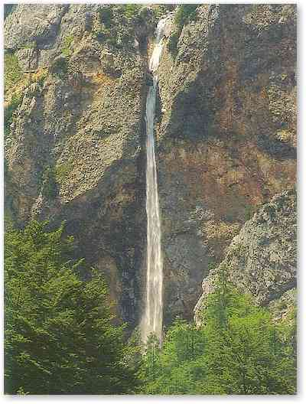
But luckily there are more good things, which can attract people:

- Unknown caves. There are a lot of caves, which are not very well researched and not damaged
- Waterfalls. The landscape is full of waterfalls which are really high. There are also small cascades suitable for rafting.
- Animal world. There are some special animals which are very rare and are attractive for visitors. Beavers, marmot, otter, black eagle, wild cat, snow owl…
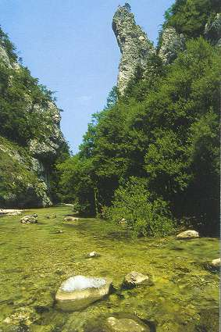
- Rocks walls there are really special. They are suitable for climbing because they have a lot of niches and are compact. The rocks seem spectacular.
- Forests. Almost the whole area is covered with forests which contain special types of trees. There is also the oldest tree in Slovenia
- Water. The water there comes out as steep mountain stream or as a spring. The water is clear so we can use it for selling.
- Fossils. The Kamnik-Savinja Alps have a rich geological history. In the past the Panonian sea covered this area. Animals like snails, sharks, fish are impressed in the rocks
- Pastoral traditions. Thatched cottages, Pastoral festivals, special pastoral clothes…

These are just examples of what are the good and bad things. The bad things are not so bad that we couldn’t repair them.
The intact nature should be protected and we should make it more popular for tourists.
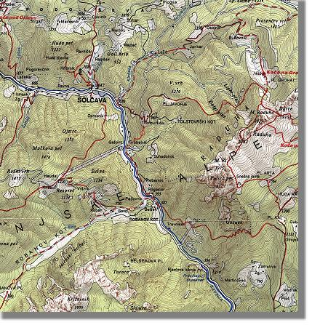
First the government should protect places where there are the tourists, so that they couldn’t destroy more nature.
If it would be a N.P. there would be more jobs, young people would be interested staying here.
People need special expert knowledge about farming in an area like this.
The government should oversee what people are building there and control where they building houses and in which style.
The roads there are bad but experts should find the less dangerous ways for nature and make new roads.
We should make new hotels and camps but accordant with nature so that our tourist could stay there longer.
We don’t need shops there because people would come to see nature not shops.
It would be good if there would be a lot of information notice boards. And there could be organised school natures days for children so that the children would be educated about nature.
The pastoral traditions should be more supported that young people will be interested.

There are a lot of possibilities to make this area attractive, because now is it very attractive.
We should just make this area friendlier to people who live there and people who go there.
There are a lot of things to do but all of them are very small. The government must make a National park here. It would have a lot of things to offer.
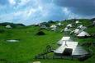
We will lose a lot if we don’t do anything for our beautiful area.

