The royal guards are groups of military [bodyguard](http://en.wikipedia.org/wiki/Bodyguard), soldiers or armed retainers responsible for the protection of a royal person. In this case the royal family:

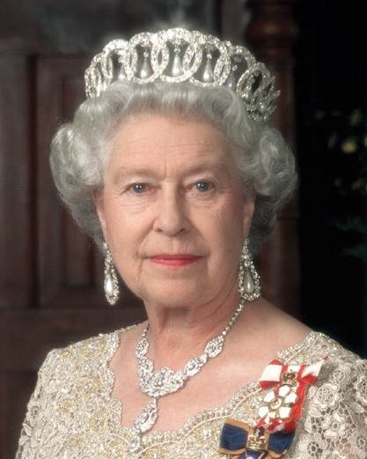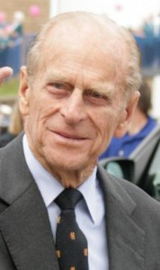

Queen Elizabeth II Prince Philip

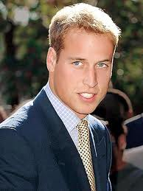

Prince William

The [Household Cavalry](http://www.woodlands-junior.kent.sch.uk/customs/questions/royal/lifeguards.htm) Regiment

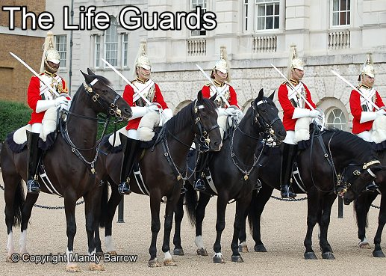

The life guards have a red tunic, white plume and a black collar. They are on horses.

The Blues and Royals have a blue tunic, red plume and a red coloured collar

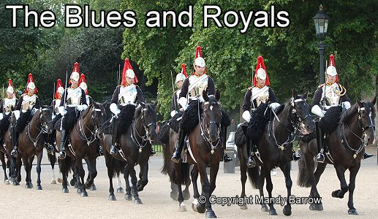

The foot guards look all very identical.

* + *The Grenadier Guards*-white plume, singly button spacing, collar badge –granade, shoulder badge-royal cypher

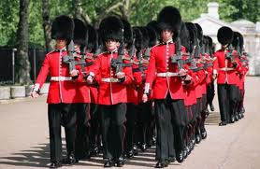

* + *The Coldstream Guards*-scarlet plume, pair button spacing, garter star collar badge, rose shoulder badge

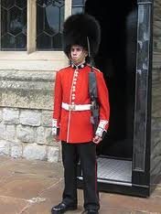

* + *The Scots Guards*-buttens in threes, thistle collar badge, thistle- shoulder badge.

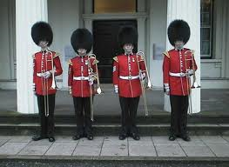

* + *The Irish Guards*-blue plume, fours buttons, shamrock collar badge, st Patrick star shoulder badge

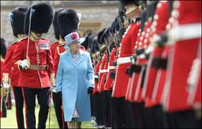

* + *The Welsh Guards*-White-green-white plume, fives-button spacing, leek collar badge, leek shoulder badge.

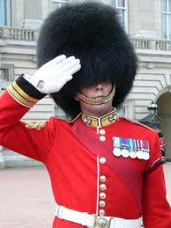

**Yeomen Warders are the colourfully-dressed bodyguards on duty at the** [Tower of London](http://www.woodlands-junior.kent.sch.uk/customs/questions/london/tower.htm)**.** They are best known for their scarlet and gold dress uniforms which date from 1552.

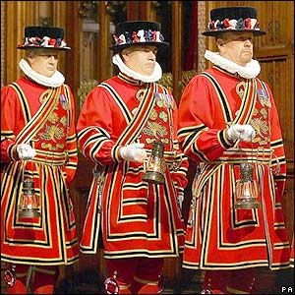

The Yeomen Warders are popularly known as the [**Beefeaters**](http://www.woodlands-junior.kent.sch.uk/customs/questions/Beefeaters.htm).