**MY COUNTRY SLOVENIA**

**Full country name:** Republic of Slovenia (Republika Slovenija)  
**Area:** 20,273 sq km  
**Population:** 1.93 million  
**Capital City:** Ljubljana (pop 330,000)  
**People:** Slovenian 88%, Croat 3%, Serb 2%   
**Language:** Slovenian, Croatian, Serbian, German, English  
**Religion:** Roman Catholic (72%), atheist (4.3%), Eastern Orthodox Christian (2.4%), Muslim (1%), Protestant (1%)  
**Government:** parliamentary democratic republic  
**Head of State:** President Janez Drnovsek  
**Head of Government:** Prime Minister Anton Rop

**GDP:** US$37.06 billion   
**GDP per capita:** US$19,200  
**Annual Growth:** 3.5%  
**Inflation:** 8%  
**Major Industries:** Textiles, manufacturing, timber products, agriculture  
**Major Trading Partners:** EU (esp. Germany, Croatia, Italy, France, Austria)  
**Member of EU:** Yes

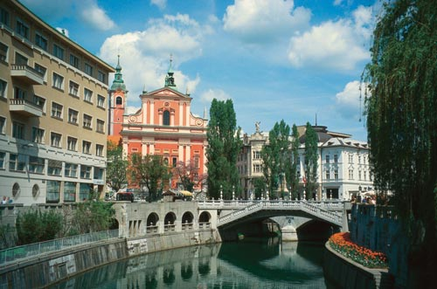

Ljubljana the capital city of Slovenia, Prešeren's square

**GREEN MEDITERRANEAN**  
The Slovene coast which measures 46.6 kilometres is covered with abundant vegetation. Here is a natural reserve with a rich supply of marl and sandstone and the unique Strunjan cliff which ascends 80 metres above the sea and is the highest flysch wall on the Adriatic coast. Here are the Sečovlje saltworks, first mentioned in the 13th century. Due to their extremely abundant natural and historical heritage they were named a regional park and are a rich sanctuary of plant and animal worlds.

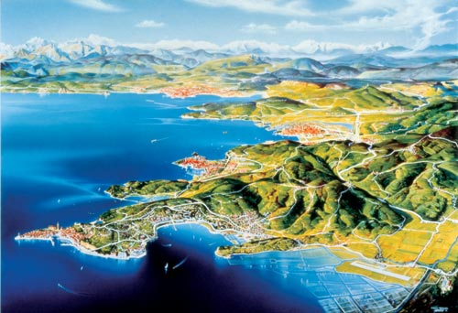

Map of Slovenian coast

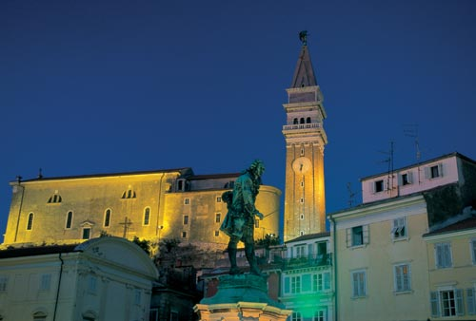

The Church above Piran

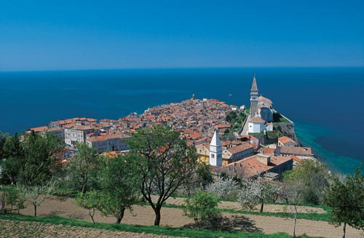

**Piran**

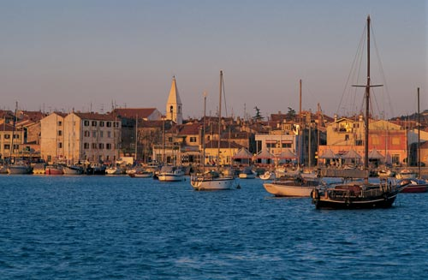

Izola with fishing boats

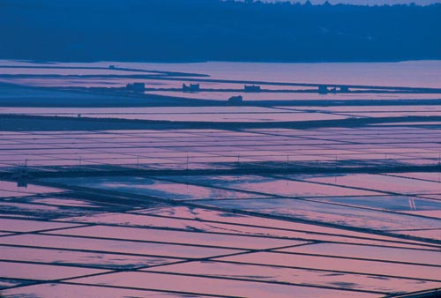

Sečovlje, salt pans and sunset

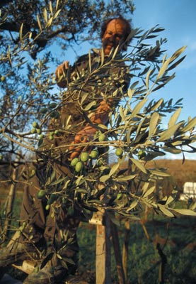

Olive picking

**Postojna Cave - A World Famous Miracle of Nature**   
The Postojna Cave is one of the largest and most easily accessible world caves where visitors are carried by electric train. Its stalactites, stalagmites, pillars, and translucent curtains constantly create unforgettable impressions, and the underground cave waters offer shelter to a unique resident, the amphibian **Proteus anguinus or human fish.**

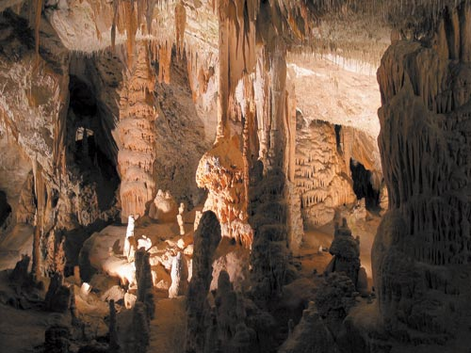

**Interior of the Postojna Cave**

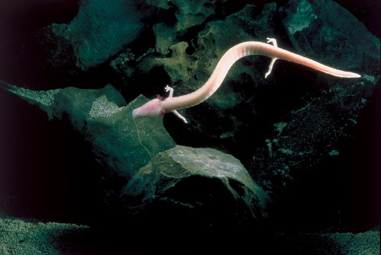

Proteus Anguinus, at the Postojna Cave

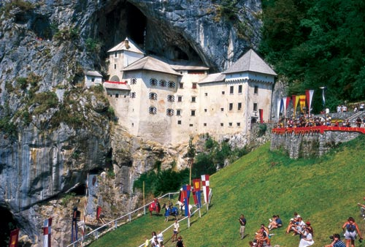

The Predjama Castle Medieval games

**Triglav National Park**   
The Triglav Nationasl Park measures 83,807 hectares and includes almost all the Slovene section of the Julian Alps, also known as the Eastern Julian Alps. Our first and so far only national park is named after Mount Triglav (2864 m), the symbol of Slovenia. The Triglav National Park is situated close to the junction of the three borders of Austria, Italy, and Slovenia and contains the most characteristic landscape elements typical of Slovenia. In addition to the alpine valleys, mountain ridges, and peaks of the Julian Alps, other distinctive natural assets in the park include high mountain lakes, Lake Bohinj, waterfalls, gorges, troughs, and high mountain karst phenomena. The remarkably rich and varied plant and animal world with its numerous endemic species deserves special attention as it reflects the interwoven contrasts between the cold alpine north and the gentle Mediterranean south. Various protection measures apply in the park area. Tourist centers: Bled, Bohinj, Bovec, Kranjska Gora, and others are located outside the park but very close to its borders.

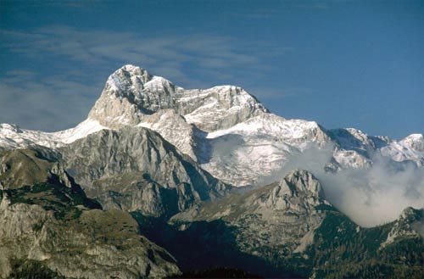

Mount Triglav 2874 m

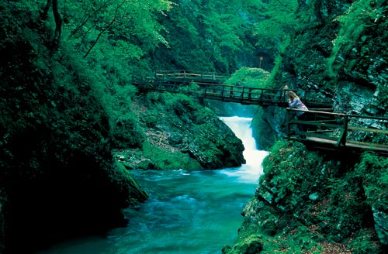

Bled Vintgar gorge

**Bled**   
Bled (501 m above sea level) is today considered one of the most beautiful alpine holiday resorts and health spas. Its beauty and peace, mild climate, fresh air, sun, and thermal water offer ideal conditions for a pleasant rest or for an active holiday, since its marvelous surroundings make possible relaxation and regeneration of lost psychophysical strength. During the long summer season, it is very pleasant to swim in the lake or in the hotel swimming pools with thermal water (28 degrees C.) and enjoy rowing, sailing, wind surfing, fishing in the lake or in alpine rivers, kayaking, canoeing, rafting and other activities. Amid beautiful surroundings you can play golf or tennis, ride horseback in nature, go mountaineering, fly a sailplane or hang-glider, and more.

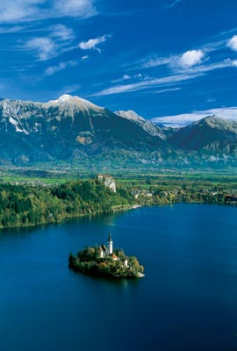

Bled, jewel of the Julian Alp

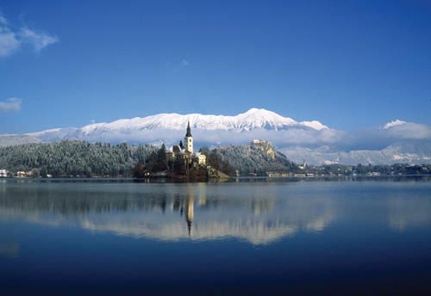

Lake Bled

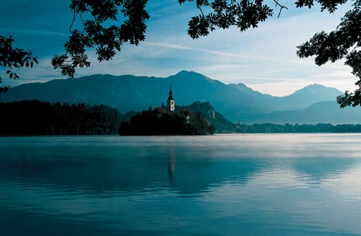

The Lake Bohinj

**SUNNY ALPS**The mighty but easily accessible Julian Alps, the tourist area in this attractive geographical area is linked by the offer of four developed tourist towns: Bled, Kranjska Gora, Bohinj and Bovec with the Soča Valley. Most of the area is within the Triglav National Park which measures 85 hectares and is one of the largest natural parks in Europe. The park lies in the vicinity of high stony mountains including Mount Triglav (2864 m); the highest mountain of Slovenia - and deep river gorges, highland karst potholes and friendly highlands.

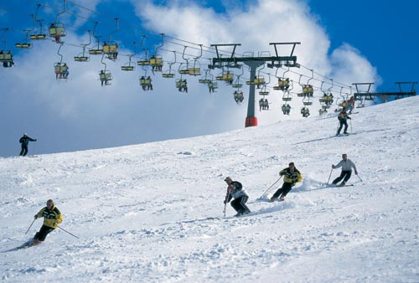

Krvavec ski slope

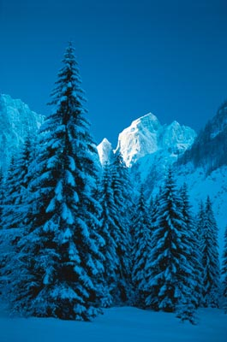

Jalovec from Tamar

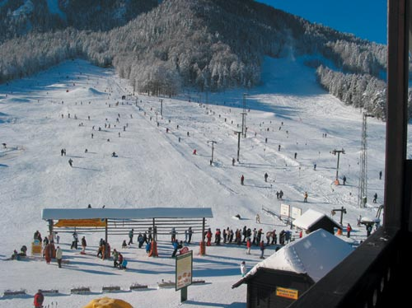

Kranjska Gora in winter time

|  |  |  |
| --- | --- | --- |
|  |  |  |

Rafting on the Soča river The Soča troughs

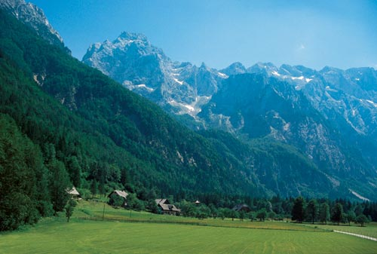

The Logarska Valley

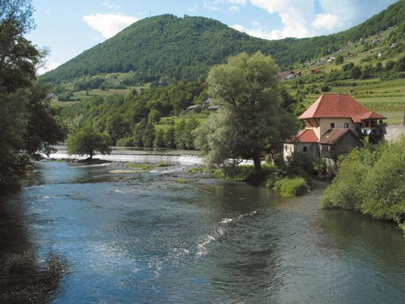

Mill on the Krka River

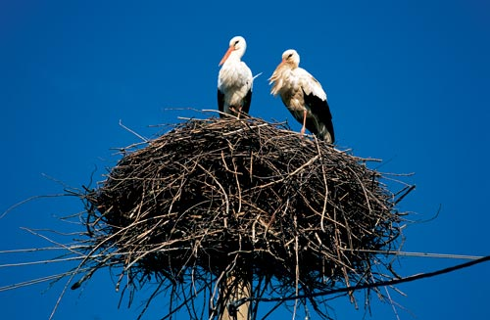

Storks in Pomurje

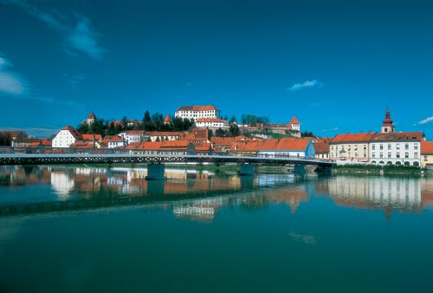

Ptuj and the Drava River

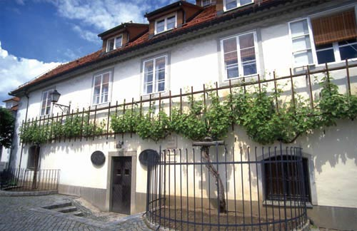

Maribor, over 400 years old grapevineat Lent

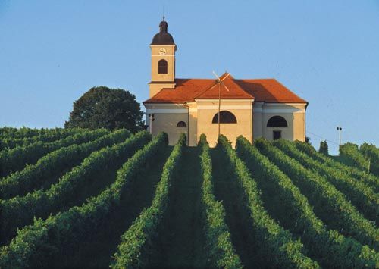

Kapela vinegrowing region

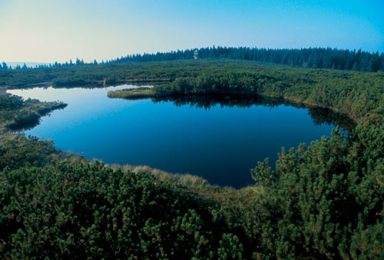

Pohorje, the Lovrenc lakes

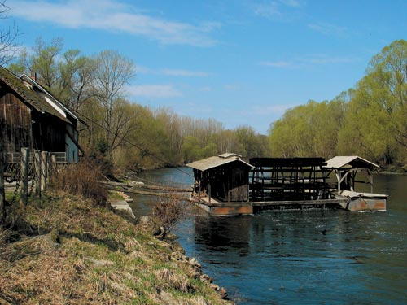

Mull on the Mura River

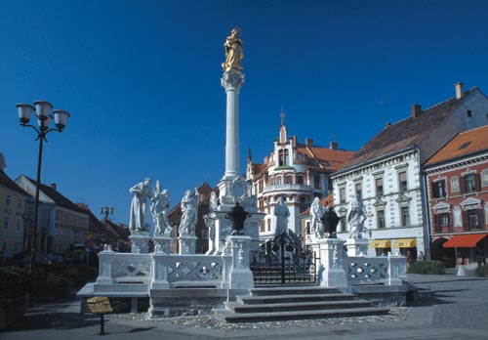

The Main square, Plaque Memorial