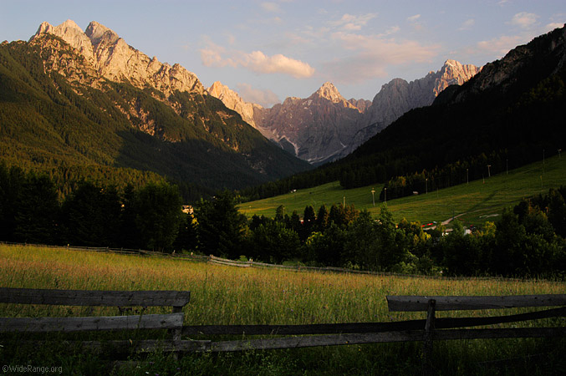

Slovenia is a country, where I live and I am proud to be Slovenian, so I decided to make a project about it. First, I am going to describe some general things.
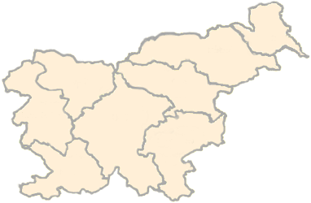
It covers the area of 20.000 square kilometers. It lies between four countries: Italy (west), Hungary ( north-east), Croatia (south) and Austria (north). The population is about 2,000,000 ( 90% of them are born in Slovenia). The capital of Slovenia is Ljubljana. It is a beautiful city. It is also the largest city in Slovenia
The city core was built by a very famous architect Jože Plečnik. He built Tromostovje, three bridges that are situated in the middle of Ljubljana, which passes the river Ljubljanica, who flows through this city.

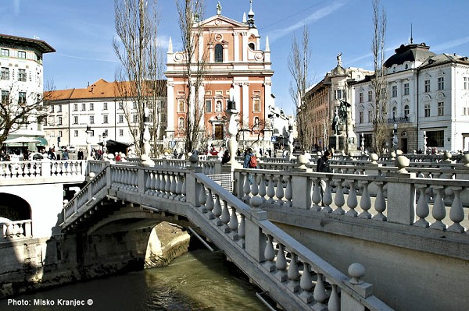

The state language is Slovenian. Its offical languages are Hungarian and Italian (and Slovenian of course) . The anthem of Sloveina is Zdravljica. The lyric was written by a well known poet France Prešeren (1800-1848). He wrote only one poetry book called Poezije. His artist works are very complicated and full of metaphoric meanings. We can find his portrait on 2€ coin.

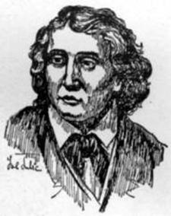
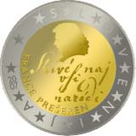

About sixty percent of the country's surface is covered by woods. The higest mountain in Slovenia is Triglav. It is 2864m high. There is Aljažev stolp at the top of the Triglav, which was built by a priest Jakob Aljaž, who bought a part of the mountain to pervert foreigners to take over Triglav.
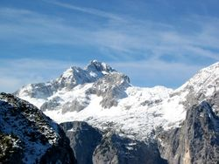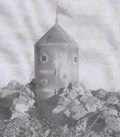

Lake Bled is the most beautiful lake. Not beacuse of its size, but because there is an island in the middle of it. There is a very old church on it.

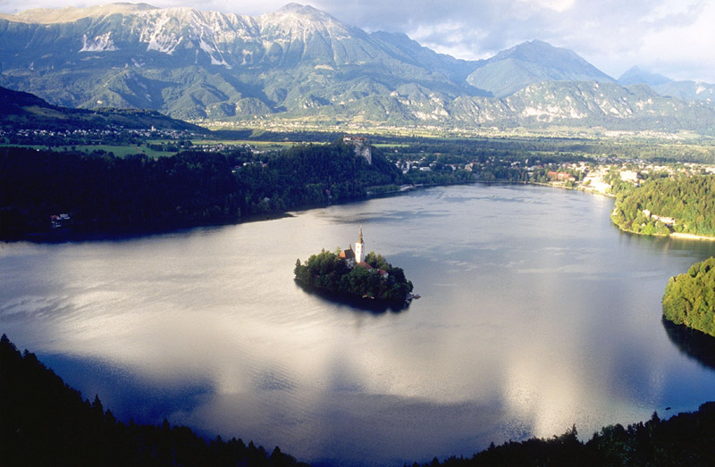

There is olso 46 km long coast line in Slovenia. There are two big tourist cities:
Koper and Portorož.
There is the biggest slovenian port in Koper.
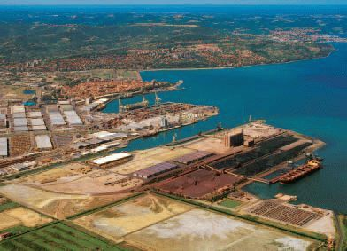

Portorož is one of the country's largest tourist areas. There is also a small international airport in nearby Sečovlje.

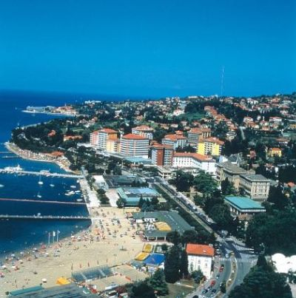

In the picture we can see a lot of tourists enjoying the beach.

Viri slik:
http://wiki.sc-nm.si/index.php/Glavna_stran
www.slovenia.info/intro/

