SLOVENIA IN 1959

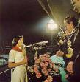
In 1959 Slovenia actually didn’t exist. We were united with south Slavonic countries in Yugoslavia: Croatia, Serbia, Montenegro and Albania. It was social regime and the president of the Yugoslavia was Mr. Josip Broz Tito. In that time he was really popular and also his wife Jouvanka Broz.
All big cities in Yugoslavia had to make a sport competition which famed Tito. The best sportsman were running relay in our case from Ljubljana to Beograde where was the final solemnity. Children or young people had to give a fire to the president Tito and the party started. This was special honor for everyone who handed over to him. On the Beograd’s stadium were around 30 thousand young people. Because this was competition for young people was named Štafeta mladosti, which means: Relay of Youth

The first thing of year 1959 which I can remember it is the birth date of my mother. She was born on 1st august 1959.
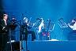
On 24 of August was born Gregor Strnišar Slovenian musician and composer. He had a band later in 70s named All capone štrajh tio and their the most popular song is Umirjeni trio. They were playing jazz music.

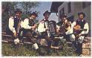
In 1959 were definitely the most popular group Avseniki. Avseniki were the folks bend. The main instrument was harmonica. They were singing about Slovenia, beautiful mountains, beautiful Slovenians girls… their most popular song is still Na Golici. They also made a career in Germany and they were really successful because Germans loved folks music.

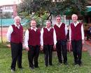
Also popular folks band were Beneški Fantje. Those were Slovenian boys but they lived in Italy. People like them because they lived in Italy but they were singing about Slovenia like their homeland.

On 1st November died Slovenian composer Milko Bizjak. He was working for Slovenian Music University. His best work is Smeh a short composition of modern songs for piano.
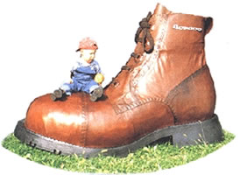
In Slovenia that was the time when people were listing Elves Presley and they were copying his style. This style was only in the cities but in village they were dressing simple clothes which were homemade. Especially popular were the shoes Borovo. Those were extra strong shoes which were made in Slovenia. All girls and all boys were shoed them.
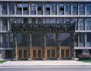

1959 was a big step for Slovenian democracy. In the capital city of Slovenia in Ljubljana was built a new parliament. Figures in the front doors made sculptors Karel Putrih and Zdenko Kalin. Inside the parliament are the famous frescos of Ivana Kobilica. This parliament was only one of the parliaments in ex Yugoslavia but today is an important institution for Slovenian people.

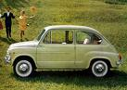
In that time was probably the most popular car in Slovenia Fičko but the really name is actually Fiat 750. This car was the best sailed car in the Yugoslavia. They made also animated cartoon about it. Today we can see this car only in museums and maybe in grand mother’s garage.

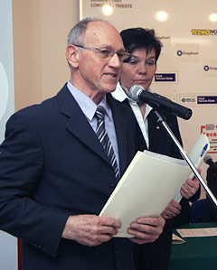
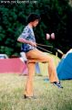
The most successful sportsman was Miro Cerar. He was the best in our country on gymnastic. He made exercises on parallel bars. But in 1963 he immediately finished his career and became a famous layer.

This was also the time when the telephones were only on the post. People were sending telegrams and letters.
There were also first TVs and we had already Slovenian films.

- Pet minut raja is a Bosnian film of Slovenian directors.
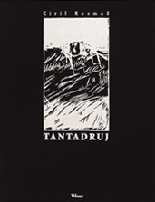
- Tri četrtine sonca is film about people that were coming back from the prison.
Novel
- Ciril Kosmač - Tantadruj
Tatadruj is really famous story about a little boy who was homeless and he was mad. He heard in the church that people can be happy only in heavens. He believed in this theory and he wanted to die. He was waiting for death but on the funny way…. This story made a big impression on people. It was also translated to foreign languages like German.

