PROJECT

Describe teenage life in your country. Page 23!
---------------------------------------------------------
1. Write a questionnarie. Here are some things to ask about.

• How do you spend your time?
• Do you do a par- time job?
• What do you like / dislike about your life?
• What things do you worry about?

2. Interview some teenagers about their lives. Make an audio or video recording of your interviws.

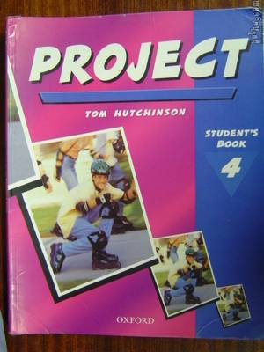

1.

• I spend most of my time with my computer and with inline skating. Also i like weight training and cycling. I like to spend much time with my friends, too.

• No i dont do the part-time job, but i would if i have a chance. In our country teenagers dont do the part-time jobs.

• I like about my life that i have good friends and my skates. I dont like that we havent got a part-time jobs in our country.

• I worry about my school scores, bicycle and skates.

2.

Me: How do you spend your time?
Andrej: With basketball, my friends and computer.
Me: Would you do a part-time job if you have a chance?
Andrej: Yes, I would.
Me: What do you like and what do you dislike in your life?
Andrej: I dont like school very much. I like that im from Ukraine.

Me: How do you spend your time?
Nejc: No comment.
Me: Would you do a part-time job?
Nejc: I said no comment. Get lost.

