TRIGLAV NATIONAL PARK
SLOVENIA
EUROPE

- 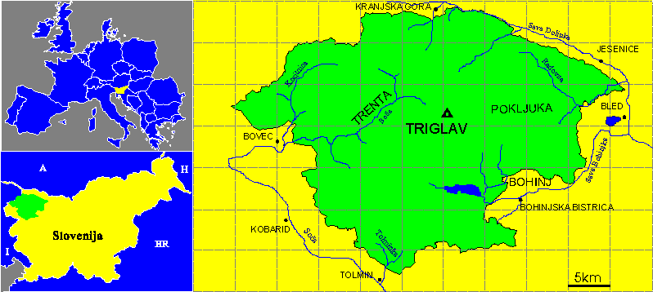Area: 83.807 ha
- The highest point: 2864m (Triglav) (highest mountain in Slovenia)
- The lowest point: 180m (River Tolminka)
- Idea: 1908
- Established: 1924
- Renewed: 1961
- Enlarged: 1981
TRIGLAV NATIONAL PARK
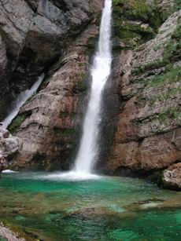The first proposal for conservation dates from the year 1908, and was realised in 1924. Then, on the initiative taken by the Nature Protection Section of the Museological Society of Slovenia together with the Slovene Alpine Society, a twenty year lease was taken out on the Triglav Lakes Valley area, some 1400 hectares: It was destined to become an "Alpine Protection Park", however permanent conservation was not possible, in 1961, after many years of effort, the protection was renewed this time on a permanent bases and somewhat enlarged, embracing some 2000 hectares. The protected area was officially designated as "The Triglav National Park". Under this act, however, all objectives of a true national park were not attained and for this reason over the next two decades, new proposals for the extension and rearrangement of the protection were put forward. Finally, in 1981, a rearrangement was achieved and the park was given a new concept and enlarged to 838 square kilometres the area which it continues to cover to this day. The park is named after Triglav (2864m), symbol of the Slovenia, which is situated almost in the middle of the protected territory. From it the valleys spread out radial, supplying water to two large river Systems which have their sources in the Julian Alps: the Soča river and the Sava river flowing to the Adriatic and Black Sea respectively.
With the exeption of the Lake Bled all of Slovenia's glacial lakes lie within the Triglav National Park, from the Lake Bohinj, the largest one, to the groups of ponds known as the Triglavska jezera (the Triglav Lakes), Kriska jezera (the Kriz Lakes), and Krnska jezera (the Krn Lakes) all situated high in the mountains. Among the park's water phenomena attention should be paid to its picturesque waterfalls: the Savica in the Bohinj Area; the two Pericnik waterfalls in the Vrata valley; the Sum waterfall in the Vintgar ravine; the Skocniki waterfalls in Beli Potok, the two in Martuljek and Nadiža waterfall in the Tamar valley. Some rivers have sections which have cut deep gorges with sheer rock faces. Such gorges or ravines can be found in the Soca river basin, in the Trenta valley, along the Koritnica near Kluze and at the confluence of the Soca and the Zadlascica rivers. On the Radovna river there is the well known Vintgar ravine near Bled as well as the Mostnica ravine in the Bohinj area. (waterfall Savica)
Limestones predominate in the Park. Notwithstanding its considerable fossil uniformity, the Julian Alps are still very diversified. In addition to the famous peak of Triglav,
- The most picturesque peaks and mountain groupings within the Park are: Jalovec (2645m)
- Mangart (2679)
- Prisojnik (2547m)
- Razor (2601m),
- Skrlatica (2738m)
- Martuljek Group with Spik (2472m)
- Kanjavec (2568m) and Spičje (2398m)
- Krn (2244m)

The relief of the Julian Alps in very dissected, there are steep and deeply cut valleys, their slopes having been smoothed down by glaciers and the bottoms are flat and enlarged or covered with the sediments originating from glacial and postglacial periods.
The attention of European botanist, visiting the Julian Alps at the end of the 18th century, was attracted by its rich flora and found new indigenous species there. The flora in the park area is for the most part alpine but due to its marginal situation and vicinity to the Mediterranean region an intertwingig with the neighbouring floral regions-occurs. The grassland of Crna prst, the slopes of Krn, Rdeci rob and of Mangart are well-known for their rich flora.
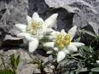Most known Indigenous flora species:
- Triglav edelweiss
- Vodne bolhe
- Velikonočnice
Similar findings as those for the flora can be claimed for the Park's fauna. There are richly represented and there are many indigenous species.
Especially well known are:
- 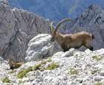the golden eagle,
- the capercailzies
- the black grouse
- special game, most numerous are species of chamois
- In recent decades some alien and other species which long ago become extinct in this parts such as the ibex, the marmot and the mufflon have been reintroduced into the Park. (ibex)
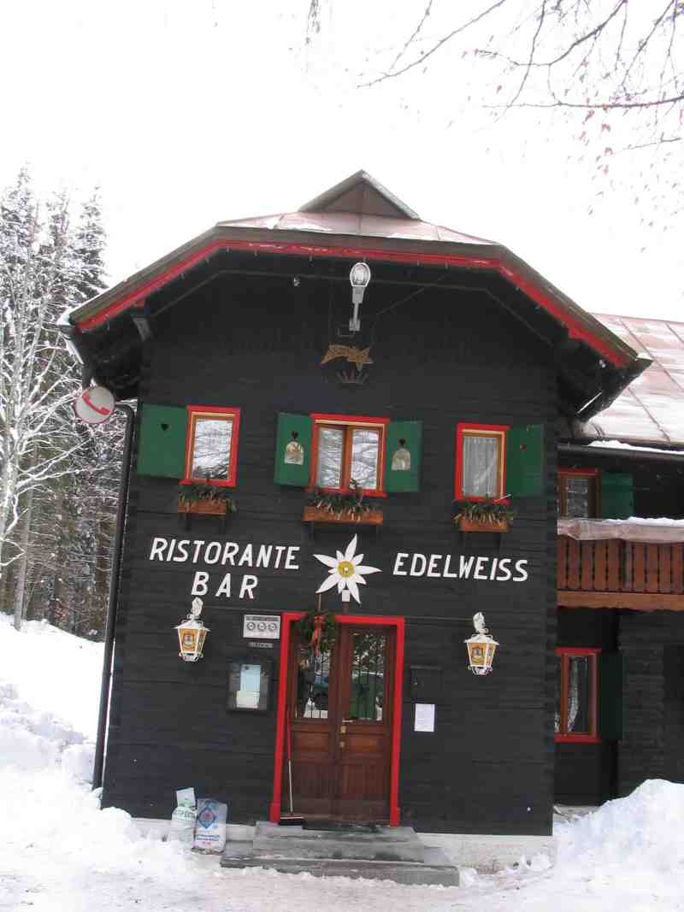A characteristic feature of the Slovene Alps was development of mountaineering. It is one of the oldest and most popular activities in the country which led to the foundation of the famous Slovene Alpine Society. This Society played a special role in the awakening of the Slovene national consciousness during the period of Austro-Hungarian rule. The interest taken mountaineering in the Slovene Alps went parallel with that taken of the Central Alps. In 1778 four local men from Bohinj were successful in making the first ascent of Triglav. The first mountain huts within the Park area were built at the end of the last century and rapidly spread after 1893 when the Slovene Alpine Society was founded. Today, the whole of the Julian Alps are traversed by the uniformly marked alpine paths. These range from those for horses to those marked on the rocks for walkers and mountaineers. Within the Park area the Alpine Association of Slovenia runs 32 alpine houses and huts.

