Primož Trubar

Place and date of birth: 8th June 1508, Raščica.
Place and date of death: 29th June 1586, Derendingen, Germany.

Primož Trubar was a Slovenian Protestant reformer, the founder and the first member of the Protestant Church of Slovenia. He was the author of the first printed book in Slovenian. He went to school in Rijeka in Croatia and continued his education in Salzburg. From there he went to Trieste to a bishop called Pietro Bonomo to teach him about humanist writers. When he returned to Ljubljana he became a priest but was soon expelled. His first two books were Catechismus and Abecedarium which were written in Slovenian. In the next few years he was the author of around 25 books, all written in Slovenian. Trubar died in Derendingen, Germany (now part of the city of Tübingen), where he is also buried.
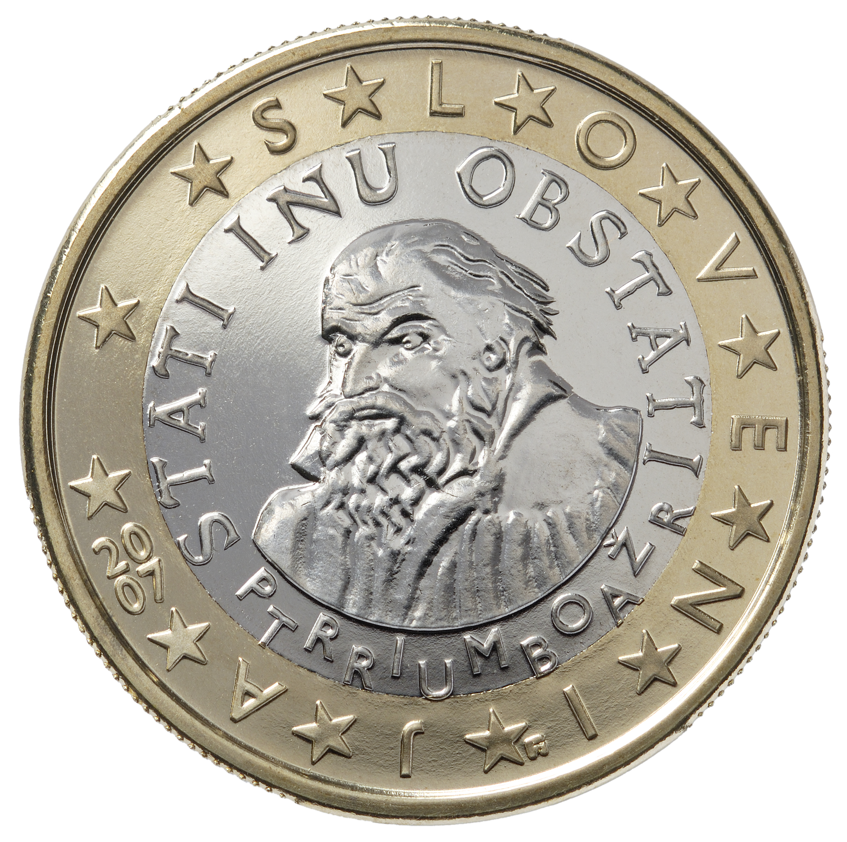
Primož Trubar on the Slovenian euro.
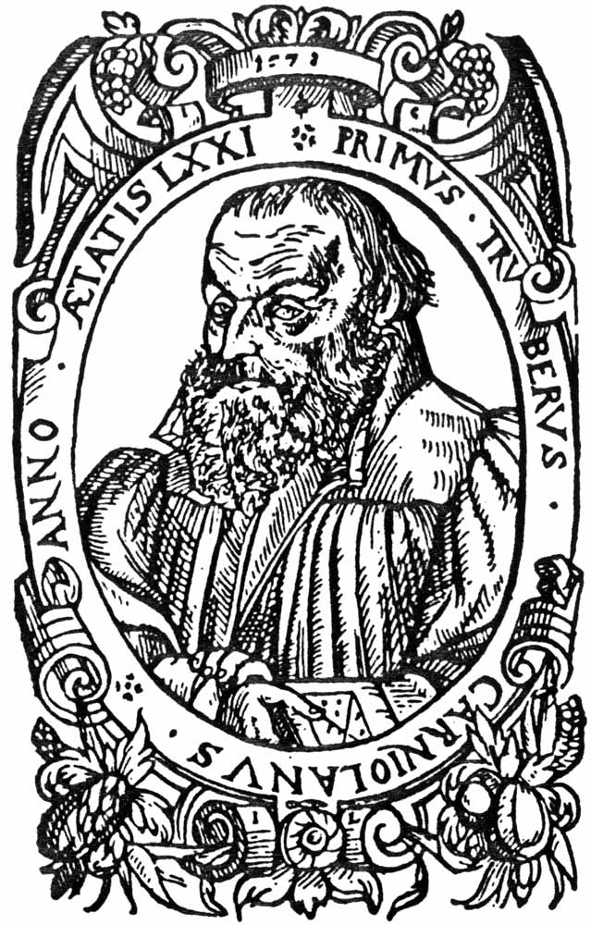
Primož Trubar.

