UNION OLIMPIJA

In Slovenia, basketball is synonymous with the name **Olimpija.** The basketball club, today known as **Union Olimpija,** was founded in 1946 as a part of the sports association Svoboda. Its first match played against Udarnik in the same year was won by the score 37:14. At the end of the year 1946, the club changed its name to Enotnost, the name being kept until 1954, when currently the best Slovenian sports club again changed its name to **AŠK OLIMPIJA**. Later on, various sponsors associated with the club added their names to the basic name Olimpija. Thus in the period between 1977 to 1978 the club's full name was **Brest Olimpija,** from 1979 to 1982 it was **Iskra Olimpija**, in 1984 season and from 1986 to 1996 the name was Smelt Olimpija and since 1997 until the present, the name **UNION OLIMPIJA** has not been

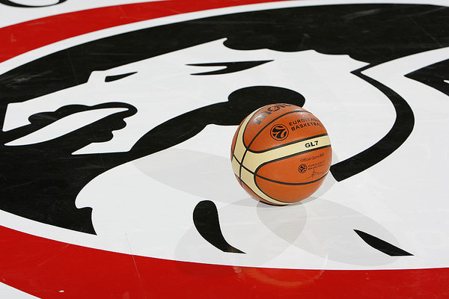

changed.   
  
The very first matches were played in **Tabor arena.** From 1951 onwards, they carried on playing on the famous sand court among lime and chestnut trees beneath the palace of Cekinov Grad. In 1954 court was covered with asphalt and in 1962 players moved to the court adjacent to the Cekin castle. On this site, the Tivoli arena was built in 1963, which, later, in 1970, hosted the **World Basketball Championship.**In 1957, Olimpija won its first Yugoslav National Championship title. The following players played for Olimpija at that time: **Janez Bajc, Primož Brišnik, Ivo Daneu, Bogo Debevc, Matija Dermastja, Igor Jelnikar, Marjan Kandus, Peter Kralj, Boris Kristančič, Jože Lampič, Miha Lokar, Rudi Pertot, Jože Podboj, Sašo Poljšak, Janez Škrjanc and Stane Fugina** was technical director. From its first Championship title up until 1991, when Slovenia gained its independence, Olimpija won five more Yugoslav National Championship titles (in 1959, 1961, 1962, 1966 and 1970).   
  
Throughout its history, the club produced many outstanding players who took part in the Olympic Games, World and European championships where as many as twelve Olimpija's players won the medals: **Ivo Daneu (8), Vinko Jelovac (8) Jurij Zdovc (4), Peter Vilfan (4), Aljoša Žorga (3), Vital Eiselt (3), Borut Bassin (3), Tine Logar (1), Miha Lokar (1), Jože Papič (1), Radosav Čurčič(1) and Marjan Kandus (1).**With the declaration of independence of Slovenia, a new era began for the club. High quality basketball environment of Ex-Yugoslavia was lost and therefore had to be replaced with European basketball region. Club reorganized itself into a modern production center. The player's search region has expanded to Eastern Europe and also Africa. Radovan Lorbek and Zmago Sagadin defined the new strategy. Permanent selection or search for talented players, their training and consequent push in the foreground of the first team, as well as permanent club presence among the top European clubs, became strategic objectives of the club. The results of the new organization are exhibited through exceptional achievements of the club in the past decade (twelve times National Champions, twelve times Cup Champions, European Cup Champions in 1994, 3rd place in the Final Four tournament in 1997, twice the club qualified among top eight teams in Europe and twice among top sixteen teams in Europe, and twice they were champions of the SBA).  
The product of Olimpija's top level basketball training methods of the past decade are various top-level players, who today play or have played in various European clubs (**Bečirović, Golemac, Gorenc, Maravić, Jurak, Ilievski, Jasikevičius, Jeklin, Jurković, McDonald, Milič, Tušek, Hukić, Ilievski, Zagorac brothers, Boisa, Baždarić** ...) and have played or are still playing in the NBA (Brezec, Ćurčić, Milić, Nachbar, Nesterović, Udrih, Soumalia, Stepania, Welsh, Jasikevičius).  
  
During the Yugoslavia championships Olimpija participated in 42 championships. The total score is: 479 victories, 353 defeats and 10 matches resulted in a draw. Dragons scored 70.466 points and received 66.503 points.

IVO DANEU

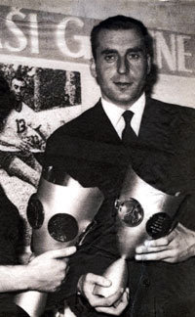

VINKO JELOVAC

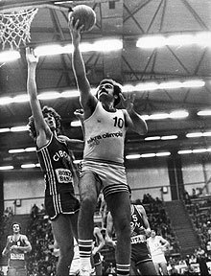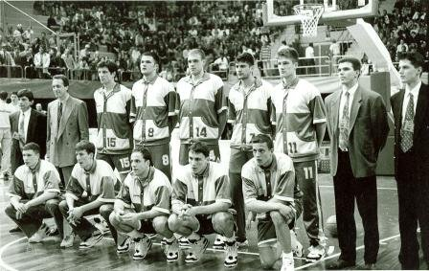

European Cup winners 1994

PETER VILFAN

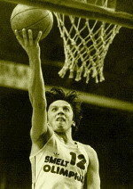

JURE ZDOVC

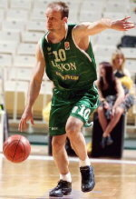

LEGENDARY DUNK, MARKO MILIČ

