WAGONTRAINS

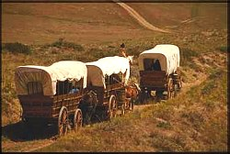

Page One

....By the 1830's, the migration had already pushed the frontier to the Mississippi Valley. Explorers, missionaries and traders who had gone farther west told of great forests and fertile valleys in the Oregon region and lands west of the Rocky Mountains. This was exciting news for many midwestern settlers and in the 1840's, some chose to go to Oregon in search of more opportunities. From the 1840's to the 1860's, more than 300,000 people crossed the plains and the mountains of the West. From 1835 to 1855, more than 10,000 people died on the Oregon Trail usually from firearms accidents and such diseases as cholera and smallpox. Indian attacks accounted for only 4 percent of the deaths.

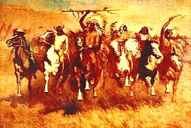

....One of the wagons used by American pioneers, was invented by the Pennsylvania Dutch and called the CONESTOGA WAGON. The wagon was named for the Conestoga Valley in Pennsylvania, where it was first built during the early 1700's. Conestoga wagons carried most of the freight and people that moved westward over the Allegheny Mountains from the 1770's until about 1850. These wagons were sometimes called the camels of the prairies. Both ends of the wagon were built higher than the middle. A high, rounded, white canvas roof could be put on the vehicle, making it a covered wagon. Wheels with broad rims prevented bogging down in mud. The wheels could be removed and the wagon could be used as a boat. Conestoga wagons were drawn by teams of from four to six horses.

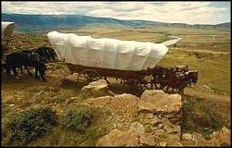

....The other wagon used by the American pioneers resembled the Conestoga but was smaller and sleeker. It was called a prairie schooner because, from a distance, its white top looked like the sails of a ship. The prairie schooner (covered wagon), was first built by the German farmers of Pennsylvania.

....On the long trip, sometimes as many as 200 wagons would join together to form a caravan called a wagon train. More common though was trains of 30 or fewer wagons.

....For a family going from Independence to Oregon or California in the 1840's, it would take about four to six months. They had to bring enough supplies for the trip because there were few places where they could buy goods along the way. Some of the travellers would trade items like food, clothing, and firearms among themselves or purchased them from one another.