**WELCOME TO DOB**

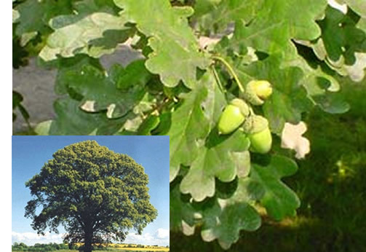

My name is Marusa and I live in Dob. It is in the central part of Slovenia, on the River Rača, and it’s a great place to live. People here are very friendly and generous. In the nineteenth century, here grew oak trees called dob.

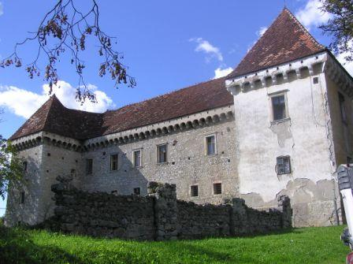

Today the population is 1600 inhabitants. Dob is known for football. There is the football team Dob. In Dob we have a lot of famous persons. One of them is a writer Tatjana Kokalj. Visitors can go to the castle Krumperk and see medieval building. The castle is in a poor state and needs to be repaired.

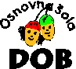

Near the castle there is the Jamarski dom and two karst caves, the Iron cave and Snow Cave. In Dob there is a Primary school, a shop Tuš, a post office, a block, a church, a theatre Močilnik, two pizza restaurants, bars, a fire station, a sport park and more.

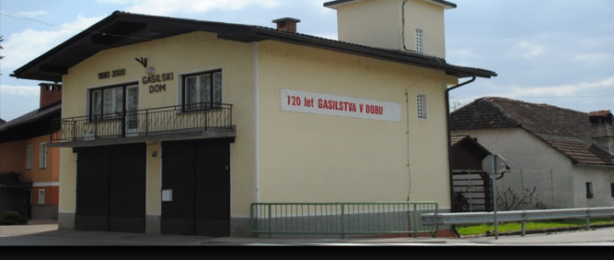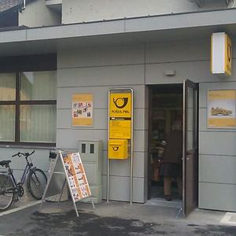

At the weekend I like to spend my free time in nature near the theatre Močilnik. I can say Dob is wonderful place to live and I am satisfied that I live in Dob.