OŠ DRAGOTINA KETTEJA
ILIRSKA BISTRICA

Project about an important event in the history of my country

WORLD CUP 2002

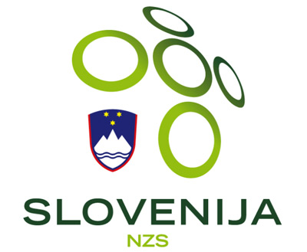

After independence in 1991 Slovenia wasn't so successful in football. Between 1991 and 2000 we were in one qualifiers for FIFA World Cup. That was between 1996 and 1998.

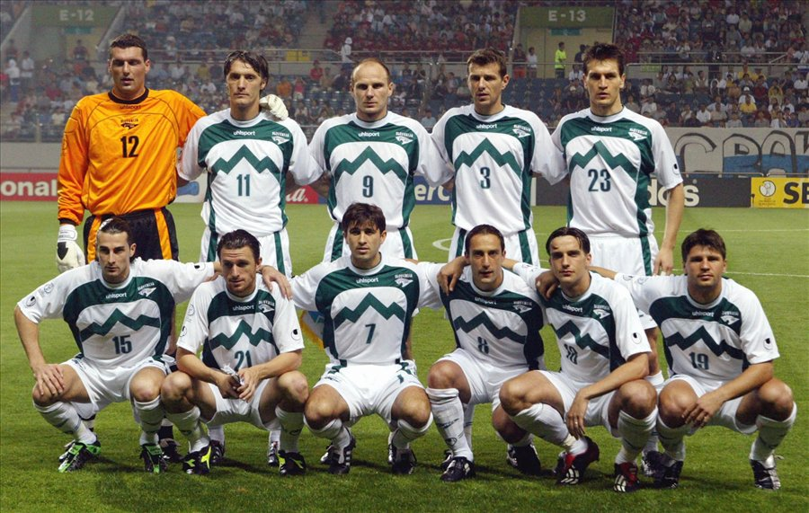
Slovenian football fairytale was (as we call sucess) start in qualifiers for FIFA World Cup 2002. We were in Group 1 and we were the only team, which doesn't lose. Anyway we were 2nd in the group so we must went to additional qualifiers, where our opponent was Romania.

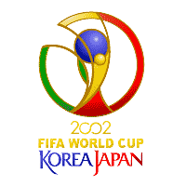
First match at home we won with result 2:1. Goals were scored by Milenko Ačimovič and Milan Osterc. In the second match result were 1:1. The only goal for Slovenia was scored by Mladen Rudonja. That was also his first and the last goal for Slovenia. After this win on 14th November we went to FIFA World Cup 2002. That was very important because that was the first time we went to FIFA World Cup after we became independence.

But on FIFA World Cup 2002 in South Korea and Japan we weren't played so well as in qualifiers. We lost all three matches. We scored only two goals. At finish we were ranked at 27th place. However, it was a great succes for our country.
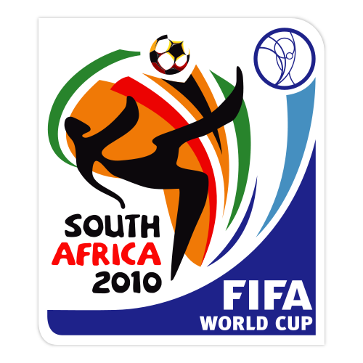
We didn't go to FIFA World Cup 2006, but we went to FIFA World Cup 2010, where we were better. Now we are ranked on 18. place.

At the moment we play in UEFA Euro Qualifiers 2012. And we will see if the Slovenian fairytale continued…



