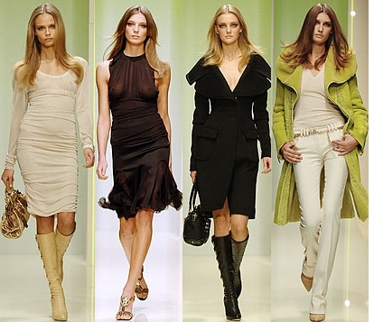

BRIEF SUMMARY

Many young girls start to model when they are only fifteen years old or even younger. That's why many of them are unprepared for the lifestyle of top models and the pressures that they face. Girls, who start modeling in a very young age are not enought emotionally developed, they don't know how to hendle the stressful life. Teenage models may also lose some of their childhood and their education. They haven't got time for school and homework, theat's why a lot of them never finishes their education. Models ofen have prblems with drugs. They are too young and many of them think that that is just the way things are. Young models also party a lot, because famous and exclusive nightclubs and restaurants love the publicity that beautiful young models attract, and so they continue to give them free entery and drinks. One of the youngest models in the world, Rachel Kitty was only 12 years old when she was spotted by a model agency. She was lucky, because her parents accompanied her on every job. They were looking after her, so that she managed to finish her schooling and didn't have poblems with drugs. Rachel shows that it is possible to combine an adult lifestyle with the experiance of a teenager. Sadly many have failed in that.

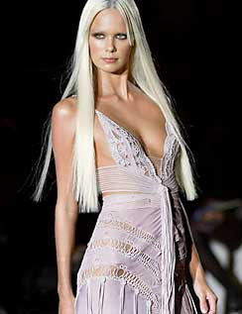

MY OPPINION

I think that too many girls start to model when they are too young. There should be a required age, when they should be allowed to start modeling. On one hand I can understand all the girls - why wear borring school uniforms when they could have a full closeth of designer dresses and meet some of the most famous designers in the world. Every girl wants to look like a model. But on the other hand, young girls see only positive things in modeling. Whan you start to model in a very young age you lose some of your childhood. Teenage models are not experiance enough,thats why they party a lot, drop out of school and take drugs. It is one of their most difficult decisions they have to make in their lives and in that case it is good, when you have a family behind you on who you can relie on.



UNKNOWN WORDS

|  |  |  |
| --- | --- | --- |
| **TO BE THROWN IN AT THE DEEP END** | To be put in a situation you have not experiance of | Doživeti nekaj novega |
| **PRESSURES** | Difficult conditions | Pritiskanje, pritisk |
| **PRE-PUBESCENT** | Before sexual developement of the body | doraščajoč |
| **JET SET** | Rich and fashionable | Bogato in modno |
| **EATING DISORDER** | Diseases such as anorexia and bulimia where the person is obsessed with losing waight | Motnje prehranjevenja |
| **TO TURN A BLIND EYE** | To ignore something that you know is bad or wrong | Ignorirati nekaj zanalašč |
| **TO BE SPOTTED** | To be discovered | Biti opazen |
| **TO ACCOMPANY** | To go with someone to look after him | Spremljati |
| **CATWALK** | A long thin stage which allowes models to walk into the audience | Modna steza |
| **TO REHABILITATE** | To help someone to go back to normal life after physical or mental problems | Rehabilitirati |
| **WAIF** | A homeless and starving child | Zapuščena oseba, zlasti otrok |
| **VOLUPTUOUS** | A shapely and full figure | Polten, čuten, nasladen |

