ANGLEŠČINA 1. LETNIK:

ČASI:
PRESENT SIMPLE
habits and routines
facts
generalisations
state verbs (no ing form)
adverbs of frecuancy

PRESENT CONTINUOUS
happening now
temporary situations
changing situations
- arranged meatings (for future)
now
these days
at the moment

PRESENT PERFECT SIMPLE
single completed action
time not importatnt – EXPERIANCES
unstated time reference

PRESENT PERFECT CONTINUOUS
začel v pret., še zmerom traja
pojasnjuje stanje

PAST SIMPLE
completed/ spec. action in the past
no conection to the present
čas dej. določen
stated or implied time reference

PAST CONTINUOUS
dalj časa v pret.

PAST PERFECT SIMPLE
had finished before
completed action

PAST PERFECT CONTINUOUS
duration continuing up to a spec. time in the past (2002-2008)
pojasnjuje stanje v preteklosti

WILL FUTURE
decisions, offers
after verbs: think, believe, assume, am sure

GOING TO FUTURE
plan, prediction with evidence, decisions made before the moment of speaking

USED TO VS WOULD:
USED TO
describes past habits , usually in contrast with the present
e.g.: I used to get up at six but now I get up at eight.
describes also past states
e.g.: I used to live in Australia
=single action

WOULD
is used to describe a person’s typical activities in the past. It can be used only to describe repeated actions and is mainly used in writing.
e.g.: Every morning was the same. Jack would turn on the radio, light his
pipe and fall asleep.
=repeated action

IF CLAUSES:
- if + present simple, + present simple (personal truths, general/natural thruths)
- if + present simple, + will future/ modal + inf
- if + past simple, + would + inf
- if + past perfect, + would + have + past participle

impossible conditional: If i were you, I wouldn't do that.
possible conditional: If I miss the bus, I will be late.

MODALS:
must
should = ought to
can = able to
may, might

JEBENI GLAGOLI:
- LIE - LIED - LIED - LYING - lagati PRAVILEN!!!
- LIE - LAY - LAIN - LYING - ležati NEPRAVILEN!!!
- LAY - LAID - LAID - LAYING - položiti NEPRAVILEN!!!

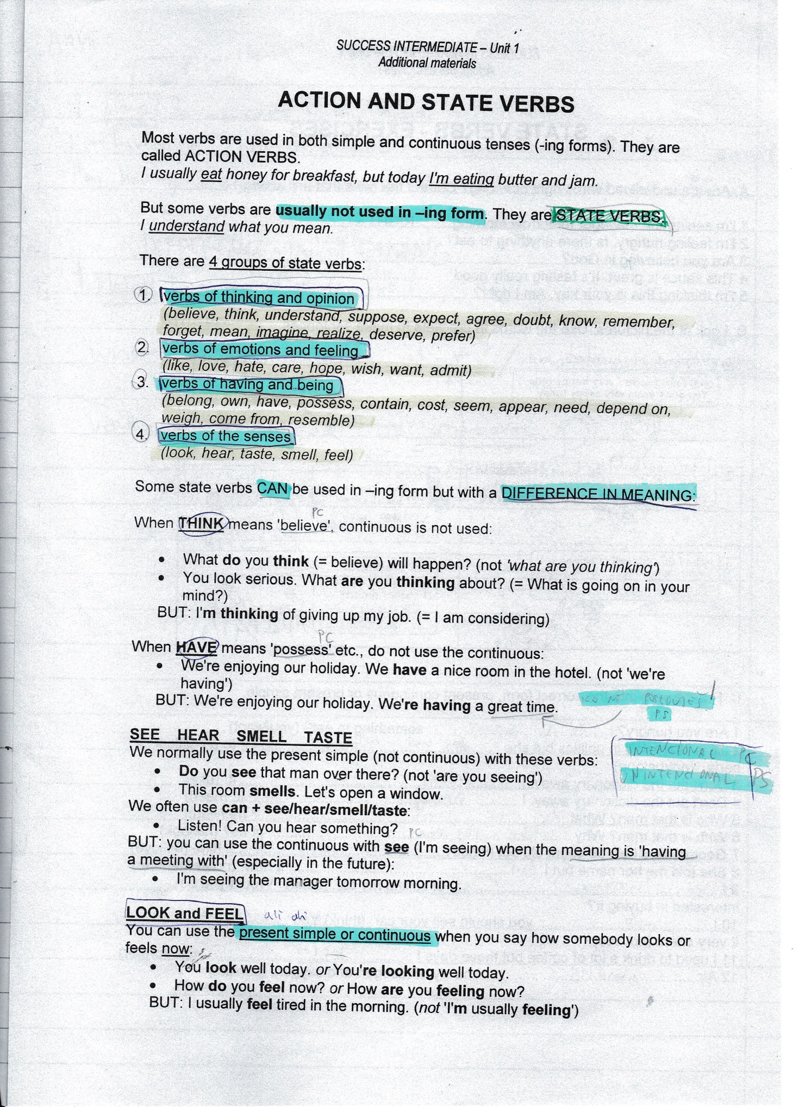
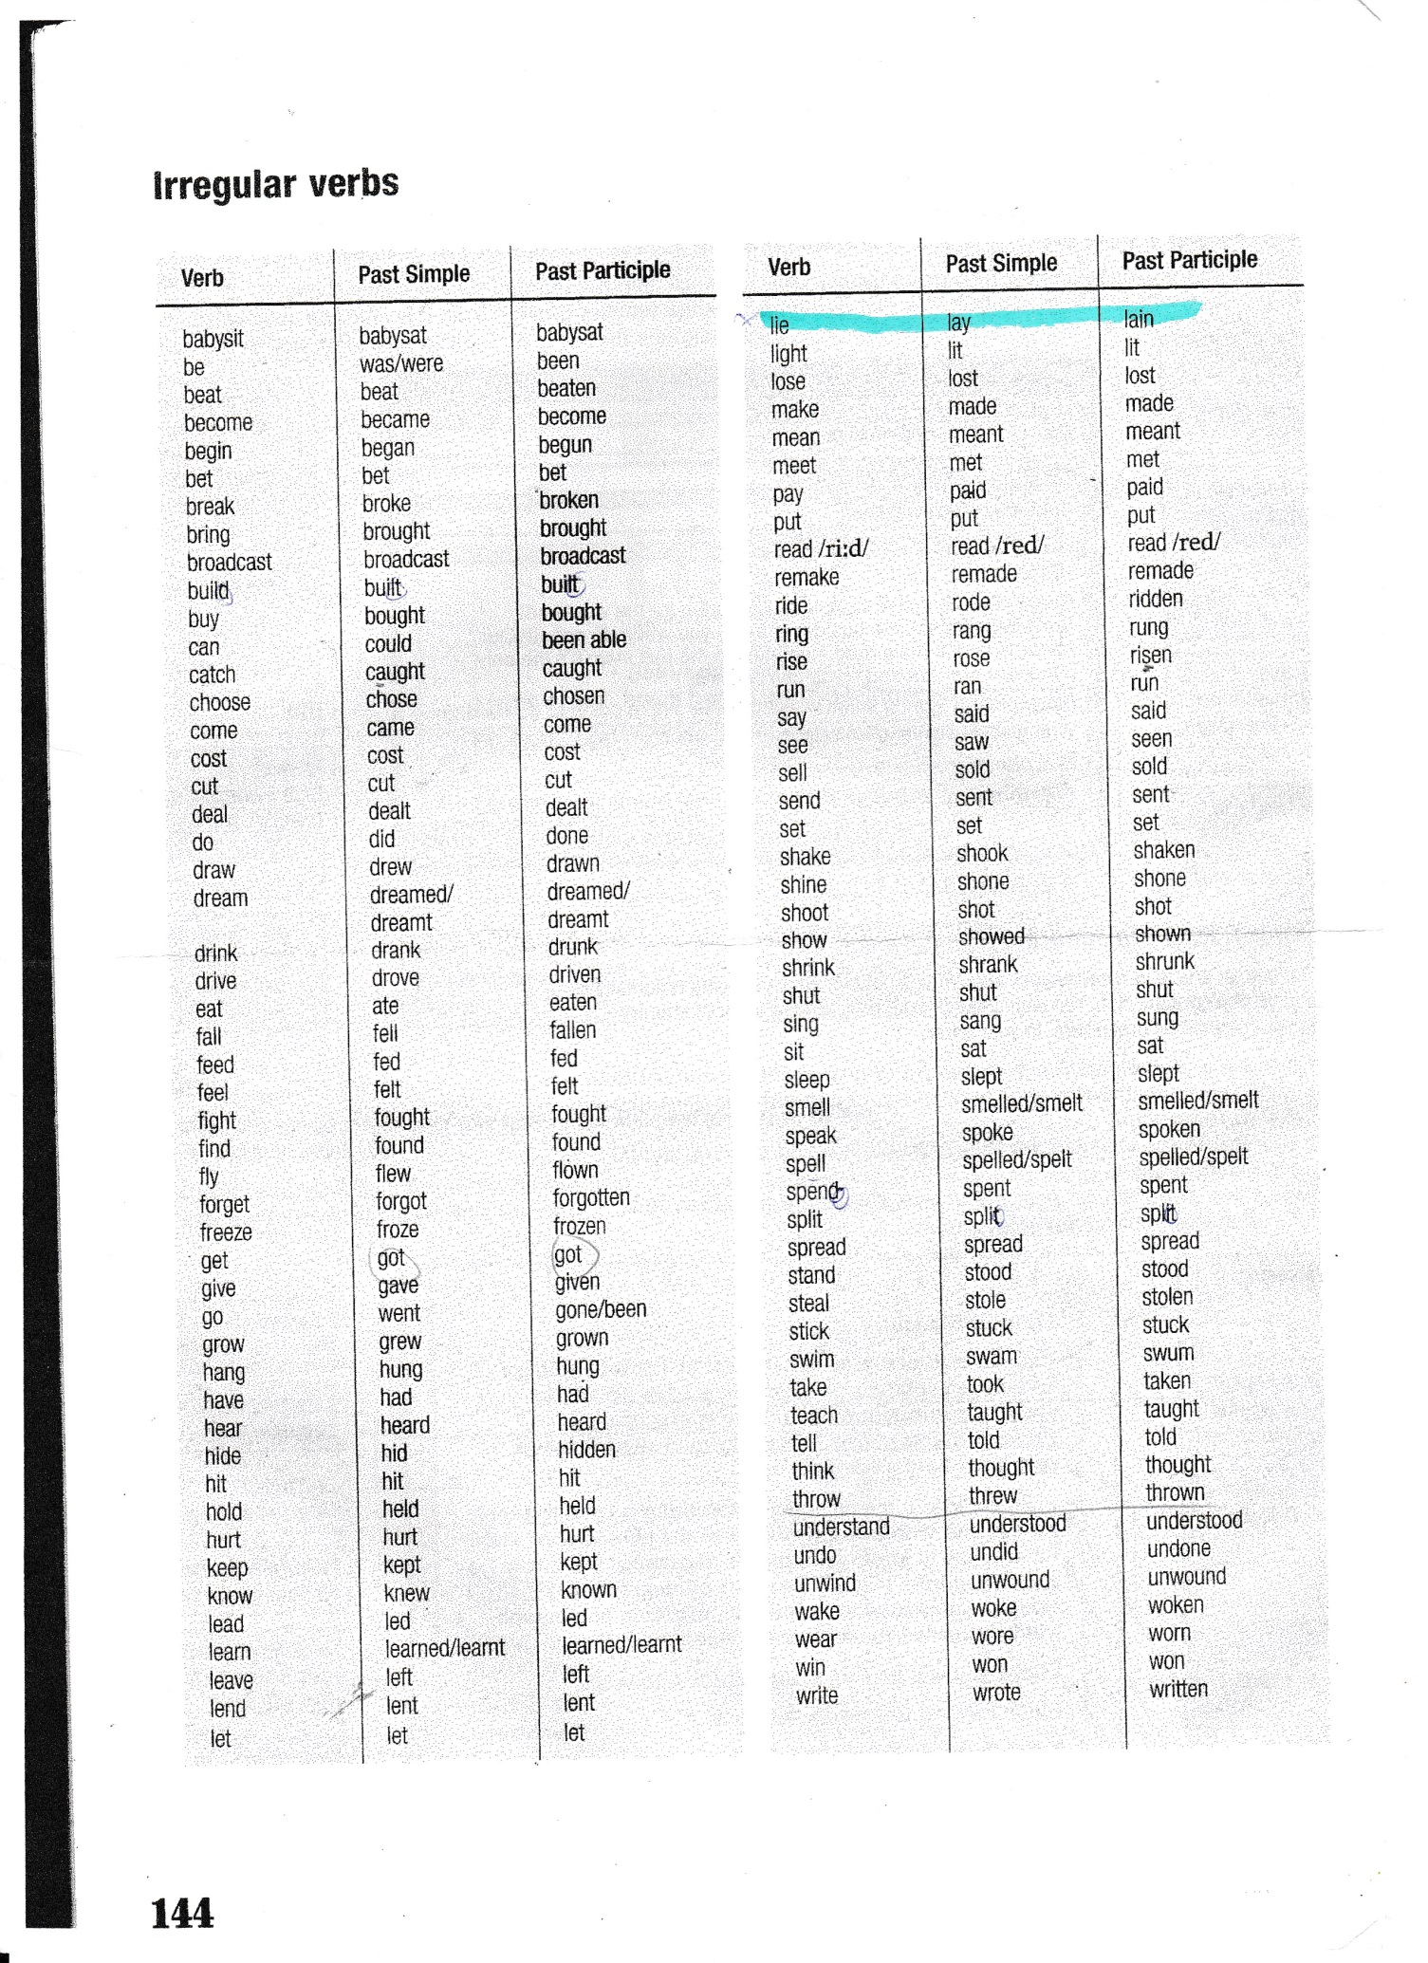

REFLEXIVE PRONOUNS:
myself, yourself, herself/himself
ourselves, yourselves, themselves
each other

NEGATIVE PREFIXES:
a + consunant
dis
il + l
im + m/p
in + (ne o/i)
ir + r
non
un

FUTURE PREDICTIONS:
100% will definately, is sure to
75% will probably, is likely to
50% might/may (not), possible
25% probably won't, unlikely to
0% certanly won't, is sure not to

BEING POLITE:
polite shit + question

polite shit:
could you (possibly) tell me … ?
do you think … ?
i wonder … ?
i was wondering …
i'd like to know …
have you any idea … ?
do you (happen to) know …?
would you mind telling me ...?

AGREEING AND DISAGREEING:
agreeing:
that's so true!
that's a good point
exactly
i couldn't agree more
absolutely

partial agreement:
that may be true, but …
you've got a point, but
i agree up to a point

disagreeing:
i'm sorry, but i can't agree with you
no way
come off it
i'm afraid i have to disagree

GIVING AND JUSTIFYING OPINIONS:
giving opinions:
personaly
in my opinion
to be honest
as far as i'm concerned
if you ask me
it seems to me
frankly

justifying opinions:
the thing is …
everybody knows that …
the reason why … is ….
it's only natural that …
i mean …
if you think about it …
look at …

PERMISSION:
asking for permission:
pleae let me + inf
can i … ?
is it ok/ alright if I … ?
do you minf if I + present simple
may I … ?
i was wondering if i could …

giving permission:
that's fine by me.
no problem.
sure .
yes, of course.
please, do.
no, i dont. –(do you mind?)

unvilling giving permision:
i suppose so.
if you must.
as long as + present simple

refusing permission:
i don't think that's a very good idea.
i'm afraid you can't.
i'm sorry, but …
no.

ADVICE:
asking for advice:
what can/should i do?
what do you think i should do?
i'd really apreciate your advice.
i've no idea how/what to …
i'm at a loss as to what to do.
i'm at my wits' end.

giving advice:
you should(n't) …
you ought (not) to …
you'd better (not) + infinitive
it's a good idea to …
it's worth + -ing
if i were you, i'd …
you might find it useful to …
why don't you … ? + inf
remember to …

LAYOUT OF A LETTER:
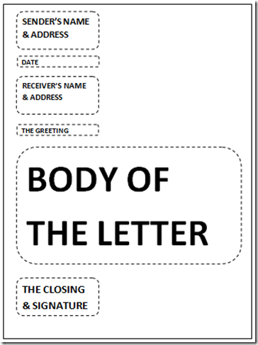

your adress: NO name
greeting: Dear sir/ madam name
yours faithfully
your name (printing, signature)

body:
introduction: why (1 paragraph)
body: explain in details (1,2)
conclusion. tell what you expect (1)

beginings: firstly, as a/the first point, to start/begin with, first of all
continuations: secondly, next, to continue, to go on with, and
conclusion: at the end, finally, to conclude, to round up

language:
the degree of formality
no contractions
no continous tenses

BESEDIŠČE:
animals:
insects
reptiles
amphibians
fish
mammals

